CHAPTER 2

MACH’S PRINCIPLE

So strongly did Einstein believe at that time in the relativity of inertia that in 1918 he stated as being on an equal footing three principles on which a satisfactory theory of gravitation should rest:

- The principle of relativity as expressed by general covariance
- The principle of equivalence
- Mach’s principle (the first time this term entered the literature): . . . that the $g_{\text{μν}}$are completely determined by the mass of bodies, more generally by $T_{\text{μν}}$.

In 1922, Einstein noted that others were satisfied to proceed without this criterion and added, “This contentedness will appear incomprehensible to a later generation however”.

. . . It must be said that, as far as I can see, to this day Mach’s principle has not brought physics decisively farther. It must also be said that the origin of inertia is and remains the most obscure subject in the theory of particles and fields. Mach’s principle may therefore have a future – but not without the quantum theory.

Abraham Pais, Subtle is the Lord, pp. 287 – 288
(Oxford University Press, Oxford, 1982)

CHAPTER SUMMARY:

Einstein’s introduction of Mach’s principle, shortly after the publication of general relativity theory, and his remarks of 1921 are considered, especially his prediction that “spectator matter” should alter the masses of nearby objects. Difficulties of implementing the principle in cosmological terms are mentioned. Sciama’s vector gravity theory is laid out noting the role of the vector potential in the production of inertial reaction forces. From Sciama’s work it follows that “critical cosmic matter density” and cosmic scale spatial flatness with their concomitant condition that the total scalar gravitational potential $φ$ is equal to the square of the speed of light is required if inertial reaction forces are solely due to gravity. The Wilkinson Microwave Anisotropy Probe results which show space at cosmic scale to be flat are mentioned in this connection. Carl Brans’ argument about the role of spectator matter and Ken Nordtvedt’s comments on gravitomagnetism are then discussed. Radiation reaction, gravity waves, and the instantaneity of inertial reaction forces are then investigated. The relationalist and physical interpretations of Mach’s principle are mentioned, and the chapter concludes with the statement of the Mach-Einstein-Sciama laws of inertia.

THE MACH’S PRINCIPLE REVIVAL:

By the early 1950s, the cosmological situation had changed. Significant theoretical work on cosmology had taken place, for example, that of Roberston and Walker in the ‘30s and ‘40s. Thomas Gold, Herman Bondi, and Fred Hoyle had proposed “steady state” cosmology, and Walter Baade had shown that there were two populations of stars, dramatically increasing the age of the universe for FRW cosmological models. So when Dennis Sciama, one of the very few doctoral students trained by Paul Dirac, came along in the early 1950s, tackling the “problem of the origin of inertia” seemed a reasonable thing to do. Sciama’s approach was to ignore GRT and write down a vector theory of gravity analogous to Maxwell’s theory of electrodynamics. He initially thought his vector theory different from GRT. But eventually it was found just to be an approximation to GRT. This, by the way, is an exceedingly important point. Sciama’s calculations are not optional. They are the exact predictions of GRT when conditions make the vector approximation valid and the idealizations he adopted reasonable.

What Sciama noticed was that when you write out the equation for the gravity field that is the analog of the electric field in electrodynamics, in addition to the commonplace term involving the gradient of a scalar potential, there is a term that is the rate of change of the “vector potential”. In electrodynamics, the vector potential is associated with the magnetic field, and the term involving the rate of change of the vector potential that appears in the equation for the electric field means that when the magnetic field changes, it contributes to the electric field, causing it to change too. Sciama noted that in the analogous case for gravity, the rate of change of the vector potential leads to a term in the “gravelectric” field that depends on acceleration of an object relative to the (on average) uniform bulk of the matter in the universe. That is,

$E_{g} = − ∇φ − \frac{1}{c}\frac{∂A_{g}}{∂t}$. (2.3)

where $E_{g}$ is the gravelectric field strength, c the vacuum speed of light, and $φ$ and $A_{g}$ the scalar and three-vector gravitational potentials respectively produced by all of the “matter” in the causally connected part of the universe. Matter is in quotes because what counts as matter is not universally agreed upon. We take “matter” to be everything that gravitates. This includes things like zero-restmass energetic radiation and “dark energy” which are sometimes excluded as “matter”. The “del” in front of the scalar potential is the “gradient” operator which returns the rate of change of the potential in space and its direction. The relationship that allows one to write the change in A_{g} terms of the scalar potential and velocity is the fact that A_{g} is just the sum over all matter currents in the universe. That is,

$A_{g} = \int_{V}{\frac{ρv}{r}\text{dV} }$, (2.4)

where $ρ$ is the matter density in the volume element dV, v the relative velocity of the object and volume element, and r the radial distance to the volume element. Sciama assumed that gravity, like electromagnetism, propagates at speed c, so normally this integration would involve a messy calculation involving retarded Green’s functions and other mathematical complications. But because of the extremely simple, idealized conditions Sciama imposed, he saw that he could side-step all of that messiness by invoking a little trick.

Sciama noted that in the case of an object moving with velocity v with respect to the rest of the universe, one could change reference frame to the “instantaneous frame of rest” of the object; and in that frame the object is at rest and the rest of the universe moves past it – apparently rigidly – with velocity – v. Since, in this special frame of reference everything in the universe, as detected by the object, is moving with the same velocity – v, the velocity in the integration of Equation (2.4) can be removed from the integration, and Equation (2.4) becomes:

$A_{g} = \int_{V}{\frac{ρv}{r}\text{dV} = v\int_{V}{\frac{ρ}{r}\text{dV}}}$. (2.5)

The result of this trick is to transform an integration over matter current densities into an integration over matter densities per se. Anyone familiar with elementary electrodynamics will instantly recognize this integration as that which gives the scalar potential of the field – but in this case, it returns the scalar potential of the gravitational field. As a result, for the simple case considered by Sciama, Equation (2.5) becomes:

$A_{g} = \int_{V}{\frac{ρv}{r}\text{dV} = v\int_{V}{\frac{ρ}{r}\text{dV} ≃ v\frac{GM}{R} = vφ}}$, (2.6)

where we have taken r as the radial distance from the local object to a spherical volume element (of thickness dR), G is Newton’s constant of gravitation, and M and R are the mass and radius of the universe respectively.

R was taken by Sciama as the radius of the “Hubble sphere”, that is, the product of the speed of light and the age of the universe. A more accurate calculation would have employed the “particle horizon”, the sphere centered on the Earth within which signals traveling at the speed of light can reach the Earth. The particle horizon encompasses considerably more material than the Hubble sphere. Sciama also neglected the expansion of the universe. These issues notwithstanding, Sciama’s work triggered an at times intense debate about the origin of inertia. Why? Because when we put the result of the integration in Equation (2.6) back into Equation (2.3), we get:

$E_{g} = − ∇φ − \frac{1}{c}\frac{∂A_{g}}{∂t} = − ∇φ − \frac{φ}{c^{2}} \frac{∂v}{∂t}$. (2.7)

Now, we return to the consideration of our object moving with velocity v with respect to the homogenous and isotropic universe that we can envisage as moving rigidly with velocity – v past the object which is taken as (instantaneously) at rest. In this case the gradient of the scalar potential vanishes. And if v is constant or zero, so too does the second term – and there is no gravelectric field felt by the object. However, if the object is accelerating with respect to the rest of the universe (due to the application of some suitable “external” force), then the second term does not vanish as $∂ v/∂ t = a$, the acceleration, is not zero. More importantly, from the point of view of the origin of inertia – and inertial reaction forces – if $φ/ c^{2} = 1$, then the gravelectric field exactly produces the “equal and opposite” inertial reaction force the accelerating agent experiences. That is, inertial reaction forces are exclusively gravitational in origin. The reason why this was so intriguing is that the condition $φ/ c^{2} = 1$ has special cosmological significance, as we will consider presently.

Clearly, Sciama’s calculation is an approximation. In particular, it is a vector approximation to a field theory that was known to require tensor form in order to be completely general. And it is an idealization. Sciama’s assumptions about the distribution and motion of the “matter” sources of the gravelectric field at the object considered are much simpler than reality, even in the early ‘50s, was known to be. Nevertheless, Sciama’s theory is not a “toy model”. Toy models are created by physicists when they can’t formulate their theory in tractable form in the full four dimensions of real spacetime. To make their theories tractable, they generate them with one or two spatial dimensions where the math is simple enough to be managed. Sciama’s theory is four-dimensional. And the above calculation returns an answer for inertial reaction forces that is essentially correct despite the approximation and idealizations adopted. The part of Sciama’s paper “On the Origin of Inertia” where he calculates this expression is reproduced as Appendix A.

It is worth noting here that an important feature of inertial reaction forces is present in Equation (2.7), and it was noted by Sciama. The two terms on the right hand side of the equation have different dependencies on distance. The scalar potential depends on the inverse first power of the distance. The gradient of the scalar potential, when you are far enough away from a body of arbitrary shape so that it can be approximated as a sphere, depends on the inverse second power of the distance. That is, Newtonian gravitational force exerted by a body on another sufficiently distant goes as the inverse square of the distance separating them. When you are calculating the effect of distant matter on a local object, inverse square dependence applies for the gradient of the scalar potential. And it drops off fairly quickly. The term that arises from the time-derivative of the vector potential scales with the scalar potential, not its gradient. So the distance dependence of this term is inverse first power. When the distances involved in a situation are small, this difference between the terms may be unimportant. When the distances are large, the difference is crucial. The term arising from the vector potential dominates because it doesn’t decrease nearly as rapidly as the Newtonian term does for large distances. This is the reason why the inertia of local objects is due almost exclusively to the action of distant matter.

The inverse first power of the distance dependence of the term from the vector potential that causes inertial forces also signals that the interaction is “radiative”. That is, the interactions that arise from this term involve propagating disturbances in the gravity field. They do not arise from instantaneously communicated effects or the passive action of a pre-existing field. So inertial forces would seem to be gravity “radiation reaction” effects. This poses a problem, for an inertial reaction force appears at the instant an accelerating force is applied to an object. How can that be true if the inertial reaction force involves an active communication with chiefly the most distant matter in the universe, and communication with the stuff out there takes place at the speed of light? If reaction forces were produced by the interaction with a passive, locally present pre-existing field, this would not be a problem. But that is not what is calculated in Sciama’s treatment. The trick of using the instantaneous frame of rest where the universe very obviously appears to be moving rigidly past the accelerating object not only side-steps a messy calculation involving Green’s functions; it blurs the issue of instantaneity of reaction forces. This is arguably the most difficult aspect of coming to grips with the origin of inertia.

You may be wondering, if this sort of thing happens with gravity, why don’t we see the same sort of behavior in electromagnetism? After all, if we accept Sciama’s theory as the vector approximation to GRT that it is, they are both vector field theories with essentially the same field equations. Ironically, as it turns out, the problems of the origin of inertia – in the form of electrical “self-energy” – and “radiation reaction” have plagued electrodynamics for years too. It just hasn’t been discussed much in recent years – but infinite ”self-energies” of point particles was the motivation,for example, for the invention the “renormalization” program of quantum field theory, and of string theory. We’ll be looking at these issues in later chapters in some detail. Here we note that although the vector field formalisms for gravity and electromagnetism are essentially the same, this type of gravitational force from the action of cosmic matter does not arise in electrodynamics – because on average the universe is electric charge neutral, so cosmic electric charge currents sum to zero everywhere. More specifically, since on average there is as much negative electric charge as positive in any region of spacetime, the total charge density is zero. So, in the calculation of the vector potential – as in Equation (2.5) – since ρ is zero, the integral for the potential vanishes. This means that in everyday electrodynamics you never have to deal with the action of distant electric charge and currents of any significance. But in gravity, you do.

Sciama’s calculation is not optional. It is a prediction of GRT providing that $φ/ c^{2} = 1$. Is $φ/ c^{2} = 1$ true? Yes. When is$φ/{c^{2}} = 1$? When “critical cosmic matter density” obtains, and space at the cosmic scale is flat. Sciama didn’t know if this were true. Indeed, even in the 1950s it was thought that the amount of luminous matter in the universe was not sufficient to be “critical”. So Sciama did not make a bald-faced claim that he could fully account for inertial reaction forces. But space at the cosmic scale sure looked pretty flat. And it was known that if cosmic scale space deviated from flatness, it would quickly evolve to far greater distortion. As the universe was at least billions of years old and still flat, most cosmologists assumed that space really was flat, and that critical cosmic matter density obtained. And the fact that luminous matter was less than 10% of the critical value came to be called the “missing mass” problem. Only after the turn of the century was space at the cosmic scale measured – by the Wilkinson Microwave Anisotropy Probe (WMAP) about a decade ago. So we know whether cosmic scale space is flat. It is.

You may be wondering, if we know that space at the cosmic scale is flat, why isn’t it common knowledge that inertial reaction forces are caused by the gravitational interaction of local accelerating objects with chiefly cosmic matter? Well, two issues figure into the answer to this question. One is the consequence of an analysis done by Carl Brans in the early 1960s. (Excerpts from Brans’ paper are to be found in Appendix B.) And the other, related to Brans’ argument, is the business about there being no “real” gravitational forces. Brans showed that if the presence of “spectator” matter (concentrations of matter nearby to a laboratory that shields the stuff in it from all external influences except gravity [which cannot be shielded]) were to change the gravitational potential energies of objects in the shielded laboratory, you could always tell whether you were in a gravity field or an accelerating lab in deep space by performing only local experiments. In particular, the gravitationally induced changes in the masses of elementary particles in the lab would change their charge to mass ratios and this would be locally detectable, No such changes in charge to mass ratios would occur in an accelerated reference frame in deep space. As a result, a gravity field could always be discriminated from an acceleration with local experiments. Since this would be a violation of the Equivalence Principle, Brans asserted that gravitational potential energy cannot be “localized”. That is, the scalar gravitational potential must have exactly the same value, whatever it might be, everywhere in the laboratory, no matter where the lab is located or how it is accelerating. As Brans noted, this condition on gravitational potential energy reveals Einstein’s first prediction quoted above as wrong. Evidently, it appears that the distribution and of matter outside of the lab cannot have any identifiable effect on the contents of the lab. Mach’s principle, however, would seem to suggest the opposite should be the case. And it was easy to infer that Mach’s principle is not contained in pristine GRT.

The inference that Mach’s principle is not contained in GRT, however, is mistaken. If you take account of the role of the vector potential in Sciama’s gravelectric field equation, it is clear that should spectator matter outside the lab be accelerated, it will have an effect on the contents of the lab, changing what are perceived to be the local inertial frames of reference. This is the action of Mach’s principle. But as the accelerating spectator matter will act on all of the contents of the lab equally, for inertial forces are “fictitious”, they produce the same acceleration irrespective of the mass of the objects acted upon. So, using local measurements in the lab it will not be discernable either as a force of gravity or a change in the acceleration of the lab. And it will not change the gravitational potential energies of the contents of the lab.

Brans’ argument about the localizability of gravitational potential energy has an even more radical consequence – one found in the excerpt from MTW on energy localization in the gravitational field found in the previous chapter. If you can eliminate the action of the gravitational field point-by-point throughout the laboratory by a careful choice of geometry that, for us external observers, has the effect of setting inertial frames of reference into accelerated motion with respect to the walls, floor and ceiling of the lab, it seems reasonable to say that there is no gravitational field, in the usual sense of the word, present in the lab. This is what is meant when people say that GRT “geometrizes” the gravitational field. In this view there are no gravitational forces. Gravity merely distorts spacetime, and objects in inertial motion follow the geodesics of the distorted spacetime. The only real forces in this view are non-gravitational. Inertia, of course, is a real force. But if you believe that there aren’t any real gravitational forces, then the origin of inertia remains “obscure” – as Abraham Pais remarked in the quote at the outset of this chapter – for it isn’t a result of the electromagnetic, weak, or strong interactions (and can’t be because they are not universal), and that leaves only gravity. But we’ve excluded gravity because we know that there aren’t any gravitational forces. And the origin of inertia remains a mystery.

There may not be any “real” gravitational forces in GRT, but there is “frame dragging”. That is, in the conventional view, matter can exert a force on spacetime to produce frame dragging, but it can’t act directly on the matter in the possibly dragged spacetime. If this sounds a bit convoluted, that’s because it is. Let me illustrate this point.

About the time that Thorne and his grad students were introducing the rest of us to traversable wormholes, a committee of the Nation Academy of Sciences was doing a decadal review of the state of physics, producing recommendations on the areas of physics that should be supported with real money. One of their recommendations was that Gravity Probe B should be supported because, allegedly, no other test of “gravitomagnetism” was contemplated, and this was an important, if difficult and expensive test of GRT. Ken Nordtvedt, a physicist with impeccable credentials who had proposed the “Nordtvedt effect”, then being tested by ranging the distance of the Moon with a laser, but who had not been a member of the decadal survey committee, pointed out that the claim was just wrong. He noted that even in doing routine orbit calculations, unless care was taken to use special frames of reference, one had to take account of gravimagnetic effects to get reasonable results. Using “parameterized post Newtonian” (PPN) formulation of gravity, a formalism that he and others had developed as a tool to investigate a variety of theories of gravity some twenty years earlier, he showed explicitly how this came about.

In the course of his treatment of orbital motion, Nordtvedt drew attention to the fact that gravity predicts that linearly accelerated objects should drag the spacetime in their environs along with themselves since the gravitational vector potential does not vanish. Nordtvedt’s 1988 paper on the “Existence of the Gravitomagnetic Interaction” where he discussed all this is excerpted in Appendix C. In effect, he recovered the same basic result as Einstein and Sciama, only where they had talked about gravitational forces acting on local objects, Nordtvedt put this in terms of “frame dragging”. Are they the same thing? Well, yes, of course they are. The reason why you may find this confusing is because in the case of everything except gravity, one talks about the sources of fields, the fields the sources create, and the actions of fields in spacetime on other sources. That is, spacetime is a background in which sources and fields exist and interact. In GRT spacetime itself is the field. There is no background spacetime in which the gravitational field exists and acts. Since there is no background spacetime, GRT is called a “background independent” theory. It is this background independence that makes gravity and GRT fundamentally different from all other fields. And it is the reason why “frame dragging” is fully equivalent to the action of a gravitational force. If you want to preserve the configuration of a system before some nearby objects are accelerated, when the nearby objects begin to accelerate, you have to exert a force that counteracts the effect of the frame dragging produced by the acceleration of the nearby objects. When you do that, what do you feel? An inertial reaction force – the force produced by the action of the dragged spacetime which is produced by the gravitational action of the accelerated nearby objects. By interposing frame dragging we’ve made it appear that no gravitational force is acting. But of course gravity is acting, notwithstanding that we’ve introduced the intermediary of frame dragging to make it appear otherwise.

When only nearby objects are accelerated to produce frame dragging, as Einstein noted for the equivalent force he expected, the predicted effects are quite small. When it is the universe that is accelerated, it is the full normal inertial reaction force that is felt if you constrain some object to not accelerate with the universe. Why the difference? Because when the entire universe is “rigidly” accelerated, the interior spacetime is rigidly dragged with it, whereas nearby objects, even with very large masses, produce only small, partial dragging. You may be thinking, yeah, right, rigidly accelerating the whole universe. That would be a neat trick. Getting the timing right would be an insuperable task. The fact of the matter, nonetheless, is that you can do this. We all do. All the time. All we have to do is accelerate a local object. Your fist or foot for example. The principle of relativity requires that such local accelerations be equivalent to considering the local object as at rest with the whole universe being accelerated in the opposite direction. And the calculation using the PPN formalism for frame dragging (with GRT values for the coefficients in the equation assumed) bears this out. At the end of his paper on gravimagnetism Nordtvedt showed that a sphere of radius R and mass M subjected to an acceleration a drags the inertial space within it as:

$δa\left(r,t\right) = − \left(2 + 2γ + \frac{α_{1}}{2}\right) \frac{U\left(r,t\right)}{c^{2}} a$ (2.8)

Where the PPN coefficients have the values $γ = 2$and $α_{1} = 0$for the case of GRT and $U\left(r,t\right)$ is the Newtonian scalar potential, that is, $U = {GM}/R$. So we have 4 times $φ$ (changing back to the notation of Sciama’s work on Mach’s principle) equal to $c^{2}$ to make $δa = a$ in Equation (2.8); that is, if the universe is accelerated in any direction, spacetime is rigidly dragged with it, making the acceleration locally undetectable.

You may be concerned by the difference of a factor of 4 between the Nordtvedt result and Sciama’s calculation. Factors of 2 and 4 are often encountered when doing calculations in GRT and comparing them with calculations done with approximations in, in effect, flat spacetime. In this case, resolution of the discrepancy was recently provided by Sultana and Kazanas who did a detailed calculation of the contributions to the scalar potential using the features of modern “precision” cosmology (including things like dark matter and dark energy, and the particle horizon rather than the Hubble sphere), but merely postulating the “Sciama force”, which, of course, did not include the factor of 4 recovered in Nordtvedt’s calculation. They, in their relativistically correct calculation, found $φ$ to have only a quarter of the required value to make the coefficient of the acceleration equal to one. Using the general relativistic calculation, with its factor of 4 in the coefficient, makes the full coefficient of the acceleration almost exactly equal to one – as expected if Mach’s principle is true.

You might think that having established the equivalence of frame dragging by the universe and the action of inertial forces, we’d be done with the issue of inertia. Alas, such optimism is premature. A few issues remain to be dealt with. Chief among them is that if $φ = {GM}/R$, since at least R is changing (because of the expansion of the universe), it would seem that $φ = c^{2}$must just be an accident of our present epoch. However, if the laws of physics are to be true everywhere and everywhen, and inertial reaction forces are gravitational, then it must be the case that $φ = c^{2}$ everywhere and everywhen if Newton’s third law of mechanics is to be universally valid. Well, we know that the principle of relativity requires that c, when it is locally measured, has this property – it is a “locally measured invariant”. So, perhaps it is not much of a stretch to accept that $φ$ is a locally measured invariant too. After all, GM/R has dimensions of velocity squared. No fudging is needed to get that to work out right. But there is an even more fundamental and important reason to accept the locally measured invariance of $φ$: it is the central feature of the “Einstein Equivalence Principle” (EEP) which is required to construct GRT. As is universally known, the EEP prohibits the “localization” of gravitational potential energy. That is, it requires that whenever you make a local determination of the total scalar gravitational potential, you get the same number, whatever it may happen to be (but we know in fact to be equal to c²). Note that this does not mean that the gravitational potential must everywhere have the same value, for distant observers may measure different values at different places – just as they do for the speed of light when it is present in the gravity fields of local objects. Indeed, this is not an accident, because $φ$ and c are related, one being the
square of the other.

Should you be inclined to blow all of this off as some sort of sophistry, keep in mind that there is a compelling argument for the EEP and the locally measured invariance of$φ$ − the one constructed by Carl Brans in 1962 that we’ve already invoked. If you view the gravitational field as an entity that is present in a (presumably flat) background spacetime – as opposed to the chief property of spacetime itself (as it is in GRT) – it is easy to believe that gravitational potential energies should be “localizable” – that is, gravitational potentials should have effects that can be detected by local measurements. Brans pointed out that were this true, it would be a violation of the principle of relativity as contained in the Equivalence Principle. Why? Because, as mentioned above, you would always, with some appropriate local experiment, be able to distinguish a gravitational field from accelerated frames of reference. Brans’ way was to measure the charge to mass ratios of elementary particles. An even simpler, cruder way to make the discrimination between gravity field and accelerated reference frame is to drop stuff. You won’t be able to tell the difference between a gravity field and accelerated frame of reference by the way things “fall” since they all “fall” with the same acceleration in both cases, irrespective of their masses or compositions. But you will be able to tell by how big a dent in the floor they make – because their masses are presumably different when gravity is present, versus when it is not, and bigger masses make bigger dents. Brans’ argument makes clear that the EEP must be correct if the principle of relativity is correct – and that Einstein was wrong in 1921 when he assumed that the piling up of spectator matter would change the masses of local objects. Notwithstanding that the non-localizability of gravitational potential energies, however, the fact that inertial reaction forces are independent of time and place requires that the masses of things be equal to their total gravitational potential energies. That is, $E = {mc}^{2}$and$E_{\text{grav}} = mφ$, so if $E = E_{\text{grav}}$ and$φ = c^{2}$ as Mach’s principle demands, we have a simple identity.

Another example:

The “relational” and “physical” versions of Mach’s principle:

Should you find the forgoing confusing and contentious, you’ll doubtless be disappointed to learn that we haven’t yet covered the full range of arguments involving Mach’s principle. As arguments about Mach’s principle developed over the decades of the ‘50s, ‘60s, and ‘70s, two distinct ways of “interpreting” the principle emerged. One came to be called the “relationalist” view, and the other I shall call the “physical” view. Serious arguments about Mach’s principle ceased to be fashionable in the mid- 1970s. A few hardy souls wrote about the principle in the late ‘70s and ‘80s, but no one paid them much mind. Mach’s principle became fashionable again in the early ‘90s, and Julian Barbour and Herbert Pfister organized a conference of the experts in the field held in Tübingen in the summer of 1993. The proceedings of the conference were published as volume six of the Einstein Studies series with the title: Mach’s principle: From Newton’s Bucket to Quantum Gravity (Birkhauser, Boston, 1994). This is an outstanding book, not least because the questions, comments, and dialog were published, as well as the technical papers presented.

Both the realtionalist and physical positions on Mach’s principle were on display at the conference. Many of the attendees seem to have been convinced relationalists. The essence of the relationalist position is that all discussion of the motion of massive objects should be related to other massive objects; that relating the motion of objects to spacetime itself is not legitimate. This probably doesn’t sound very much like our discussion of Mach’s principle here. That’s because it isn’t. The relationalist approach says nothing at all about the origin of inertial reaction forces. The physical view of Mach’s principle, however, does. After the conference, one of the leading critics of Mach’s principle, Wolfgang Rindler, wrote a paper alleging that Mach’s principle was false, for it led to the prediction of motion of satellites in orbit around planets that is not observed – that is, the motion was in the opposite direction from that predicted by GRT. It was three years before Herman Bondi and Joseph Samuel’s response to Rindler was published. They pointed out that while Rindler’s argument was correct, it was based on the relationalist interpretation of Mach’s principle. They argued that the physical interpretation that they took to be exemplified by GRT and Sciama’s model for inertia, gave correct predictions. Therefore, Mach’s principle could not be dismissed as incorrect on the basis of satellite motion as Rindler had hoped to do. I cannot resist the temptation to remark here that it seems that Einstein was right in 1922, and Pais in 1982, when they remarked that Mach’s principle was a missing piece of the puzzle of the origin of inertia. We should now know better. After all, the WMAP results show that as a matter of fact space is flat, and it is certainly not empty, so if the principle of relativity, introduced by Galileo, is right, then Mach’s principle is correct too. And we should simply drop all of the arguments and assumptions that distract us from this conclusion.

APPENDIX A

Excerpt from “On the Origin of Inertia”, Monthly Notices of the Royal Astronomical Society 113, 34 − 42 (1953):
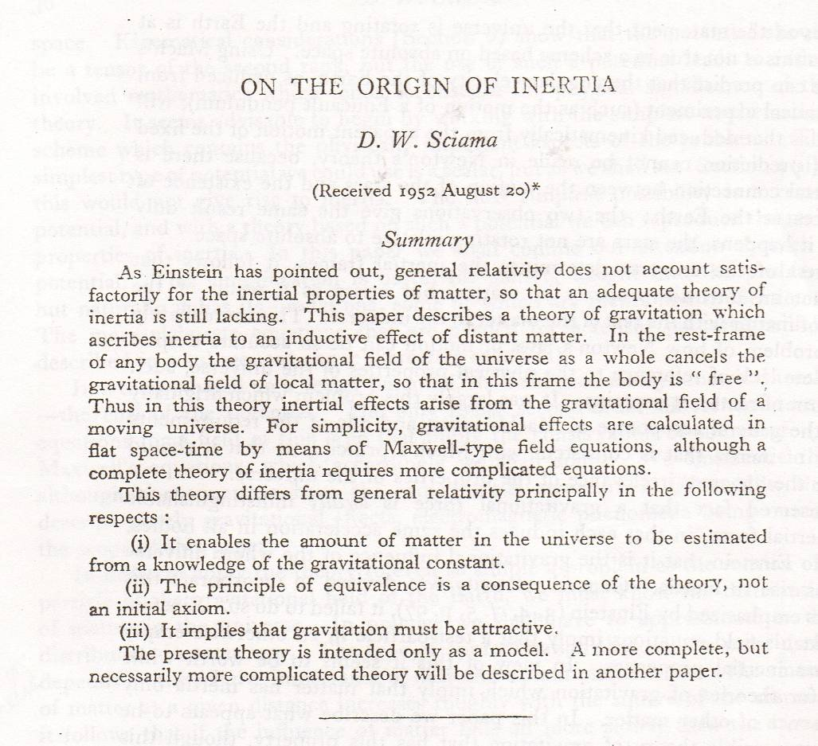

The main calculation of interest in Sciama’s paper occupies about one page:

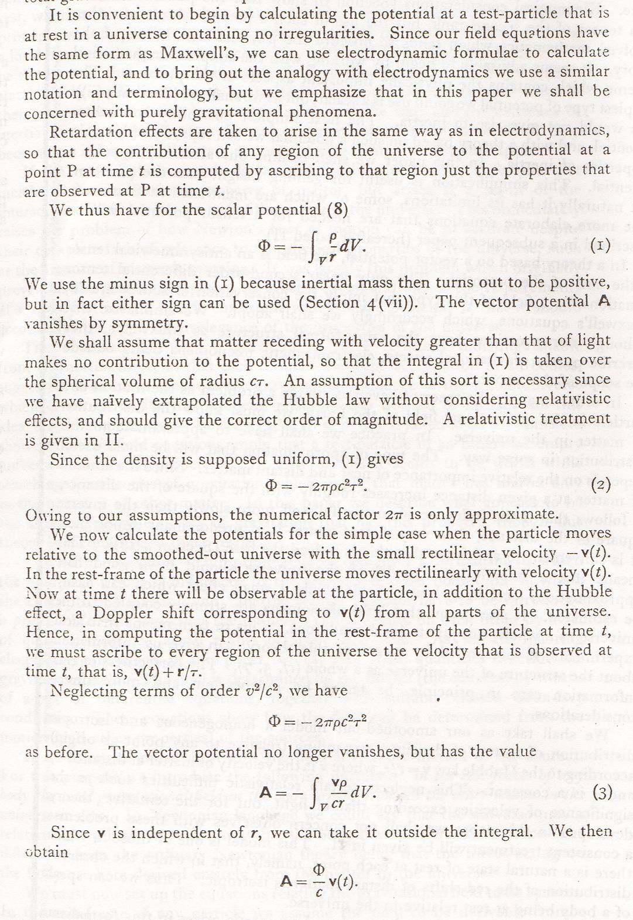
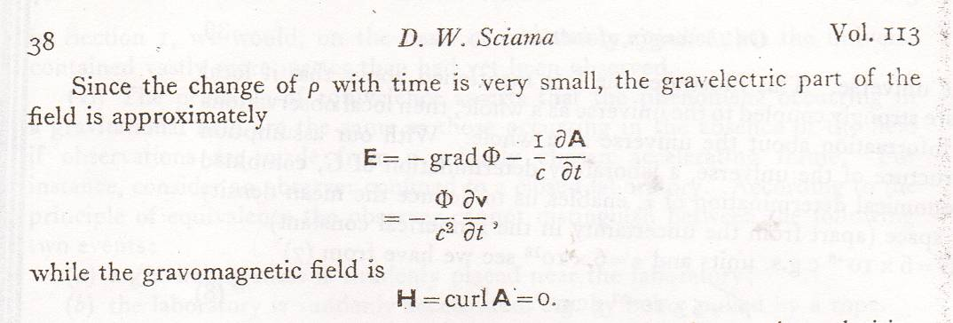

And if $\frac{Φ}{c^{2}} = 1$, then the gravelectric field just produces the full inertial reaction force.

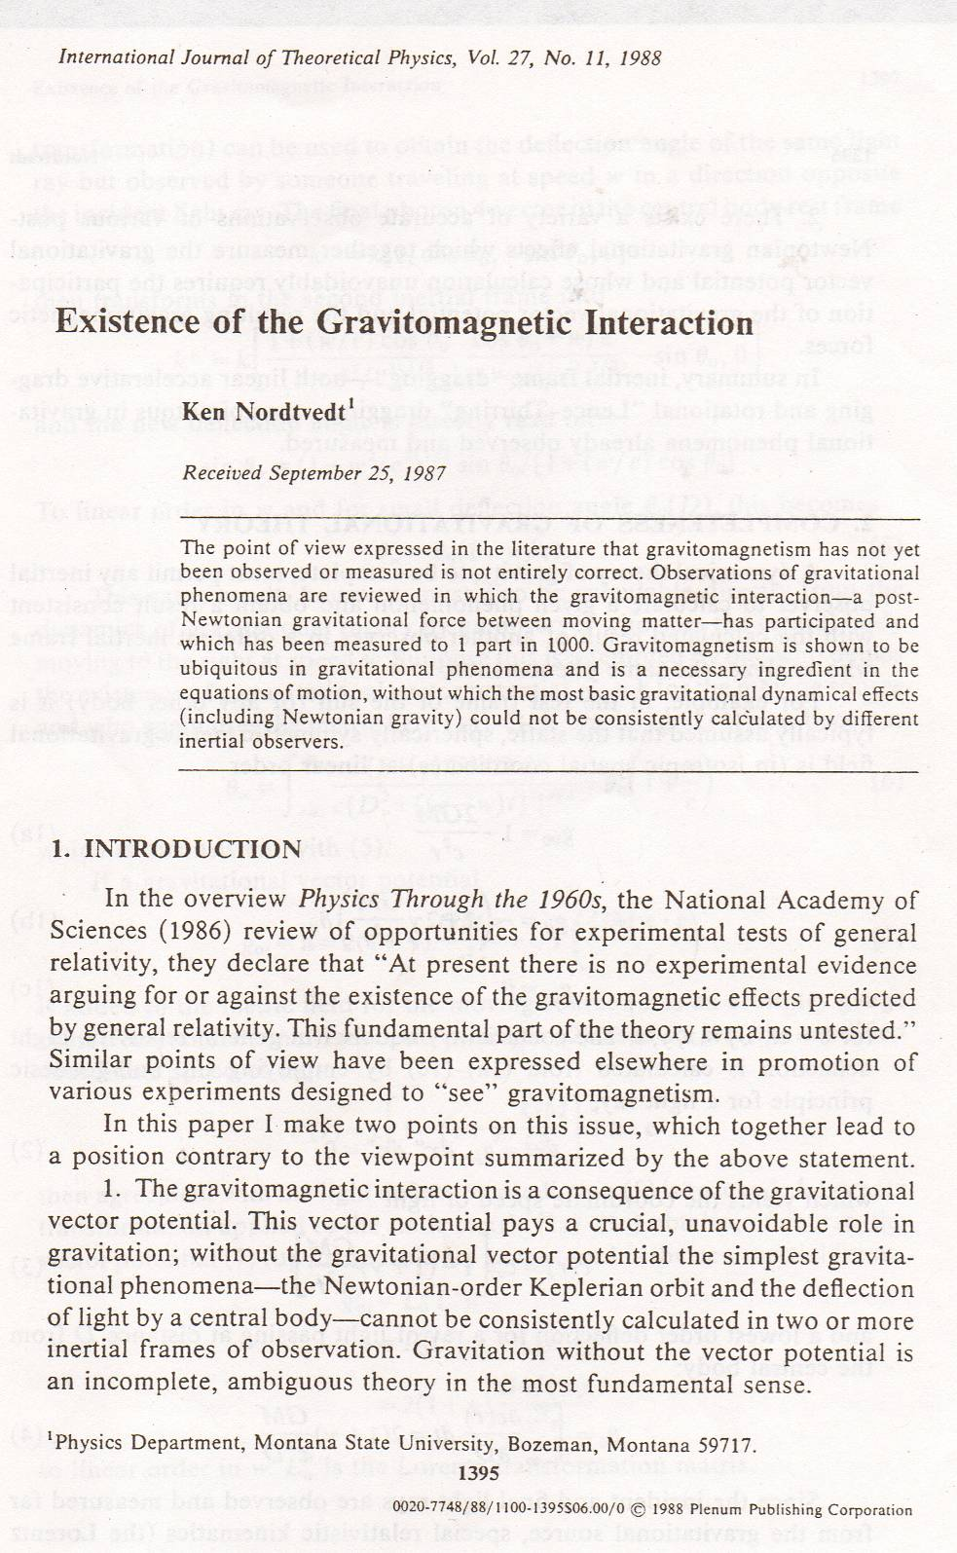

Toward the end of his paper Nordtvedt discusses linear accelerational frame dragging:

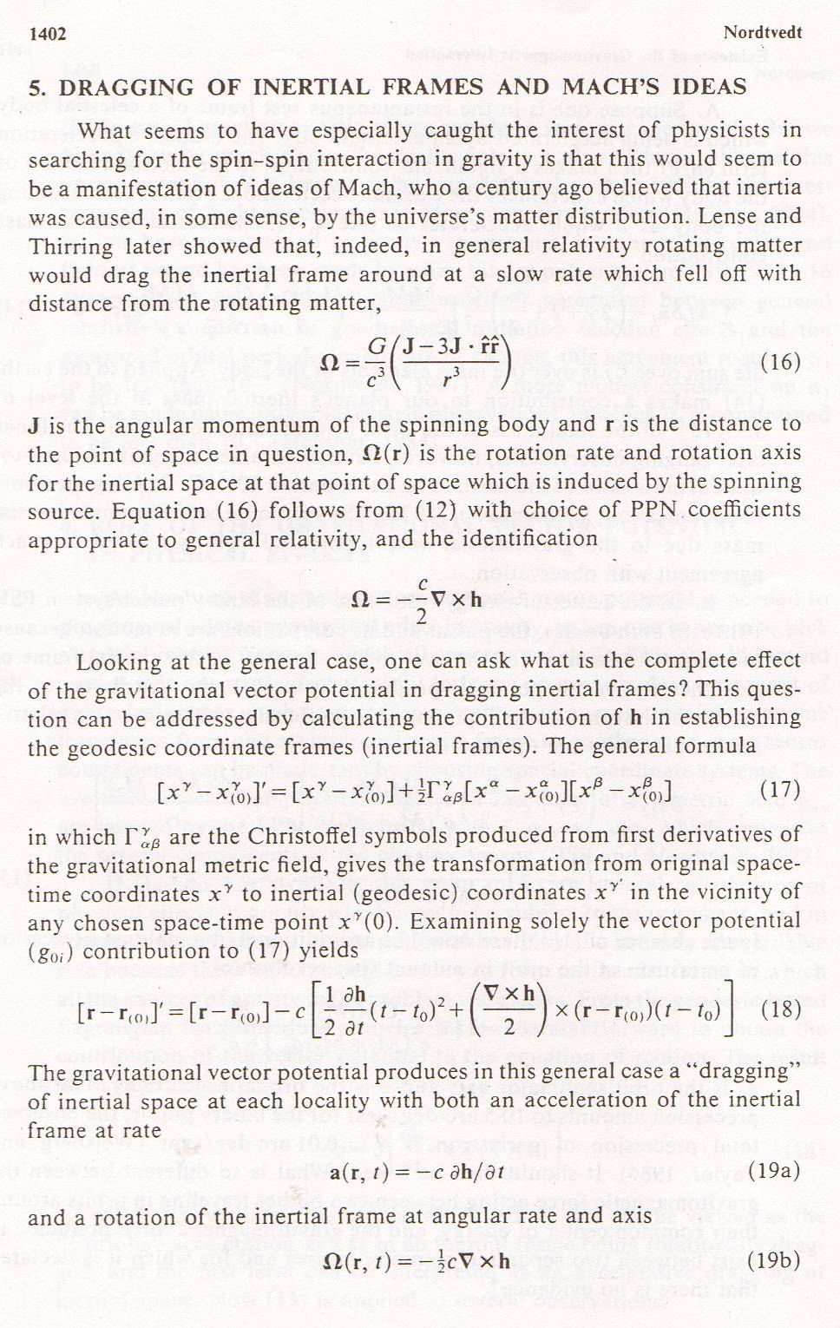

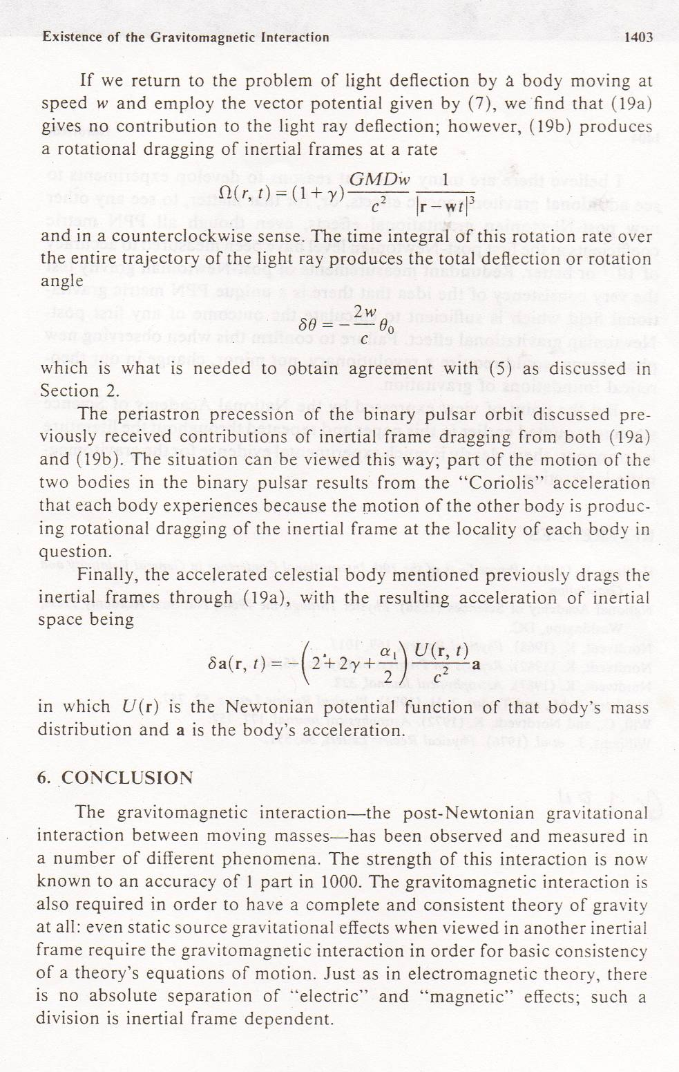

The last step in tying up Mach’s ideas, not taken by Nordtvedt in this paper, is to ask what the linear accelerational frame dragging would be if it were the entire universe that were accelerated by an “external” force? If we insert GRT values for the PPN coefficients in Nordtvedt’s last equation and assume a simple spherical universe of homogeneous and isotropic “matter” distribution, we find that the condition for “rigid” frame dragging – so that the acceleration of the universe is undetectable by any of its constituent parts – is, up to a geometric factor of 4. Exactly the condition found by Sciama for intertial reaction forces being entirely due to the gravitational action of chiefly distant matter in the universe. The factor of 4 in Brans’ calculation turns out to be due to his assumption of a rigid sphere of uniform density as the object accelerated. When a flat Friedmann cosmology with modern parameters and the particle horizon is used, that factor turns out to be 1.

Newton is routinely credited with the discovery of the inverse square law of universal gravitation. But his contemporary Robert Hooke claimed to have independently discovered the inverse square law before Newton made public his claim. Newton refused the Presidency of the Royal Society until shortly after Hooke’s death. Shortly thereafter, the Royal Society moved to new quarters, and Hooke’s papers from the 1680s were lost in the move. Whether Hooke actually discovered the inverse square nature of gravity, absent his papers, is a matter of conjecture. It seems unlikely, though, that he discovered the universal nature of the interaction.
Actually, the “missing mass” problem was first identified in the 1930s by Fritz Zwicky by applying the “virial theorem” to clusters of galaxies. The virial theorem says that on average, the kinetic and potential energies of galaxies in clusters should be the same. So, by measuring the motions of galaxies in a cluster, you can estimate the mass of the cluster. It leads to galaxy cluster mass estimates 10 to 100 times greater than the light emitted suggests is present. Only later was it extended to encompass cosmology too.
Or Einstein’s vector approximation equation for the force exerted by spectator matter that is accelerating on other local objects.
The Nordtvedt effect proposes that gravitational potential energies do contribute to the mass-energy of things, and predicts (small) deviations from the predictions of GRT that would follow. Such effects have not been observed.
He also predicted that the masses of things should vary as they are accelerated, an effect of the sort that we’ll be looking at in the next chapter.
Nordtvedt considered only a rigid sphere of uniform density of modest dimensions. He did not extend the argument to the case where the sphere is the entire universe, as did Sciama.
See: J. Sultana and D. Kazanas, arXiv:1104.1306v1 [astro-ph.CO], later published in the Journal of Modern Physics D). They find that the “Sciama” force is one quarter of that needed for an exact inertial reaction force. The factor of 4 discrepancy arises from the fact that Sultana and Kazanas simply assumed the “Sciama” force without deriving it from GRT, and Sciama’s calculation is not exactly equivalent to a general relativistic calculation like Nordtvedt’s. The difference is the factor of 4 that when multiplied times their result returns 1 almost exactly.
In this connection, Paul Davies relates an apposite story: “. . . I ventured: “What is the origin of the random phase assumption?” To my astonishment and dismay, [David] Bohm merely shrugged and muttered: “Who knows?” “But you can’t make much progress in physics without making that assumption,” I protested. “In my opinion,” replied Bohm, “progress in science is usually made by dropping assumptions!” This seemed like a humiliating put-down at the time, but I have always remembered these words of David Bohm. History shows he is right. . . .

