CHAPTER 2

MACH’S PRINCIPLE

So strongly did Einstein believe at that time in the relativity of inertia that in 1918 he stated as being on an equal footing three principles on which a satisfactory theory of gravitation should rest:

- The principle of relativity as expressed by general covariance
- The principle of equivalence
- Mach’s principle (the first time this term entered the literature): . . . that the 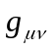are completely determined by the mass of bodies, more generally by 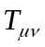.

In 1922, Einstein noted that others were satisfied to proceed without this criterion and added, “This contentedness will appear incomprehensible to a later generation however”.

. . . It must be said that, as far as I can see, to this day Mach’s principle has not brought physics decisively farther. It must also be said that the origin of inertia is and remains the most obscure subject in the theory of particles and fields. Mach’s principle may therefore have a future – but not without the quantum theory.

Abraham Pais, Subtle is the Lord, pp. 287 – 288
(Oxford University Press, Oxford, 1982)

CHAPTER SUMMARY:

Einstein’s introduction of Mach’s principle, shortly after the publication of GRT, and his remarks of 1921 are considered, especially his prediction that “spectator matter” should alter the masses of nearby objects. Difficulties of implementing the principle in cosmological terms are mentioned. Sciama’s vector gravity theory is laid out noting the role of the vector potential in the production of inertial reaction forces. From Sciama’s work it follows that “critical cosmic matter density” and cosmic scale spatial flatness with their concomitant condition that the total scalar gravitational potential is equal to the square of the speed of light is required if inertial reaction forces are solely due to gravity. The WMAP results are mentioned in this connection. Carl Brans’ argument about the role of spectator matter and Ken Nordtvedt’s comments on gravitomagnetism are then discussed. Radiation reaction, gravity waves, and the instantaneity of inertial reaction forces are then investigated. The relationalist and physical interpretations of Mach’s principle are mentioned, and the chapter concludes with the statement of Mach’s two laws of inertia.

INTRODUCTION:

. Recapitulating, we have seen that when the implications of the principle of relativity for space and time were understood in the early 20th century, Einstein quickly apprehended that the quantity of interest in the matter of inertia was not (rest)mass per se, rather it was the total non-gravitational energy contained in an object (isolated and at rest). This followed from Einstein’s second law, which says:

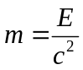, (1)

where m is now understood as the total inertial mass, not just the restmass of an object, and E is the total non-gravitational energy. If one restricts oneself to SRT, this is about all one can say about inertial mass. It was Einstein’s hope that he could go farther in identifying the origin of inertia in GRT, as is evident in the quote from A. Pais above.

As we have seen in the previous chapter, Einstein didn’t need “Mach’s principle” to create GRT. He did, though, shortly after publishing his first papers on GRT, try to incorporate the principle into his theory. He did this by adding the now famous “cosmological constant” term to his field equations. Those equations, without the cosmological constant term, are:

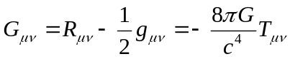, (2)

where 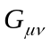is the Einstein tensor that embodies the geometry of spacetime, 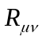is the “contracted” Ricci tensor (obtained by “contraction” from the Riemann curvature tensor which has four “indexes”, each of which can take on values 1 through 4 for the four dimensions of spacetime), is the “metric” of spacetime, and is the “stress-energy-momentum” tensor, that is, the sources of the gravitational field. The cosmological term gets added to . We need not worry about the details of these tensor equations. But it’s worth remarking here that the coefficient of , with factors of Newton’s constant of gravitation G in the numerator and the speed of light c to the fourth power in the denominator, is exceedingly small. This means that the sources of the field must be enormous to produce even modest bending of spacetime. That is why a Jupiter mass of exotic matter is required to make wormholes and warp drives.

Ostensibly, Einstein added the cosmological constant term to make static cosmological solutions possible by including a long-range repulsive force. But he also hoped that the inclusion of the cosmological constant term would render his field equations solutionless in the absence of matter. Willem deSitter quickly showed that Einstein’s new equations had an expanding, asymptotically empty solution, one with full inertial structure. And a vacuum solution too. So Einstein’s attempt to include Mach’s principle in this way was deemed a failure. The chief reason for his failure seems to have been the way he defined the principle: that the inertial properties of objects in spacetime should be defined (or caused) by the distribution of matter (and its motions) in the universe. Put a little differently, Einstein wanted the sources of the gravitational field at the global scale to determine the inertia of local objects. He called this “the relativity of inertia”. The problem Einstein encountered was that his GRT is a local field theory (like all other field theories), and the field equations of GRT admit global solutions that simply do not satisfy any reasonable formulation of, as he called it, Mach’s principle. Even the addition of the “cosmological constant” term to his field equations didn’t suffice to suppress the non-Machian solutions.

Alexander Friedmann and Georges Lemaitre worked out cosmological solutions for Einstein’s field equations in the 1920s, but cosmology didn’t really take off until Edwin Hubble, very late in the decade, showed that almost all galaxies were receding from the Earth. Moreover, they obeyed a velocity-distance relationship that suggested that the universe is expanding. From the 1930s onward work on cosmology has progressed more-or-less steadily. The cosmological models initiated by Friedman, predicated on the homogeneity and isotropy of matter at the cosmic scale, were developed quickly by Robertson and Walker. So now cosmological models with homogeneity and isotropy are called Friedmann, Robertson, Walker (FRW) cosmologies. One of them is of particular interest: the model wherein space is flat at cosmological scale. Spatial flatness corresponds to “critical” cosmic matter density – 2 X 10⁻²⁹ grams per cubic centimeter – and has the unfortunate tendency to be unstable. Small deviations from this density lead to rapid evolution away from flatness. Since flatness is the observed fact of our experience and the universe is more than 10 billion years old, how we could be in a spatially flat universe so long after the primeval fireball was considered something of a problem. The advent of “inflationary” cosmologies twenty or so years ago is widely thought to have solved this problem. As we will see shortly, spatial flatness and critical cosmic matter density figure into the answer to the question of the origin of inertia. But we are getting ahead of the story.

MACH’S PRINCIPLE:

As the Equivalence Principle makes clear, gravity defines local inertial frames of reference as those in a state of free fall in the vicinity of a local concentration of matter. Moreover, gravity is the only truly “universal” interaction in that gravity acts on everything. For these reasons Einstein was convinced that GRT should also account for inertial phenomena as inertia, like gravity, is a universal property of matter. (Good historical articles on his attempts to incorporate Mach’s principle in GRT can be found in: Mach’s Principle: From Newton’s Bucket to Quantum Gravity [Brikhauser, Boston, 1995], edited by Julian Barbour and Herbert Pfister.) Notwithstanding that Willem deSitter shot down his early efforts to build Mach’s principle into GRT by adding the “cosmological constant” term to his field equations, Einstein persisted. When he gave a series of lectures on GRT at Princeton in 1921, he included extended remarks on the principle and the issue of inertia in GRT. (These remarks can be found in The Meaning of Relativity, [5th ed., Princeton University Press, Princeton, 1955] pp. 99 − 108). In his words:

. . . the theory of relativity makes it appear probable that Mach was on the right road in his thought that inertia depends upon a mutual action of matter. For we shall show in the following that, according to our equations, inert masses do act upon each other in the sense of the relativity of inertia, even if only very feebly. What is to be expected along the line of Mach’s thought?

- The inertia of a body must increase when ponderable masses are piled up in its neighborhood.
- A body must experience an accelerating force when neighbouring masses are accelerated, and, in fact, the force must be in the same direction as that acceleration.
- A rotating hollow body must generate inside of itself a “Coriolis field,” which deflects moving bodies in the sense of the rotation, and a radial centrifugal field as well.

We shall now show that these three effects, which are to be expected in accordance with Mach’s ideas, are actually present according to our theory, although their magnitude is so small that confirmation of them by laboratory experiments is not to be thought of. . . .

The first of Einstein’s criteria is the idea that when “spectator” matter is present in the vicinity of some massive object, the spectator matter should change the gravitational potential energy of the object. And since 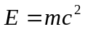, that gravitational potential energy should contribute to E and change the mass of the object. It turns out that Einstein was wrong about this. Only non-gravitational energies contribute to E when it is measured locally. But the reason why E locally measured doesn’t include gravity involves a subtlety about the nature of gravity and inertia that is easily missed. The second criterion is the prediction of, as it is now known, “linear accelerative frame dragging”, though Einstein states it as the production of a force by the accelerating spectator matter on the body in question, rather than the dragging of local spacetime by the accelerating matter. This, when the action of the universe is considered, turns out to be the nub of Mach’s principle as, if the universe is accelerated in any direction, it rigidly drags inertial frames of reference along with it in the direction of the acceleration. As Einstein showed, this effect depends on gravity being at least a vector field theory (analogous to Maxwell’s theory of electrodynamics). The effect is not to be found in Newtonian gravity, a scalar field theory (as the field equation can be written in terms of a scalar “potential” alone with the direction and magnitude of gravitational forces recovered using the “gradient operator”). The third criterion is just the Lens-Thirring effect and Gravity Probe B prediction.

Solving the full tensor field equations of GRT exactly is notoriously difficult, so Einstein did a calculation in the “weak field” approximation [where the metric tensoris approximated by 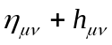 with 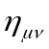 the Minkowski tensor of flat spacetime and 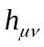 the tensor that represents the field] and put his results into vector formalism. Suffice it to say, he found results that seemed to support each of his three criteria. (The formal predictions can be found in an excerpt from a paper by Carl Brans on the localization of gravitational energy appended to this chapter.) His predicted effects are indeed very small when one considers even quite large local concentrations of matter (other than black holes in the vicinity of event horizons of course). Why didn’t Einstein see that the sort of force that, because of the universality of gravity, is equivalent to frame dragging in his second prediction could explain Mach’s principle? At least part of the problem here seems to be that he wasn’t thinking cosmologically when looking for predicted quantitative effects – and so little was understood about the structure and size of the universe in the ‘20s that there was no plausible basis, other than the most general sorts of considerations, to make inferences about the action of cosmic matter on local objects. Shortly after Einstein gave his Princeton lectures, he found out through posthumously reported remarks made by Mach shortly before his death in 1916, that Mach had disavowed any association with Einstein’s ideas on relativity and inertia. Einstein, not long thereafter, asserted that any correct cosmological model should be spatially closed so that its geometry (the left hand side of his field equations) would be completely determined by its sources (the right hand side of his field equations) without the stipulations of additional boundary conditions and abandoned further work on Mach’s principle.

THE MACH’S PRINCIPLE REVIVAL:

By the early 1950s, the cosmological situation had changed. Significant theoretical work on cosmology had taken place, for example, that of Roberston and Walker in the ‘30s and ‘40s. Thomas Gold, Herman Bondi, and Fred Hoyle had proposed “steady state” cosmology, and Walter Baade had shown that there were two populations of stars, dramatically increasing the age of the universe for FRW cosmological models. So when Dennis Sciama, one of the very few doctoral students trained by Paul Dirac, came along in the early 1950s, tackling the “problem of the origin of inertia” seemed a reasonable thing to do. Sciama’s approach was to ignore GRT and write down a vector theory of gravity analogous to Maxwell’s theory of electrodynamics. He initially thought his vector theory different from GRT. But eventually it was found just to be an approximation to GRT.

What Sciama noticed was that when you write out the equation for the gravity field that is the analog of the electric field in electrodynamics, in addition to the commonplace term involving the gradient of a scalar potential, there is a term that is the rate of change of the “vector potential”. In electrodynamics, the vector potential is associated with the magnetic field, and the term involving the rate of change of the vector potential that appears in the equation for the electric field means that when the magnetic field changes, it contributes to the electric field, causing it to change too. Sciama noted that in the analogous case for gravity, the rate of change of the vector potential leads to a term in the “gravielectric” field that depends on acceleration of an object relative to the (on average) uniform bulk of the matter in the universe. That is,

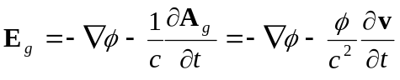. (3)

Where 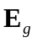 is the gravielectric field strength, c the vacuum speed of light, v the velocity of the instantaneous rest frame where the field is computed relative to the rest of the universe, and and 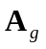 the scalar and vector gravitational potentials respectively produced by all of the “matter” in the causally connected part of the universe. The relationship that allows one to write the change in A_{g} terms of the scalar potential and velocity is the fact that A_{g} is just the sum over all matter currents in the universe. That is,

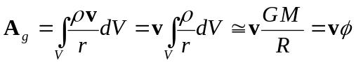, (4)

where  is the matter density in the volume element dV, r is the radial distance from the local object to a spherical volume element (of thickness dR), G is Newton’s constant of gravitation, and M and R are the mass and radius of the universe respectively. Clearly, this is an approximation. And Sciama used the trick of a special reference frame (that of instantaneous rest of the object) to extract the velocity of the object from the integration. Nonetheless, the calculation returns an answer for the inertial reaction force that is essentially correct. The part of Sciama’s paper “On the Origin of Inertia” where he calculates this expression is reproduced as Appendix A.

It is worth noting here that an important feature of inertial reaction forces is present in Equation (3), and it was noted by Sciama. The two terms on the right hand side of the equation have different dependencies on distance. The scalar potential depends on the inverse first power of the distance. The gradient of the scalar potential, when you are far enough away from a body of arbitrary shape so that it can be approximated as a sphere, depends on the inverse second power of the distance. That is, Newtonian gravitational force exerted by a body on another sufficiently distant goes as the inverse square of the distance separating them. When you are calculating the effect of distant matter on a local object, inverse square dependence applies for the gradient of the scalar potential. And it drops off fairly quickly. The term that arises from the time-derivative of the vector potential scales with the scalar potential, not its gradient. So the distance dependence of this term is inverse first power. When the distances involved in a situation are small, this difference between the terms may be unimportant. When the distances are large, the difference is crucial. The term arising from the vector potential dominates because it doesn’t decrease nearly as rapidly as the Newtonian term does for large distances. This is the reason why the inertia of local objects is due almost exclusively to the action of distant matter. The inverse first power of the distance dependence of the term from the vector potential that causes inertial forces also signals that the interaction is “radiative”. That is, the interactions that arise from this term involve propagating disturbances in the gravity field. They do not arise from instantaneously communicated effects or the passive action of a pre-existing field.

Now, for the body moving with respect to the rest of the universe, if the matter is distributed homogeneously and isotropically, the gradient of the potential at the body is zero. And if the relative motion, v, is zero or constant, the second term is zero too. But if v is changing, then the universe exerts a “gravielectric” force on the accelerating object that resists the acceleration. And if 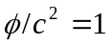, then this force is exactly the inertial reaction force. When is? When “critical cosmic matter density” obtains, and space at the cosmic scale is flat. Sciama didn’t know if this were true. Indeed, even in the 1950s it was thought that the amount of luminous matter in the universe was not sufficient to be “critical”. So Sciama did not make a bald-faced claim that he could fully account for inertial reaction forces. But space at the cosmic scale sure looked pretty flat. And it was known that if cosmic scale space deviated from flatness, it would quickly evolve to far greater distortion. As the universe was at least billions of years old and still flat, most cosmologists assumed that space really was flat, and that critical cosmic matter density obtained. And the fact that luminous matter was less than 10% of the critical value came to be called the “missing mass” problem. Only after the turn of the century was space at the cosmic scale measured – by the Wilkinson Microwave Anisotropy Probe (WMAP) about a decade ago. So we know whether cosmic scale space is flat. It is.

You may be wondering, if we know that space at the cosmic scale is flat, why isn’t it common knowledge that inertial reaction forces are caused by the gravitational interaction of local accelerating objects with chiefly cosmic matter? Well, two issues figure into the answer to this question. One is the consequence of an analysis done by Carl Brans in the early 1960s. (Excerpts from Brans’ paper are to be found in Appendix B.) And the other, related to Brans’ argument, is the business about there being no “real” gravitational forces. Brans showed that if the presence of “spectator” matter (concentrations of matter nearby to a laboratory that shields the stuff in it from all external influences except gravity [which cannot be shielded]) were to change the gravitational potential energies of objects in the shielded laboratory, you could always tell whether you were in a gravity field or an accelerating lab in deep space by performing only local experiments. In particular, the gravitationally induced changes in the masses of elementary particles in the lab would change their charge to mass ratios and this would be locally detectable, No such changes in charge to mass ratios would occur in an accelerated reference frame in deep space. As a result, a gravity field could always be discriminated from an acceleration with local experiments. Since this would be a violation of the EP, Brans asserted that gravitational potential energy cannot be “localized”. That is, the scalar gravitational potential must have exactly the same value, whatever it might be, everywhere in the laboratory, no matter where the lab is located or how it is accelerating. As Brans noted, this condition on gravitational potential energy reveals Einstein’s first prediction quoted above as wrong. Evidently, it appears that the distribution and of matter outside of the lab cannot have any identifiable effect on the contents of the lab. Mach’s principle, however, would seem to suggest the opposite should be the case. And it was easy to infer that Mach’s principle is not contained in pristine GRT.

The inference that Mach’s principle is not contained in GRT, however, is mistaken. If you take account of the role of the vector potential in Sciama’s gravielectric field equation, it is clear that should spectator matter outside the lab be accelerated, it will have an effect on the contents of the lab, changing what are perceived to be the local inertial frames of reference. This is the action of Mach’s principle. But as the accelerating spectator matter will act on all of the contents of the lab equally, it will not be discernable using local measurements in the lab. And it will not change the gravitational potential energies of the contents of the lab.

Brans’ argument about the localizability of gravitational potential energy has an even more radical consequence – one found in the excerpt from MTW on energy localization in the gravitational field found in the previous chapter. If you can eliminate the action of the gravitational field point-by-point throughout the laboratory by a careful choice of geometry that, for us external observers, has the effect of setting inertial frames of reference into accelerated motion with respect to the walls, floor and ceiling of the lab, it seems reasonable to say that there is no gravitational field, in the usual sense of the word, present in the lab. This is what is meant when people say that GRT “geometrizes” the gravitational field. In this view there are no gravitational forces. Gravity merely distorts spacetime, and objects in inertial motion follow the geodesics of the distorted spacetime. The only real forces in this view are non-gravitational. Inertia, of course, is a real force. But if you believe that there aren’t any real gravitational forces, then the origin of inertia remains a complete mystery (as Abraham Pais remarked in the quote at the outset of this chapter), for it isn’t a result of the electromagnetic, weak, or strong interactions (and can’t be because they are not universal), and that leaves only gravity which we’ve excluded because we know that there aren’t any gravitational forces. And the origin of inertia remains mysterious.

There may not be any “real” gravitational forces in GRT, but there is “frame dragging”. That is, in the conventional view, matter can exert a force on spacetime to produce frame dragging, but it can’t act directly on the matter in the possibly dragged spacetime. If this sounds a bit convoluted, that’s because it is. Let me illustrate this point.

About the time that Thorne and his grad students were introducing the rest of us to traversable wormholes, a committee of the Nation Academy of Sciences was doing a decadal review of the state of physics, producing recommendations on the areas of physics that should be supported with real money. One of their recommendations was that Gravity Probe B should be supported because, allegedly, no other test of “gravitomagnetism” was contemplated, and this was an important, if difficult and expensive test of GRT. Ken Nordtvedt, a physicist with impeccable credentials who had proposed the “Nordtvedt effect”, then being tested by ranging the distance of the Moon with a laser, but who had not been a member of the decadal survey committee, pointed out that the claim was just wrong. He noted that even in doing routine orbit calculations, unless care was taken to use special frames of reference, one had to take account of gravitomagnetic effects to get reasonable results. Using “parameterized post Newtonian” (PPN) gravity, a formalism that he and others had developed as a tool to investigate a variety of theories of gravity some twenty years earlier, he showed explicitly how this came about.

In the course of his treatment of orbital motion, Nordtvedt drew attention to the fact that gravity predicts that linearly accelerated objects should drag the spacetime in their environs along with themselves since the gravitational vector potential does not vanish. Nordtvedt’s 1988 paper on the “Existence of the Gravitomagnetic Interaction” where he discussed all this is excerpted in Appendix C. In effect, he recovered the same basic result as Einstein and Sciama, only where they had talked about gravitational forces acting on local objects, Nordtvedt put this in terms of “frame dragging”. Are they the same thing? Well, yes, of course they are. The reason why you may find this confusing is because in the case of everything except gravity, one talks about the sources of fields, the fields the sources create, and the actions of fields in spacetime on other sources. That is, spacetime is a background in which sources and fields exist and interact. In GRT spacetime itself is the field. There is no background spacetime in which the gravitational field exists and acts. Since there is no background spacetime, GRT is called a “background independent” theory. It is this background independence that makes gravity and GRT fundamentally different from all other fields. And it is the reason why “frame dragging” is fully equivalent to the action of a gravitational force. If you want to preserve the configuration of a system before some nearby objects are accelerated, when the nearby objects begin to accelerate, you have to exert a force that counteracts the effect of the frame dragging produced by the acceleration of the nearby objects. When you do that, what do you feel? An inertial reaction force – the force produced by the action of the dragged spacetime which is produced by the gravitational action of the accelerated nearby objects. By interposing frame dragging we’ve made it appear that no gravitational force is acting. But of course gravity is acting, notwithstanding that we’ve introduced the intermediary of frame dragging to make it appear otherwise.

When only nearby objects are accelerated to produce frame dragging, as Einstein noted for the equivalent force he expected, the predicted effects are quite small. When it is the entire universe that is accelerated, it is the full normal inertial reaction force that is felt if you constrain some object to not accelerate with the universe. Why the difference? Because when the entire universe is “rigidly” accelerated, the interior spacetime is rigidly dragged with it, whereas nearby objects, even with very large masses, produce only small, partial dragging. You may be thinking, yeah, right, rigidly accelerating the whole universe. That would be a neat trick. Getting the timing right would be an insuperable task. The fact of the matter, nonetheless, is that you can do this. We all do. All the time. All we have to do is accelerate a local object. Your fist or foot for example. The principle of relativity requires that such local accelerations be equivalent to considering the local object as at rest with the whole universe being accelerated in the opposite direction. And the calculation using the PPN formalism for frame dragging (with GRT values for the coefficients in the equation assumed) bears this out. Rigid frame dragging occurs when, up to a geometrical factor of order unity, 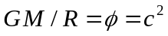, where M and R are the mass and radius of the universe, just as Sciama found. And we now know is the measured fact of our reality.

You might think that having established the equivalence of frame dragging by the universe and the action of inertial forces, we’d be done with the issue of inertia. Alas, such optimism is premature. A few issues remain to be dealt with. Chief among them is that if 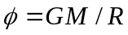, since at least R is changing (because of the expansion of the universe), it would seem that 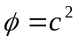must just be an accident of our present epoch. However, if the laws of physics are to be true everywhere and everywhen, and inertial reaction forces are gravitational, then it must be the case that everywhere and everywhen if Newton’s third law of mechanics is to be universally valid. Well, we know that the principle of relativity requires that c, when it is locally measured, has this property – it is a “locally measured invariant”. So, perhaps it is not much of a stretch to accept that is a locally measured invariant too. After all, GM/R has dimensions of velocity squared. No fudging is needed to get that to work out right. But there is an even more fundamental and important reason to accept the locally measured invariance of : it is the central feature of the “Einstein Equivalence Principle” (EEP) which is required to construct GRT. As is universally known, the EEP prohibits the “localization” of gravitational potential energy. That is, it requires that whenever you make a local determination of the total scalar gravitational potential, you get the same number, whatever it may happen to be (but we know in fact to be equal to c²). Note that this does NOT mean that the gravitational potential must everywhere have the same value, for distant observers may measure different values at different places – just as they do for the speed of light when it is present in the gravity fields of local objects. Indeed, this is not an accident, because and c are related, one being the
square of the other.

Should you be inclined to blow all of this off as some sort of sophistry, keep in mind that there is a compelling argument for the EEP and the locally measured invariance of − the one constructed by Carl Brans in 1962 that we’ve already invoked. If you view the gravitational field as an entity that is present in a (presumably flat) background spacetime – as opposed to the chief property of spacetime itself (as it is in GRT) – it is easy to believe that gravitational potential energies should be “localizable” – that is, gravitational potentials should have effects that can be detected by local measurements. Brans pointed out that were this true, it would be a violation of the principle of relativity as contained in the Equivalence Principle. Why? Because, as mentioned above, you would always, with some appropriate local experiment, be able to distinguish a gravitational field from accelerated frames of reference. Brans’ way was to measure the charge to mass ratios of elementary particles. An even simpler, cruder way to make the discrimination between gravity field and accelerated reference frame is to drop stuff. You won’t be able to tell the difference between a gravity field and accelerated frame of reference by the way things “fall” since they all “fall” with the same acceleration in both cases, irrespective of their masses or compositions. But you will be able to tell by how big a dent in the floor they make – because their masses are presumably different when gravity is present, versus when it is not, and bigger masses make bigger dents. Brans’ argument makes clear that the EEP must be correct if the principle of relativity is correct – and that Einstein was wrong in 1921 when he assumed that the piling up of spectator matter would change the masses of local objects. Notwithstanding that the non-localizability of gravitational potential energies, however, the fact that inertial reaction forces are independent of time and place requires that the masses of things be equal to their total gravitational potential energies. That is, 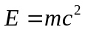and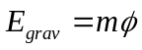, so if 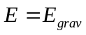 and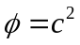 as Mach’s principle demands, we have a simple identity.

To bring home the full import of the foregoing discussion of GRT and Mach’s principle, we briefly consider a slightly more complicated example than that used so far. Instead of considering a test body in an otherwise uniform universe, we look at the behavior of a test object (with negligible mass) in the vicinity of the Earth. In Newtonian physics we say that the mass of the Earth produces a gravitational field in its vicinity that exerts a force on the test object. If the test object is unconstrained, it falls toward the center of the Earth with an acceleration of one “gee”. We can arrest this motion by applying an upward force with equal magnitude, balancing the “force” of gravity. The agent applying the upward balancing force, of course, experiences the downward force which s/he attributes to the Earth’s gravity. This is the commonplace explanation of these circumstances that even relativists intuitively fall into.

The general relativistic explanation of the circumstances of our test body in proximity to the Earth, however, is fundamentally different. The Earth does not produce a gravity field that acts to produce a force on the test body. The Earth does produce a local distortion of spacetime (which is the gravity field), changing the local inertial structure of spacetime from the otherwise flat character it would have (as measured by the WMAP project). As a result, if our test body engages in unconstrained motion, it responds inertially and finds itself in a state of free fall. Despite the fact that the test body appears to us to be accelerating, and we intuitively assume that accelerations are the consequence of the application of forces, no forces act on the falling test body. What happens then when we apply a constraining force to the test body to stop its free fall acceleration? Does this somehow turn on the Earth’s gravity force to balance the constraining force we have applied? No. You can’t turn gravity off and on (yet). The balancing force that you feel is the inertial reaction force that arises in response to the “arresting” force that you have applied to the test object. Your arresting force has actually produced acceleration of the test object – with respect to local inertial frames of reference that are in free fall. The force that we normally ascribe to the gravitational action of the Earth, which is quite real, is not produced by the Earth. It is produced chiefly by the distant matter in the universe. The reason why we associate it with the action of the Earth is because the Earth determines the extent of the local distortion of inertial spacetime, and thus the amount of acceleration required to arrest the inertial motion of objects in the vicinity of the Earth’s surface.

One may ask: is it really necessary to adopt this arguably very odd way of looking at the circumstances that seem to make such intuitive sense when viewed from the Newtonian point of view? That is, can we in some sense accept GRT, but take the above description as an “equivalent representation” to the Newtonian viewpoint with its objective gravity field that produces forces on nearby objects? No. The representations are in no sense equivalent. The reason why is the EEP. The geometrization of the gravitational field in GRT depends on the complete indistinguishability of accelerated reference frames from the local action of gravity fields. There are those who argue that the presence of tidal effects in all but (unphysical) uniform gravity fields always allow us to distinguish gravity fields from accelerated reference frames, but this is a red herring. We can always choose our local Lorentz frame sufficiently small so as to reduce tidal effects to insignificant levels, making the two types of frames indistinguishable. Were gravitational potential energies localizable, however, we would be faced with a real violation of the indistinguishability condition which would vitiate field geometrization. Using either Brans’ charge to mass ratios, or the cruder dents criterion, no matter how small we make the region considered, we can always make determinations that tell us whether we are dealing with a gravity field or an accelerated reference frame, because, unlike tidal forces, charge to mass ratios and dents don’t depend on the size of the region considered. They are so-called “first” or “lowest” order effects.

The foregoing considerations are sufficient in themselves to reject attempts to “objectify” static gravity fields. But they are attended by an even stronger argument. If local gravitational potential energies really did contribute to locally observable phenomena, then 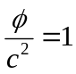 everywhere and when would not in general be true. Consequently, inertial reaction forces would not always equal “external” applied forces, and Newton’s third law would be false. That would open the way to violations of the conservation of energy and momentum.

As we have now seen, the principle of relativity has present within it a collection of interlocking principles – one of which is Mach’s principle, which says both that inertial reaction forces are the gravitational action of everything in the universe, and the inertia of objects is just their total gravitational potential energy (divided by c²). Objects are to be understood as including everything that gravitates (including things we do not yet understand in detail like “dark matter” and “dark energy”). Are these principles ones that can be individually rejected if we don’t like them without screwing up everything else? No. If the principle of relativity is correct, then the EEP and Mach’s principle follow inexorably. If either the EEP or Mach’s principle is false, then so too is the principle of relativity – and Newton’s laws of mechanics. That’s a pretty high price to pay for rejecting a principle you may not care for.

Two issues remain to be addressed in a little detail. One is the instantaneity of inertial reaction forces. The other is how Mach’s principle squares with traditional gravity wave physics. We address inertial reaction forces and how they relate to gravity wave physics first.

Inertial reaction forces and gravity wave physics:

It has been known since Einstein created GRT in 1915 that his theory predicted propagating disturbances in the gravitational field, that is, it predicted “gravitational waves”. The whole business of gravity waves and how they are generated by and interact with matter sources, however, was at times quite contentious. Should you want to know the details of how all of this developed, Dan Kennefick has written an outstanding history of the subject: Traveling at the Speed of Thought: Einstein and the Quest for Gravitational Waves. Most, if not all of the issues of debate were settled many years ago now. One of the issues was the manner in which the prediction is calculated. As noted above, exact solutions of the full non-linear Einstein field equations are few and far between. One of the standard techniques for dealing with this is to invoke the “weak field approximation” where you assume that the Einstein tensor (describing the geometry of spacetime) can be written as the “Minkowski” metric of flat spacetime with an added “perturbation” metric field that accounts for gravity, as mentioned earlier in this chapter. Since the flat spacetime metric in this approach is effectively a “background” spacetime unaffected by the presence of matter and gravity fields, Einstein’s theory is effectively “linearized” by this procedure. With a few further assumptions, Einstein’s field equations can be put in a form that closely resemble Maxwell’s equations for the electromagnetic field – as Einstein himself did in his discussion of Mach’s principle mentioned above, and Sciama and Nordtvedt (among many others) subsequently did.

Solutions of Maxwell’s equations have been explored in great detail in the roughly century and a half since their creation. The standard techniques include classification according to the disposition of the sources of the fields and their behavior (how they move). This leads to what is called a “multipole expansion” of the field, each component of the field being related to a particular aspect of the distribution and motion of its sources. The simplest part of the field in this decomposition is the so-called “monopole” component where the sources can be viewed as consisting of a single “charge” located at one point in spacetime. In electromagnetism the next least complicated source distribution is the so-called “dipole” component. Electrical charges come in two varieties: positive and negative, and the dipole component of a multipole expansion consists of the part that can be characterized by a positive charge located at one point and a negative charge located somewhere else in spacetime. The measure of this charge distribution is called its dipole “moment”, defined as the product of the charges times the separation distance between them. If the dipole moment of the dipole component of the field is caused to change, the changes in the surrounding field are found to propagate away from the charges at the speed of light. The propagating disturbance in the field is the “radiation” field. Non-propagating fields are called “induction” fields as they are induced by the presence of sources of the field.

The next term in the multipole expansion for source distributions and their associated field components is the so-called “quadrupole” term. It is the part of the field that takes into account the simplest charge distribution for sources of the same sign (positive or negative in the case of electromagnetism) that cannot be covered by the monopole term. It corresponds to two charges of the same sign separated, like the dipole distribution, by some distance in spacetime. Just as there is a dipole moment, so too is there a quadrupole moment. And if the quadrupole moment changes, like the dipole term, a propagating disturbance in the field is produced. Since there are no negative masses (yet), and the vector approximation of GRT is a vector theory analogous to Maxwell’s equations for electrodynamics, it is found that the “lowest order” radiative component of the gravitational field is that produced by sources with time-varying quadrupole moments. An example is a dumbbell spinning about the axis of symmetry that passes perpendicularly through the bar separating the bells. Another more fashionable example is a pair of black holes in orbit about each other. An example that does not involve spinning stuff is two masses separated by a spring that are set into oscillatory motion along their line of centers. Even in the case of orbiting black holes, the amount of momenergy involved in the gravitational radiation is exceedingly minute. (This is the stuff being sought with LIGO, with a price tag now approaching a gigabuck.) Laboratory scale gravitational quadrupoles, even operating at very high frequencies, produce hopelessly undetectable amounts of gravitational radiation.

What does all this have to do with inertial reaction forces? Well, as Sciama was at pains to point out, his calculation of those forces show two things: one, they depend on the acceleration of sources; and two, their dependence on distance in his gravitoelectric field equation goes as the inverse first power, not inverse square. These are the well-known signatures of radiative interactions. It would seem then that inertial reaction forces should involve radiation, and that they should be called radiation reaction forces. But there is a problem. The quadrupole radiation given off by an accelerating massive object is incredibly minute. How can this be squared with the fact that inertial reaction forces are, by comparison, enormous, decades of orders of magnitude larger than quadrupole radiation reaction? To answer this question we must first tackle the instantaneity of inertial reaction forces.

The instantaneity of inertial reaction forces:

The immediate fact of inertial reaction forces is that they respond to applied forces instantaneously. Why? Well, if you believe, as Newton and legions after him have, that inertia is an inherent property of material objects needing no further explanation, then this question needs no answer. The problem with this view, of course, is the fact noted famously by Mach that inertial frames of reference seem to be those in inertial motion with respect to the “fixed stars”. Today we would say inertial motion with respect to the local cosmic frame of rest, and that, remarkably, isn’t rotating. This suggests that the stuff out there has something to do with inertia. But it is so far away, typically billions of light-years distant. How can that produce instantaneous effects? The easy answer to this question is to assert that the distant stuff produces a gravity field, which we know to be spacetime in GRT, here, and when we try to accelerate anything in spacetime, spacetime pushes back. Since the local spacetime is the gravity field of the distant stuff, obviously we should expect local inertia to be related to the distant stuff.

Sounds good, doesn’t it? It is, however, a flawed view of things, as was made evident by Sciama’s argument back in the early ‘50s. As we’ve noted already, Sciama used a little trick in his calculation to avoid a tedious calculation involving Lienard-Wiechert potentials, Green’s functions, and a lot of associated mathematical machinery. To calculate the effect of very distant matter on a local accelerating body, he noted that from the perspective of the local body, the entire universe appears to be accelerating rigidly in the opposite direction. Since the calculation of the vector potential A_{g} involves summing up the effects of the distant matter currents – equal to the distant matter density times the velocity of the matter – he wanted a way to remove the velocity from the summing process. The apparent rigid motion provides the justification for doing this. What is left in the summing process is just the matter density – divided by the distance between the matter current element and the local object. And the sum of this just turns out to be the total scalar gravitational potential mentioned above.

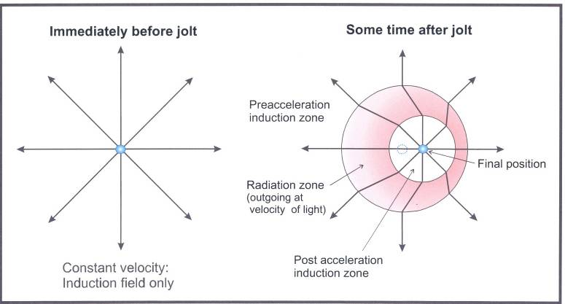
Sciama, of course, knew that this was just a trick to avoid a messy integration, for, as already mentioned, he was quick to point out that distance dependence of the scalar gravitational potential was inverse first power, rather than the inverse second power of Newtonian gravity. Those familiar with the process of radiation immediately recognize the inverse first power as the signature of a radiative interaction. What Sciama’s calculation (and those of Einstein, Nordtvedt, and others) shows is that inertial reaction forces are conveyed by a radiative process. Inertial forces are not the simple passive action of a pre-existing field that acts when local objects are accelerated. A way to visualize what’s going on here is to consider what happens to the spacetime surrounding a local object that is given a quick impulsive acceleration. Before the acceleration, its gravity field is symmetrically centered on it. The same is true shortly after the impulse. But the impulse displaces the center of symmetry of the field from the prior center of symmetry. That produces a “kink” in the gravity field, like that shown in Figure 2.1. The radiative nature of the interaction means that the kink induced in the field by the impulsive acceleration propagates outward from the object during the acceleration at the speed of light. It is the production of the kink in the field by the source, not the field itself, that produces the inertial reaction force on the source and accelerating agent. In electrodynamics, this is known as the problem of “radiation reaction”. Should you trouble yourself to read up on this in, say, Feynman’s Lectures on Physics, or a pretty much any advanced text on electrodynamics, you’ll find that this is a messy problem with some very curious features. For example, “pre-acceleration” where an object starts to accelerate before the force producing the acceleration acts (as Dirac showed in a classic paper on electromagnetic radiation reaction published in 1938). All those problems carry over to the gravity case if inertial reaction forces are forces of radiative reaction – as seems to be the case now that the WMAP results are known.

Now, there are two problems here. The first is that the kink in the field is normally taken as due to the monopole term in the multipole expansion, and it is allegedly non-radiative. We will deal with this issue presently. The second problem is that if the coupling between the test object and the distant matter in the universe is carried by the kink in the field propagating at the speed of light, it will take billions of years for the kink to reach the distant matter, and billions of years for a return signal to get back to the accelerating object. Inertial reaction forces, however, are instantaneous. Push something and it pushes back immediately. How can the distant matter in the universe act instantly on an object when it is accelerated by an external force without violating the speed limit, c, of SRT?

The simplest, most elegant way to deal with the problems just mentioned was worked out for electrodynamics by John Wheeler and Richard Feynman in the 1940s. Their theory, intended to deal with the problems attending classical electron theory (infinite self-energies, radiation reaction, and so forth), goes by the name “action-at-a-distance” or “absorber” electrodynamics. It is a scheme designed to account for seemingly instantaneous radiation reaction forces that are produced by an interaction with a distant “absorber”. To do this, Wheeler and Feynman noted that the propagating solutions to “classical” wave equations can either be “retarded” – that is, propagate forward in time – or “advanced” – that is, propagate backward in time. Physically and mathematically, there is no discernable difference between the two classes of solutions. Since it appears to us that waves propagate into the future, we just ignore the solutions that propagate backward in time. After all, we do not appear to be constantly buffeted by waves coming back from the future.

The business of advanced waves can be a bit confusing, so we make a brief foray into this topic to ensure that we are all on the same page. The usual story about the role of time in the laws of physics is that the laws of physics possess a property called “time reversal symmetry”. That is, you can replace the time t with – t everywhere in your equations, and the processes described by the time-reversed equations are just as valid as the original equations. Another way this is sometimes illustrated is to film some process running forward in time, and then point out that if the film is run backward, the processes depicted also obey the laws of physics, albeit the time-reversed laws. The fact that the laws of physics are time-reversal invariant has led to endless speculations on “the arrow of time”, and how time could be asymmetric given the symmetry of the underlying laws. Philosophers, and physicists with a philosophical bent, seem to be those most prone to delving into the mysteries of time. We’ll be concerned here with a much more mundane problem: how exactly do advanced waves work?

A commonplace example used to illustrate advanced waves is the spreading of ripples on a pond when a rock is thrown into the middle. When the rock hits the water, it sets up a series of waves that propagate from the point of impact in symmetrical circles toward the shoreline. If we make a film of this sequence of events and run it backward, we will see the waves forming near the shoreline, and then moving in concentric circles of decreasing diameters toward the center. This is illustrated in Figure 2.2. And when the waves arrive at the center, the rock will emerge from the water as though thrust from the depths by the waves. The problem with this picture is that when we run the movie backward to supposedly reverse the direction of time, what we really do – since we can only run the movie forward in time, regardless of which end of the movie we start with – is run the waves backward in space as the movie runs forward in time. A true advanced wave starts in the future at the shoreline and propagates backward in time toward the center of the pond, something we cannot actually see from the present. So, when we watch a movie running backward, we must imagine that we are running backward in time, notwithstanding that we are actually “moving” forward in time. What we do see, moving forward in time, when and advanced wave comes back from the future is a wave that appears to be propagating away from the impact of the rock toward the shoreline of the pond. That is, the advanced wave looks exactly like a retarded wave. As long as the advanced wave coming back from the future didn’t propagate farther into the past than the rock hitting the water that initiated all of the waves, neither you nor I could tell whether the waves in the pond had any advanced component. So, using retarded and advanced waves to get distant objects to “instantaneously” affect local objects becomes finding a solution for wave action that cancels the advanced waves at the source (the rock hitting the water) to keep them from traveling farther into the past.

What Wheeler and Feynman noted was that if a forward in time propagating wave in the electromagnetic field was eventually absorbed by enough material out there in the distant universe, and as it was absorbed it produced an “advanced” wave propagating backward in time, all of the contributions from all of the parts of the absorber would just get back to the source at exactly the right time to produce the apparent force of radiative reaction. And as they passed the origin of the waves into the past, if the waves were half advanced and half retarded, they would cancel out the “advanced” wave propagating from the source into the past. So future events would not indiscriminately screw up the past (and our present). This solution to the problems of radiation reaction is so neat it almost has the appearance of a cheap tourist trick, too good to be true. But it actually works.

Some exceedingly important features of action-at-a-distance electrodynamics must be mentioned, as they figure critically into the understanding of inertial reaction forces when the theory is extended to include gravity. Of these, far and away the most important is the fact that there is no radiation as understood in conventional electrodynamics in the action-at-a-distance version. I’ve not mentioned it yet, but in addition to acceleration dependence and inverse first power of the distance dependence of the “amplitude” or field strength of the radiation field, there is another condition that a radiation field must satisfy: it must have a “freely propagating” non-vanishing energy density as it approaches “asymptotic infinity”. This property gives the field “independent degrees of freedom”. What this means, in simple physical language, is that once a radiation field has been launched by the acceleration of some charges of the field, the radiation is “decoupled” from both the source (which can no longer affect it) and the sinks (just sources soaking up the field), if any, that ultimately absorb it. Note that the launching of the radiation does not depend on it ever being absorbed by sinks out there somewhere in the future. That’s what “freely propagating at asymptotic infinity” means. Note that there are no classical radiation fields in action-at-a-distance electrodynamics, for no electromagnetic disturbances (that might be considered radiation in classical theory) are ever launched without the circumstances of their eventual absorption being established before they are launched. That is, there are no field “modes” with “independent degrees of freedom”, no loose radiation that might make it to “asymptotic infinity”. Why is this the case? Because the theory only works if the eventual absorption of all disturbances is guaranteed so that the requisite “advanced” disturbances, needed to combine with the “retarded” disturbances, are present to yield the world as we see it. What this means it that if your field theory is an action-at-a-distance theory, you can have “monopole” propagating disturbances in the field that carry energy and momentum – as the “kink” diagram suggests ought to be possible – and that they can have the acceleration and inverse first power of the distance characteristics of classical radiation, but they will not be considered “radiation” by those ignorant of action-at-a-distance theory.
You may ask at this point: how can such radically different results be obtained from action-at-a-distance and classical field theory? The answer is really quite simple. Michael Faraday, the pre-eminent experimental physicist of the 19th century, hated action-at-a-distance. In his day, it was the chief feature of Newtonian gravitation, and even Newton himself had thought that instantaneous action of gravity over arbitrarily large distances stupid. Indeed, Newton’s famous “hypotheses non fingo” [I make no hypotheses {about the mechanism of gravity}] remark was his response to his critics who assailed him about action-at-a-distance. Faraday, despite repeated attempts, never found a way to rid gravity of action-at-a-distance. But he invented the field concept for electrodynamics to head off a similar fate for electrical and magnetic phenomena. Maxwell incorporated Faraday’s concept into his elaboration of the equations of electrodynamics. If you look at reality through “local” eyes, this approach makes eminent good sense. After all, you can wiggle some electric charges and launch an electromagnetic wave without giving any thought at all to what eventually happens to the wave. For all you know, it may well end up propagating freely at asymptotic infinity. If all you know about the totality of reality is emerging astronomical knowledge of the galaxy, as was the case through the early 20th century, this is perfectly reasonable. But when you know more about cosmology, the know-nothing strictly local view is not so obviously reasonable.

How can the classical “local” view be squared with the action-at-a-distance picture? Well, we can’t just take some source distribution with a quadrupole moment, say, a dumbbell, create a time varying quadrupole moment by spinning the dumbbell or making the masses of the dumbbell accelerate along their line of centers with respect to each other. That will just give us back the idiotically small radiation calculated by gravity wave physicists. What’s missing in the dumbbell picture? The rest of the universe. How can we include it? By taking note of the fact that it acts seemingly instantaneously, so we can imagine that some non-negligible part of the whole universe is located in very close proximity to one (or the other) of our dumbbell masses. The dumbbell mass, if you will, anchors the local system in the universe. And this anchoring mass must be present in any real system in order to accelerate the primary mass to produce the “monopole” kink in the field depicted in Figure 1. That is, the idealization of a single mass that is accelerated is unrealizable as there must always be a second reaction mass against which the accelerating agent acts to produce the acceleration of the primary mass. So all real accelerations necessarily involve quadrupoles. But when we are talking about the monopole kink in the field of one of the masses, the second mass of the equivalent quadrupole is a significant part of the mass of the universe. We can consider the mass of the universe effectively present at the second dumbbell mass because of the instantaneous action-at-a-distance character of inertial effects. The radiation produced by this quadrupole is decades of orders of magnitude larger than that for the local dumbbell quadrupole taken by itself. The reaction to the quadrupole radiation produced by the effective universe—dumbbell system is the inertial reaction force that acts on the dumbbell mass being accelerated.

There are obvious problems with carrying through a calculation of the sort just sketched. Concentrating a large fraction of the mass of the universe at a point in proximity to anything will recreate the initial singularity, and so on. But the point nonetheless remains that if you insist on doing a standard quadrupole calculation, you’ve got to get the right quadrupole if you expect to get reasonable results. When you are considering inertial reaction forces, the right quadrupole always includes the effective universe, and it acts immediately and as if it were very, very nearby.

Wheeler and Feynman’s elegant solution to the problem of radiation reaction is the only way I know of to get seemingly instantaneous reaction forces that depend on distant matter without screwing up the dictum of the principle of relativity that limits signal propagation velocities to the speed of light. I suspect that Feynman may have harbored similar views, for he devoted the first part of his Nobel Address to absorber electrodynamics. In electrodynamics you can hold either view, for the two are fully equivalent. But when you come to grips with Mach’s principle, you find that this is the only convincing way deal with inertial reaction forces while preserving the finite signal velocity required by the principle of relativity. When Mach’s principle was hotly debated in the ‘60s, Fred Hoyle and Jayant Narlikar figured this out and wrote papers and a book on the subject. No one paid much attention it seems. Their contemporaries may have been influenced by Hoyle’s support for the “steady state” cosmology which was then loosing credibility. Wheeler’s last book in the mid-‘90s was an attempt to evade action-at-a-distance by invoking “constraint” equations on “initial data” that have instantaneous propagation (because they are “elliptic” rather than “hyperbolic”). Wheeler had abandoned the action-at-a-distance theory that he and Feynman had developed 50 years earlier. However, this should be evaluated keeping in mind that the propagating kink in the field is the field response to the acceleration of sources. Inertia is not just the action of the pre-existing gravity field on sources as they accelerate. In the ‘80s, John Cramer adapted Wheeler-Feynman theory to quantum mechanics to explain “entanglement”, another instance of seemingly instantaneous signal propagation that is customarily explained away in less than completely convincing ways. Cramer’s “transactional interpretation” of quantum mechanics has not yet attracted widespread adherents. The culture of “shut up and calculate” has softened over the years. But serious examination of alternate interpretations of quantum mechanics has yet to make it into the mainstream of physics pedgogy. Before Hoyle and Narlikar, and Cramer were others who saw the writing on the wall. Herman Weyl, the father of “gauge theory”, famously remarked shortly after the first of the Wheeler-Feynman papers on action-at-a-distance electrodynamics, “reality simply is, it does not happen.” And Olivier Costa de Beauregard made early attempts to apply it to quantum theory.

The reason why the action-at-a-distance view of radiation reaction meets such stiff resistance is captured in Weyl’s remark just quoted. The passage of time is an illusion. Indeed, “persistent illusion” was exactly the way Einstein characterized our notions of past, present, and future and the passage of time to the relatives of his lifelong friend Michel Besso after Besso’s death, shortly before his own. The past and the future are really out there. Really. Not probably. You may think that this must all be a lot of nonsense dreamed up by people who don’t have enough real work to fill their time. But let me point out that if absurdly benign wormholes are ever to be built and actually work, then this worldview must be correct. The past and the future must really “already” be out there. How can you travel to a past or future that doesn’t “already” exist?

The “relational” and “physical” versions of Mach’s principle:

Should you find the forgoing confusing and contentious, you’ll doubtless be disappointed to learn that we haven’t yet covered the full range of arguments involving Mach’s principle. As arguments about Mach’s principle developed over the decades of the ‘50s, ‘60s, and ‘70s, two distinct ways of “interpreting” the principle emerged. One came to be called the “relationalist” view, and the other I shall call the “physical” view. Serious arguments about Mach’s principle ceased to be fashionable in the mid- 1970s. A few hardy souls wrote about the principle in the late ‘70s and ‘80s, but no one paid them much mind. Mach’s principle became fashionable again in the early ‘90s, and Julian Barbour and Herbert Pfister organized a conference of the experts in the field held in Tübingen in the summer of 1993. The proceedings of the conference were published as volume six of the Einstein Studies series with the title: Mach’s principle: From Newton’s Bucket to Quantum Gravity (Birkhauser, Boston, 1994). This is an outstanding book, not least because the questions, comments, and dialog were published, as well as the technical papers presented.

Both the realtionalist and physical positions on Mach’s principle were on display at the conference. Many of the attendees seem to have been convinced relationalists. The essence of the relationalist position is that all discussion of the motion of massive objects should be related to other massive objects; that relating the motion of objects to spacetime itself is not legitimate. This probably doesn’t sound very much like our discussion of Mach’s principle here. That’s because it isn’t. The relationalist approach says nothing at all about the origin of inertial reaction forces. The physical view of Mach’s principle, however, does. After the conference, one of the leading critics of Mach’s principle, Wolfgang Rindler, wrote a paper alleging that Mach’s principle was false, for it led to the prediction of motion of satellites in orbit around planets that is not observed – that is, the motion was in the opposite direction from that predicted by GRT. It was three years before Herman Bondi and Joseph Samuel’s response to Rindler was published. They pointed out that while Rindler’s argument was correct, it was based on the relationalist interpretation of Mach’s principle. They argued that the physical interpretation that they took to be exemplified by GRT and Sciama’s model for inertia, gave correct predictions. Therefore, Mach’s principle could not be dismissed as incorrect on the basis of satellite motion as Rindler had hoped to do. I cannot resist the temptation to remark here that it seems that Einstein was right in 1922, and Pais in 1982, when they remarked that Mach’s principle was a missing piece of the puzzle of the origin of inertia. We should now know better. After all, the WMAP results show that as a matter of fact space is flat, and it is certainly not empty, so if the principle of relativity, introduced by Galileo, is right, then Mach’s principle is correct too. And we should simply drop all of the arguments and assumptions that distract us from this conclusion.

Mach’s principle, starships, and stargates:

You may be thinking that all of this Mach’s principle stuff is just too confusing and contentious to take seriously. There must be another way – one with simple principles that no one argues about – to make starships and stargates. Sorry. No such luck. The only way to build starships and stargates is by making traversable absurdly benign wormholes. That can only happen when we understand the role of inertia in gravity. It might seem to you, if this is true, that we are doomed never to build such devices. It’s now a hundred years since Einstein first tried to model Mach’s ideas in a vector theory of gravity, and we seem no closer to getting a version of Mach’s principle that might collect a consensus.

The problem here is that Mach’s principle has been understood from the first days of general relativity to be essentially a cosmological problem. Look at Einstein’s statement of the principle in the quote at the beginning of this chapter. The geometry must be fully specified in terms of the sources – that is, no solutions of the field equations should exist when there are no sources, or when other “non-Machian” conditions (like rotation of the universe) exist. The fact of the matter is that non-Machian, self-consistent solutions of Einstein’s equations do exist. This has led some to the view that the principle should be taken to be a boundary condition on the cosmological solutions of Einstein’s equations. But even this approach yields equivocal results.

Let me give you an example of what I’m talking about. In the years before Guth and others proposed the cosmological models containing the process of “inflation”, one of the outstanding issues of cosmology was the so-called “flatness” problem. The then prevailing preferred cosmological models – Friedman-Robertson-Walker (FRW) cosmologies – could be classified as “open” [expands forever] or “closed” [expands to some finite radius and then collapses] separated by a model that expands forever, but tends to zero expansion at temporal asymptotic infinity. The separating model is characterized by spatial flatness (and “critical” cosmic matter density) at all times. Even then (and now moreso given the WMAP results), the universe looked very flat at cosmological scale. As noted above, the problem with the spatially flat model is that it is unstable. The slightest deviation from exact flatness produces very rapid evolution away from flatness – but the universe has been around for billions of years. The inflationary scenario invented by Guth and others, in fact, was intended to address precisely this problem.

Most cosmologists accept the inflationary model. But it doesn’t have the status of a paradigm; not yet anyway. Other cosmological models are offered for other reasons. And there is a camp that argues that the consensus cosmology is wrong for other reasons. Hoping for a consensus to emerge on Mach’s principle in such circumstances is simply not realistic. I don’t know about you, but to be frank, I don’t really care that much about the technical details of fashionable cosmological models. I want to build starships and stargates. Do I need to wait until cosmologists decide on some model and then see if it includes Mach’s principle? No. Whatever that model, if it is ever found, turns out to be, it will be one with spatial flatness. Why? Because spatial flatness is measured to be the fact of our reality. Spatial flatness in FRW cosmologies guarantees “critical” cosmic matter density obtains, and that guarantees. We know that for the EEP, Mach’s principle, and Newton’s third law to be true, this condition must be true everywhere and everywhen in local measurements. And this must be true no matter what cosmological model you choose to believe in.

Now, building starships and stargates is not a matter of cosmology. It is a matter of using the law of gravity and inertia at the local level. We want to find a way to manipulate stuff we can lay our hands on and figure out how to make it produce effects that will make it possible to effectively induce outrageous amounts of exotic matter. We may have to pay attention to cosmological scale effects in some circumstances. But whether the fashionable cosmological model is explicitly Machian is really irrelevant to what we are up to. So we accept the physical version of Mach’s principle – the assertion that inertial reaction forces are gravitational, and mass is just the total gravitational potential energy divided by the square of the speed of light – and ask: does the principle lead to any effects that we might be able to use to make starships and stargates? We address the answer to this question in the next chapter. Here, to sum up, we note that one way to suppress the confusion surrounding Mach’s principle is to codify the principle in the form of a simple law or two. Imagine trying to do mechanics without Newton’s laws, or electrodynamics without Maxwell’s equations, or relativity without Einstein’s laws. I therefore propose the adoption Mach’s laws of inertia:

First law: locally always; or, inertial reaction forces are due to the gravitational action of
causally connected “matter”, where matter is understood as everything that gravitates.

Second law: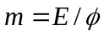, or the mass of an entity (isolated and at rest) is equal to its non-
gravitational energy divided by the locally measured total gravitational potential.

A zeroth law might be added: Inertial reaction forces are instantaneous. But that is arguably belaboring the obvious. The first and second laws, in contradistinction, are not obvious. We will use these laws, and mostly ignore cosmology, to derive some interesting local effects that may make stargates possible. Cosmology will only come back into our consideration after those effects have been derived and some experimental work aimed at detecting them has been presented.

APPENDIX A

Excerpt from “On the Origin of Inertia”, Monthly Notices of the Royal Astronomical Society 113, 34 − 42 (1953):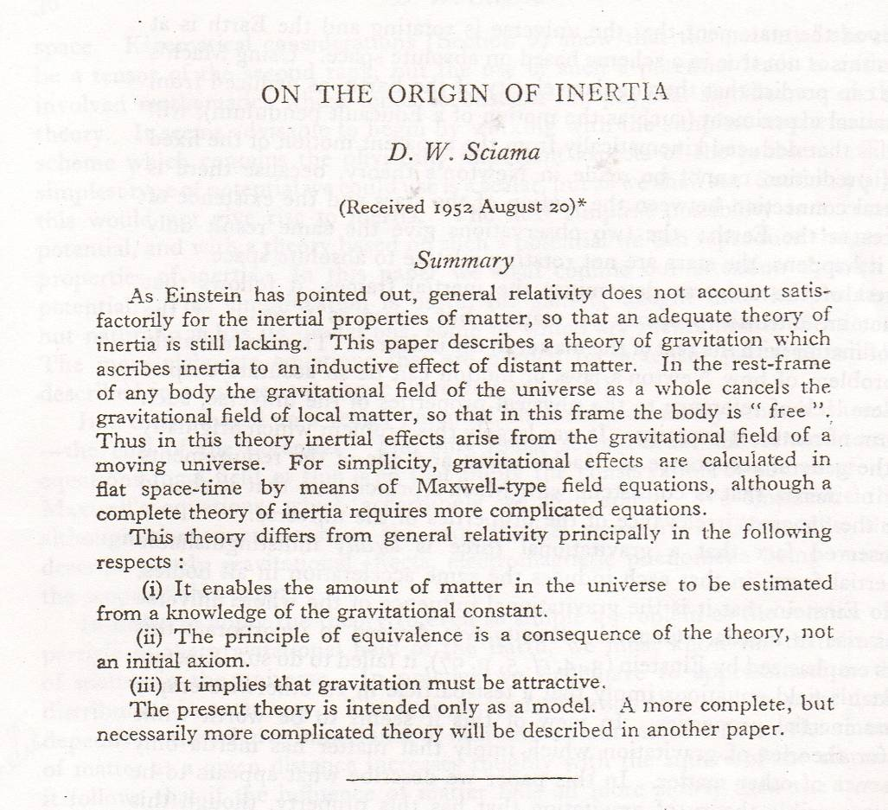

The main calculation of interest in Sciama’s paper occupies about one page:

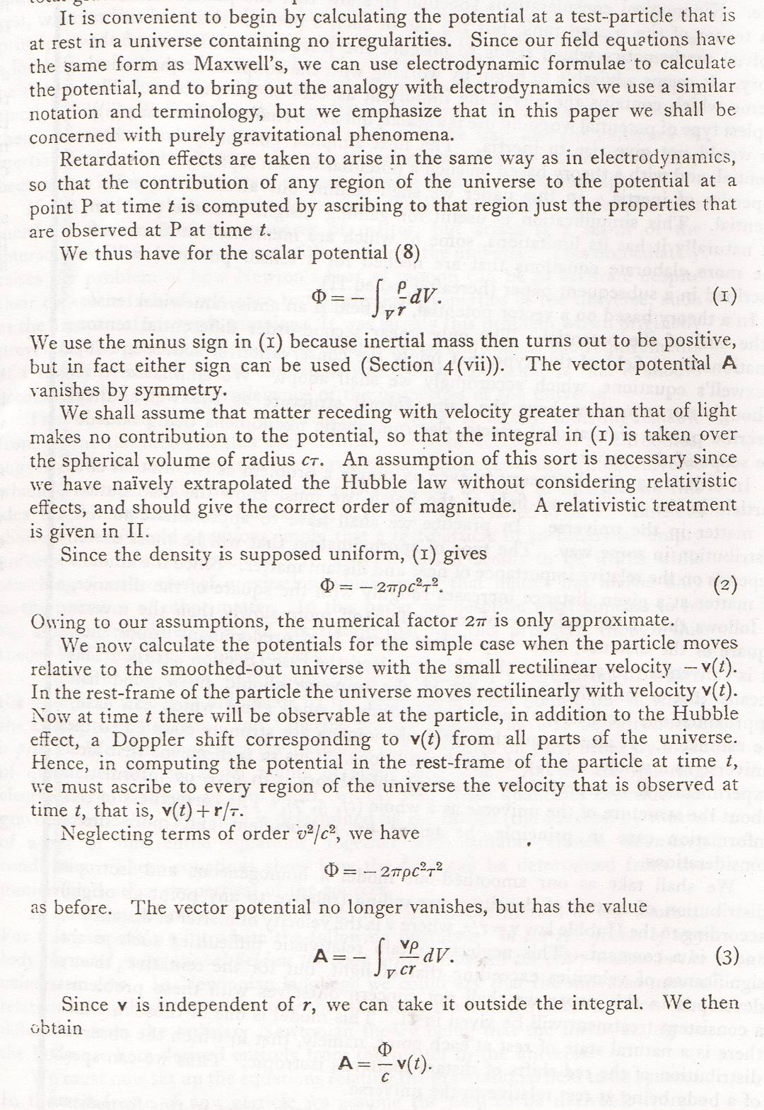
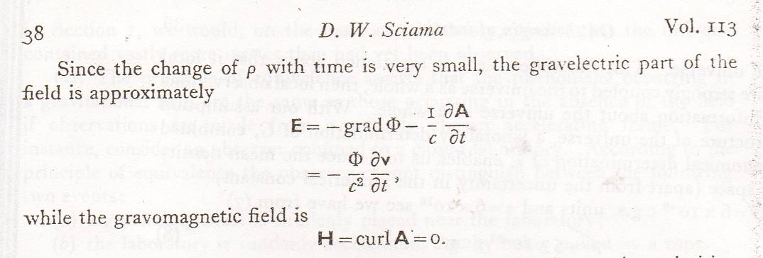

And if 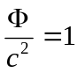, then the gravito-electric field just produces the full inertial reaction force.

APPENDIX B

BRANS ON GRAVITATIONAL ENERGY LOCALIZATION

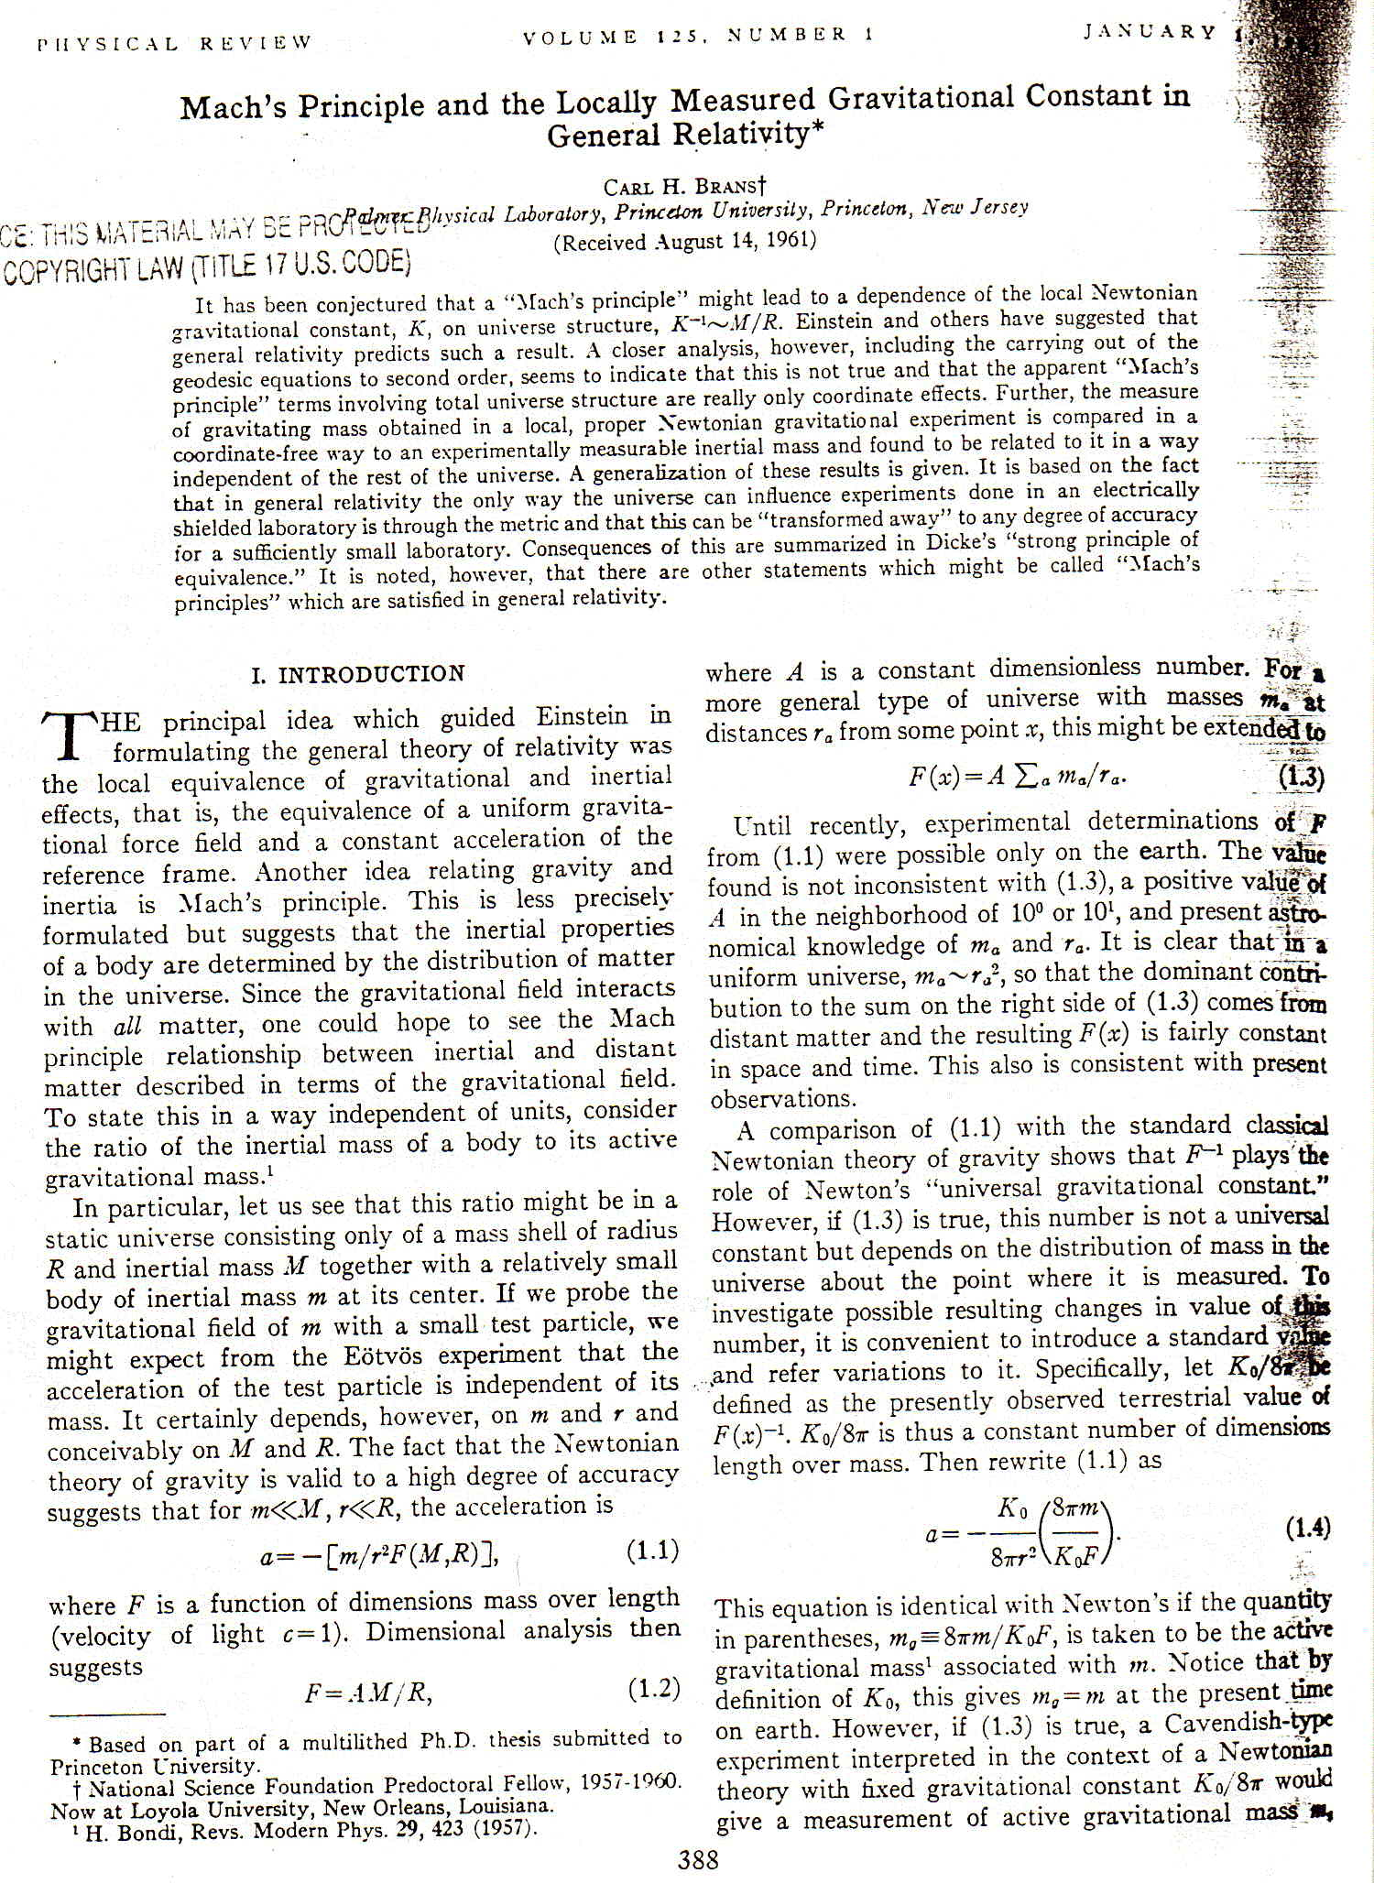
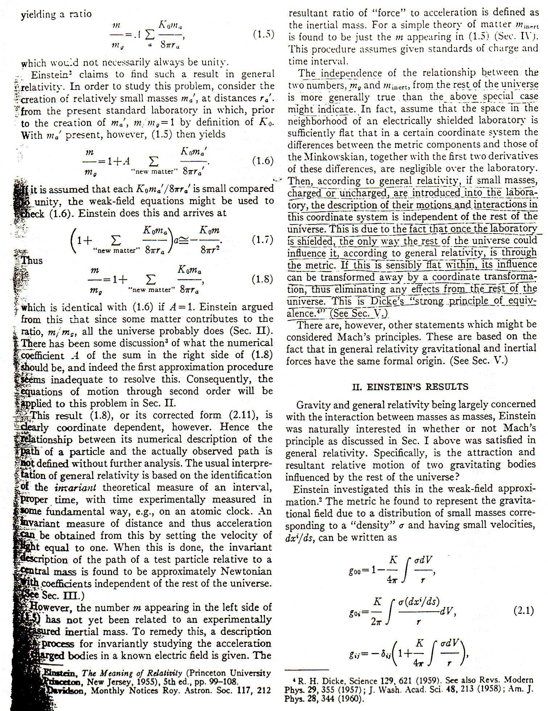
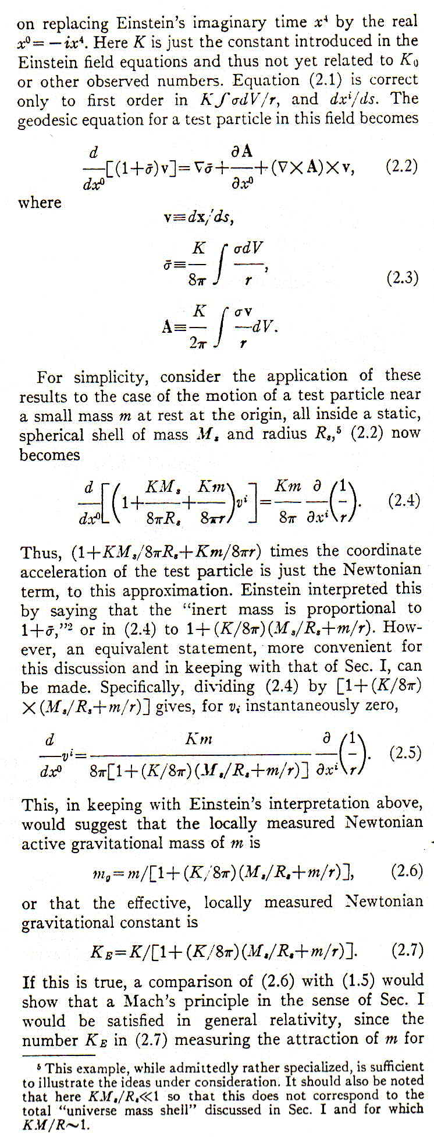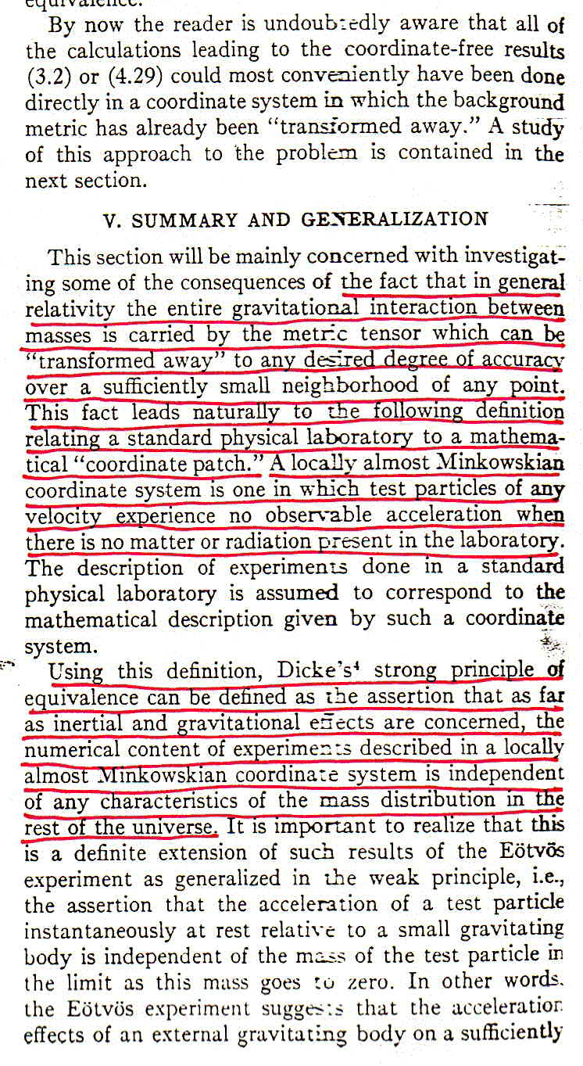

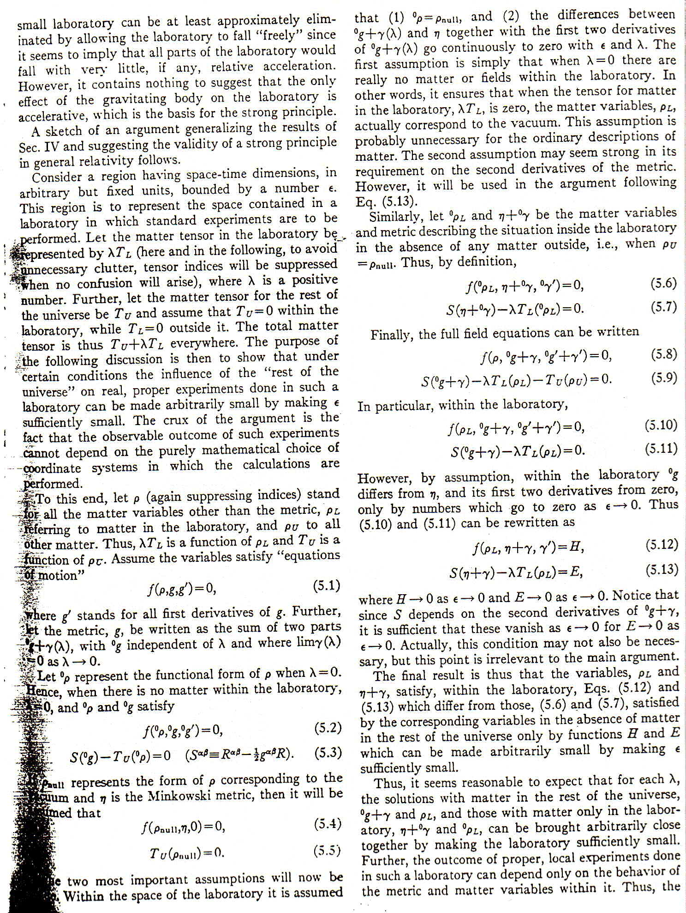
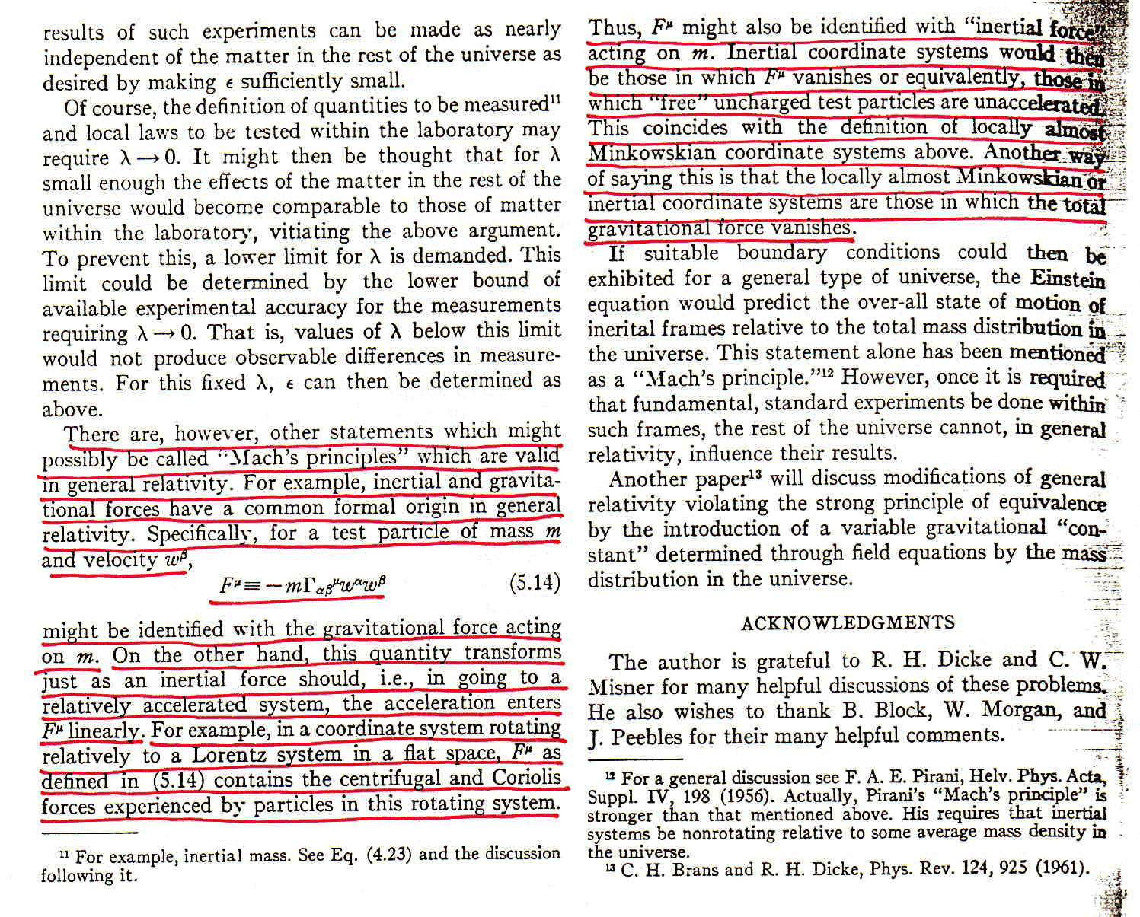

APPENDIX C

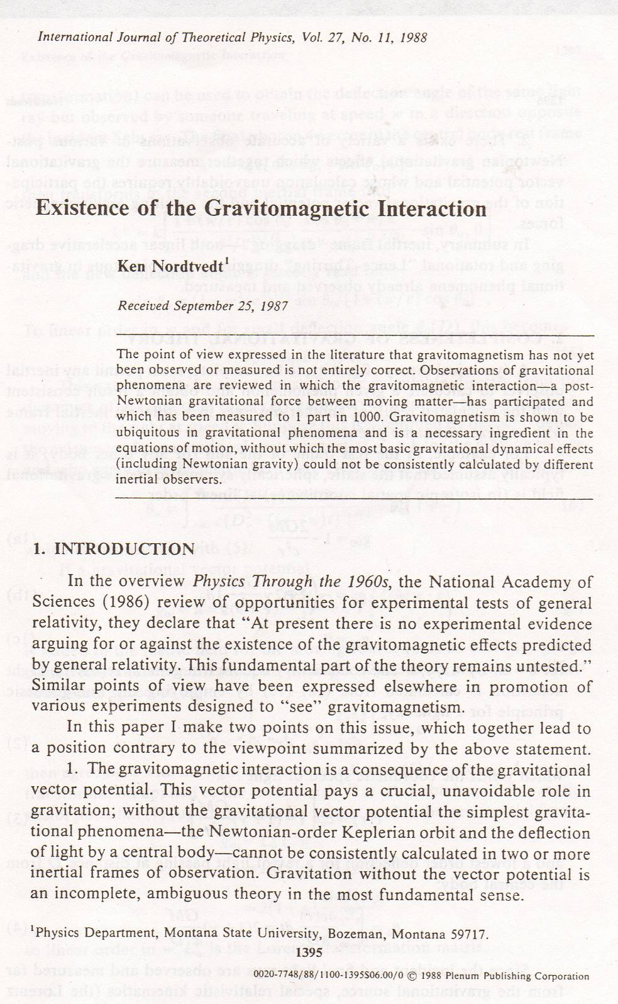

Toward the end of his paper Nordtvedt discusses linear accelerational frame dragging:

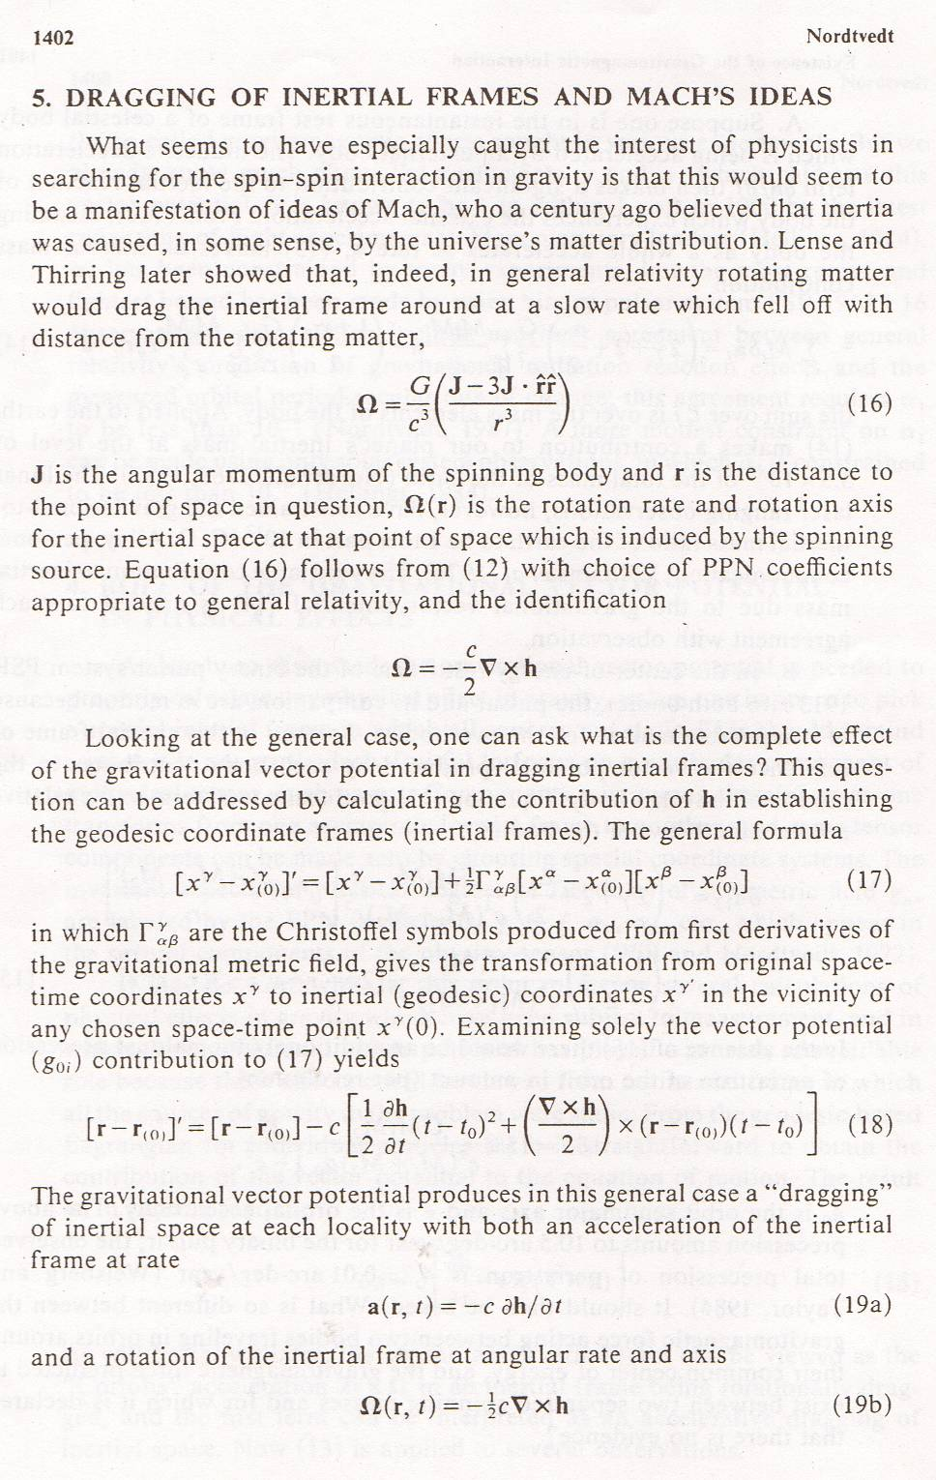

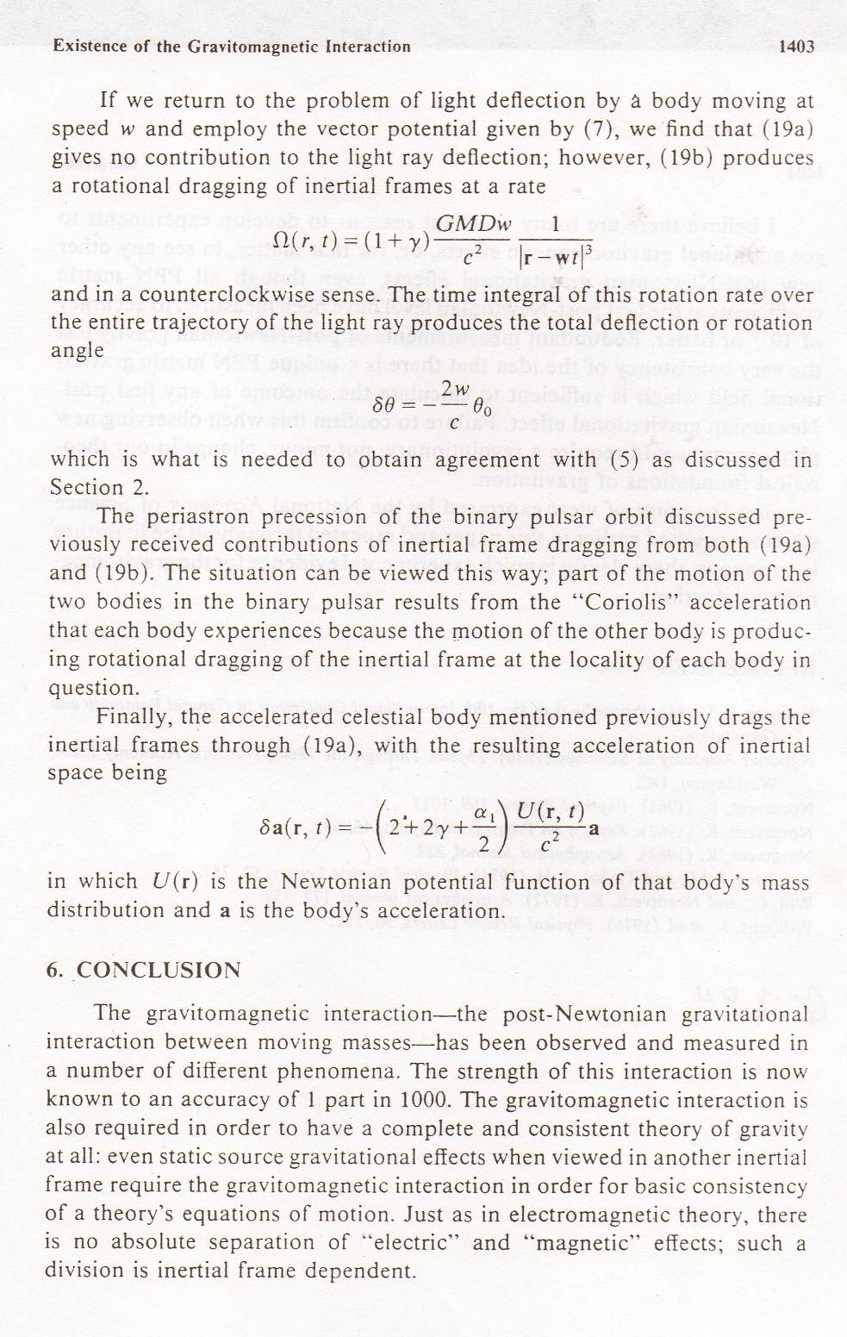

The last step in tying up Mach’s ideas, not taken by Nordtvedt in this paper, is to ask what the linear accelerational frame dragging would be if it were the entire universe that were accelerated by an “external” force? If we insert GRT values for the PPN coefficients in Nordtvedt’s last equation and assume a simple spherical universe of homogeneous and isotropic “matter” distribution, we find that the condition for “rigid” frame dragging – so that the acceleration of the universe is undetectable by any of its constituent parts – is, up to a geometric factor of 4. Exactly the condition found by Sciama for intertial reaction forces being entirely due to the gravitational action of chiefly distant matter in the universe. The factor of 4 in Brans’ calculation turns out to be due to his assumption of a rigid sphere of uniform density as the object accelerated. When a flat Friedmann cosmology is used, that factor turns out to be 1.

Initially conceived of by George Pugh and Leonard Schiff in the 1960s, Gravity Probe B was a collection of high precision gyroscopes flown in a satellite in polar orbit intended to detect the dragging of spacetime caused by the rotation of the Earth. The project, which flew several years ago, spanned decades and cost nearly a billion dollars. One noted relativist queried by the press on the launch of the satellite was reported to have remarked, “never was so much spent to learn so little.” The history of this project is yet to be written. But it will doubtless prove fascinating.
R was taken by Sciama as the radius of the “Hubble sphere”, that is, the product of the speed of light and the age of the universe. A more accurate calculation would have employed the “particle horizon”, the sphere centered on the Earth within which signals traveling at the speed of light can reach the Earth. The particle horizon encompasses considerably more material than the Hubble sphere. Sciama also neglected the expansion of the universe. These issues notwithstanding, Sciama’s work triggered an at times intense debate about the origin of inertia.
Actually, the “missing mass” problem was first identified in the 1930s by Fritz Zwicky by applying the virial theorem to clusters of galaxies. The virial theorem says that on average, the kinetic and potential energies of galaxies in clusters should be the same. It leads to galaxy mass estimates 10 to 100 times greater than the light emitted suggests is present. Only later was it extended to encompass cosmology too.
Or Einstein’s vector approximation equation for the force exerted by spectator matter that is accelerating on other local objects.
The Nordtvedt effect proposes that gravitational potential energies do contribute to the mass-energy of things, and predicts (small) deviations from the predictions of GRT that would follow. Such effects have not been observed.
He also predicted that the masses of things should vary as they are accelerated, an effect of the sort that we’ll be looking at in the next chapter.
Nordtvedt considered only a rigid sphere of uniform density of modest dimensions. He did not extend the argument to the case where the sphere is the entire universe, as did Sciama.
This factor – of 4 in fact when GRT PPN values are used – is a consequence of Nordtvedt’s assumption of a rigidly accelerating sphere of uniform density. When cosmological parameters of a spatially flat FRW model are used instead, the factor becomes 1 and 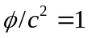as expected. This follows from a calculation of the “Sciama” force expected when the calculation of the vector potential is done in a correct FRW flat cosmology (see: J. Sultana and D. Kazanas, arXiv:1104.1306v1 [astro-ph.CO]). They find that the “Sciama” force is one quarter of that needed for an exact inertial reaction force. The factor of 4 discrepancy arises from the fact that Sciama’s calculation is not exactly equivalent to a general relativistic calculation like Nordtvedt’s.
The field strength of gravitational radiation depends on the frequency at which it is emitted. Gravitational waves, all other things held constant, depend on the fifth power of the emission frequency. This strong frequency dependence has led some to speculate that very high frequency gravitational waves might be used for propulsive purposes. Since the momenergy in gravity waves produced by human scale sources is so hopelessly minute, even allowing for unrealistically high frequency sources, gravity waves hold out no promise of practical scale effects.
Self energy in electrodynamics arises because the parts of an electric charge repell the other parts of the charge, and work must be done to compress the parts into a compact structure. The energy expended to affect the assembly is stored in the field of the charge. When the electron was discovered by J.J. Thomson in 1897, it was not long until H.A. Lorentz and others suggested that the electron’s mass might be nothing more than the energy stored in its electric field (divided by c²). They used this conjecture to calculate the so-called “classical electron radius” that turns out to be about 10⁻¹³ centimeters. But should you assume that the size of the electron is zero, the energy of assembly turns out to be infinite.
The “amplitude” (for an oscillatory field) or “field strength” (the magnitude of the scalar potential or field vector) is not the same as the “intensity” of the field. The intensity is proportional to the square of the field strength. So, a field whose strength decreases as 1/r has an intensity that decreases as 1/r², as does electromagnetic radiation (light) for example. When the intensity decreases at this rate, some energy just barely makes it to “asymptotic infinity”. If the intensity decreases faster than 1/r², as it does for any field whose strength decreases more quickly than 1/r, then no freely propagating energy makes it to asymptotic infinity.
As Faraday discovered in the early 1840s when Newton’s “third letter to Bentley” was first published. Hitherto, Newton’s true views on action-at-a-distance were not generally known. After reading Newton’s letter, it is said that Farady became positively boorish regaling everyone with the news that Newton rejected action-at-a-distance.
Two exceptions to this rule should be noted. First, a spherical object whose parts are undergoing a uniform radial acceleration does not radiate as the quadrupole moment is and remains zero. While such an expansion changes the radial tension in the field, it produces no “kink” in the field of the sort shown in Figure 1. Second, there are those who hope to find a way to couple an object directly to the distant matter in the universe and produce accelerations without the need for an anchoring local mass. Such speculations are sometimes referred to as “field effect” propulsion. Hope springs eternal.
When I read it as a grad student in the ‘60s, I thought he was nuts.
Paul Davies, author of many popular books on physics, however, recounts in his About Time that it was attendance at one of Hoyle’s lectures on this topic that set him on his early research career.
In this connection, Paul Davies relates an apposite story: “. . . I ventured: “What is the origin of the random phase assumption?” To my astonishment and dismay, [David] Bohm merely shrugged and muttered: “Who knows?” “But you can’t make much progress in physics without making that assumption,” I protested. “In my opinion,” replied Bohm, “progress in science is usually made by dropping assumptions!” This seemed like a humiliating put-down at the time, but I have always remembered these words of David Bohm. History shows he is right. . . .

