Resolving the extra dimensions for gravity
Michael E. Boyd Soquel California boyd.michaele@gmail.com
https://orcid.org/0000-0001-8039-4166 June 2023
Abstract
The weakness of the force of gravity compared to the electromagnetic force and the other fundamental forces has been referred to as the hierarchy problem. If gravity propagates in several additional spatial dimensions that are large compared to the Planck scale, the hypothesis is that gravity is stronger close-up, e.g., below a certain interaction distance the force of gravity is magnified. In the hard disk drive assembly, the magneto-resistor (MR) read sensor in the head assembly operates within 100nm of the spinning disk surface. Fourteen variable size nano-bumps and nano-pits were fabricated on a magnetic disk platen’s surface designed to be less than the Planck mass 21.77μgrams. These nano-features were measured over the spinning disk with both piezoelectric and MR sensors. The data was validated using both atomic force microscope (AFM) and magnetic force microscope (MFM) measurements. Results are reviewed and theoretical implications are discussed. The results suggest that the force of gravity is magnified and there are two forms of gravitation. Implications to modified spacetime are discussed.
Introduction
In 1998 theoretical physicists Arkani-Hamed, Dimopoulos and Dvali pointed out [1] that gravity had not been measured below a millimeter. Their model, known as ADD, suggests that there could be extra dimensions as large as a millimeter in diameter. In particle physics, the ADD model, also known as the model with large extra dimensions[2] offers to explain the weakness of gravity relative to the other forces. This theory requires that the fields of the standard model are confined to a four-dimensional membrane, while gravity propagates in several additional spatial dimensions that are large compared to the Planck scale.
The hierarchy problem poses the question why the force of gravity is so weak compared to the electromagnetic force and the other fundamental forces. The ADD model attempts to solve this problem. Theoretical physics assumes the Planck scale as the highest energy scale and all dimensional parameters are measured in terms of the Planck scale. In models of large extra dimensions, the fundamental scale is much lower than the Planck scale. This occurs because the strength of gravity changes below a certain interaction distance R_{ED}. When there are two extra dimensions of size d, the power law of gravity is 1/r⁴ for objects with r ≪ d and 1/r² for objects with r ≫ d. This relationship suggests the Planck scale to be equal to the next accelerator energy (1 TeV) takes d approximately 1mm. [1][2]
Other searches for Large Extra Dimensions have been performed using tabletop gravitational experiments [3-6] finding a R_{ED} < 1-100mm range, collider experiments [7-11] finding R_{ED} < 200μm, performing analyses of astrophysical data [12-16] finding a R_{ED} < 0.3-1μm range, and cosmological data [17-19] finding a R_{ED} < 22-110nm range. Using astrophysical data, very strong constraints ranging in R_{ED} < 0.16 - 916nm have been obtained. However, these limits depend on the technique and some assumptions [20] in the analyses. It should be noted that the bound that was obtained from the data of neutrino experiments is two orders of magnitude stronger than the constraints obtained using tabletop experiments, which achieved a limit of R_{ED} < 37 μm at 95% C.L. [20]. The existence of Large Extra Dimensions has been probed in various neutrino experiments. “[C]urrent experiments can put strong bounds on the size R_{ED} of the extra dimension: R_{ED} < 0.20μm and R_{ED} < 0.10μm at 90% C.L. for normal and inverted ordering of the standard neutrino masses, respectively.”(Forero et al., 2022)[21]
Postulates for the extra dimensions for gravitation
The analysis of the experiment’s results, postulates r= R_{ED} is the distance between the gravitomagnetic induction sensor and the microfabricated features, nano bumps, and nano pits, fabricated on the surface of the hard disk platen [22]. In the experiment the disk with the nano features located on a radius is spinning under a GMR sensor located at less than 100nm distance [R_{ED} < 0.10μm] from the stationary sensor. The postulate is that there exist two extra gravitation dimensions, one for gravity that is a pull force, and another for antigravity that is a push force, and these forces are magnified within the interaction distance of the extra dimension(s) for gravitation. The design criteria used for fabrication of the nano features is validated using an atomic force microscope [AFM] to compare those measurements to measurements made utilizing the Lecroy Oscilloscope to measure the time delay between the two electromagnetic induction signals [pulses] produced by the subject nano feature as it passed under the sensor. The force measurement was calibrated to magnetic force microscopy [MFM] measurements on a control 200 nm deep 10μm x 10μm square nano-pit. Results are shown in Table I and Figures 5 and 7.]
Technology considerations for testing the extra dimensions for gravitation.
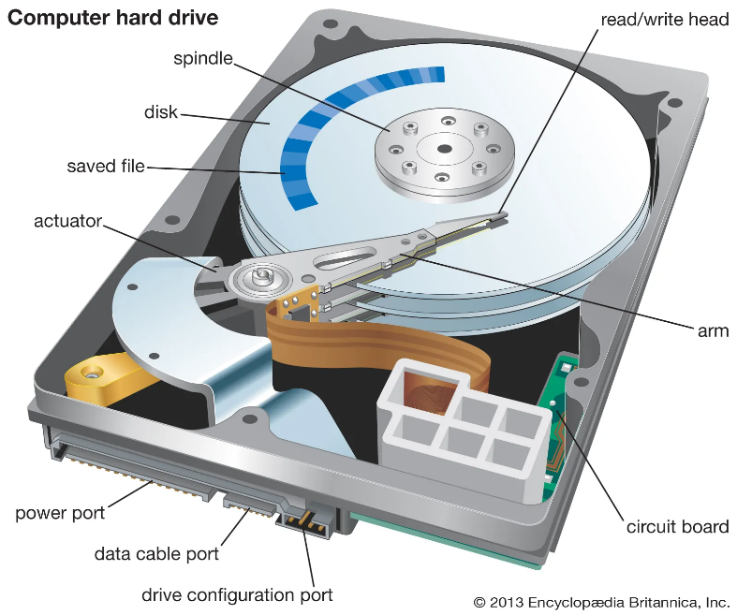
Figure 1 Computer Hard Drive [23]
A hard drive Figure 1 [23] has only a few basic parts. There are one or more disk platens where information is stored magnetically, there is an actuator arm that moves a read-write head back and forth over the disk platens to record or store information, and there's an electronic circuit to control the assembly that links the hard drive and the rest of your computer through its mother board. The components inside a hard drive include an actuator arm that moves the read-write head across the disk platen, and a central spindle controls disk platen rotation speed. A thin magnetic film deposited on the disk platen stores information in binary form. A multipin plug connects the hard drive to the mother board in the computer.
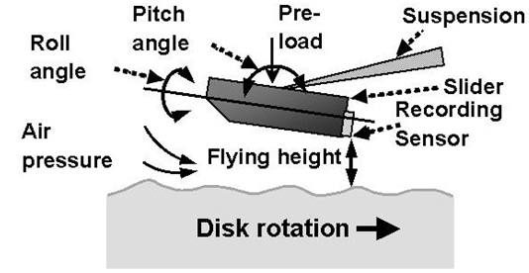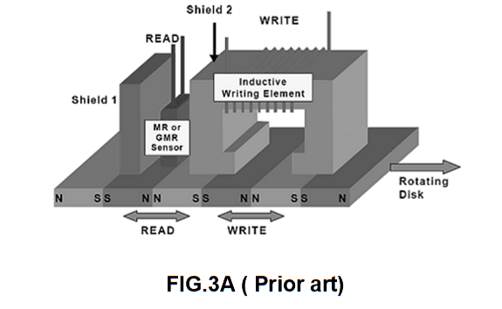
Figure 2a Read-write head “slider”[24] Figure 2b “merged” read-write head element [25]
On the end of the actuator arm is a sled shaped device called a “slider” Figure 2a [24] that contains the “merged” read-write head Figure 2b [25] containing a tiny magnetoresistor or giant magnetoresistor [MR or GMR] for reading and a tiny electromagnet coil for writing. This is the type of gravitomagnetic sensor used in the experiment.
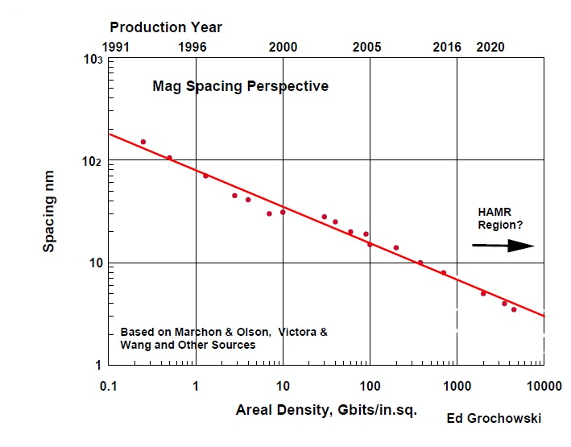
Figure 3 Areal Density vs Flying Height [27]
Consideration is needed for the fact that at the time the experimental data was collected in 1997, utilizing circa 1995 components Figure 3 [27]. As storage density has increased in magnitude [28] and to maintain low bit error rates [29] the clearance between the read/write element and the recording medium has been reduced. The flying height has decreased from initially about 20 μm [30] to a few nanometers in today's hard disk drives. At the time nano features were fabricated on three disks in 1997, flying heights were in the 80-100 nm range.[27] In current technology the flying heights is less than 5 nm.
Device and method
Figure 4, fourteen features, were fabricated on a 2400 Oe 31.5mil 95mm magnetic film coated disk platen using a Focused Ion Beam (FIB). Seven tungsten bumps of ~1.25μin (~32nm) height were deposited, and seven pits ~2μin (~51nm) deep were etched, on a disk 50 mils (~1.27mm) apart on a radius, as shown. The specified areal dimensions were 40x40 μm², 20x20 μm², 10x10 μm², 6x6 μm², 4x4 μm², 2x2 μm² and 1x1 μm² respectively. [25]
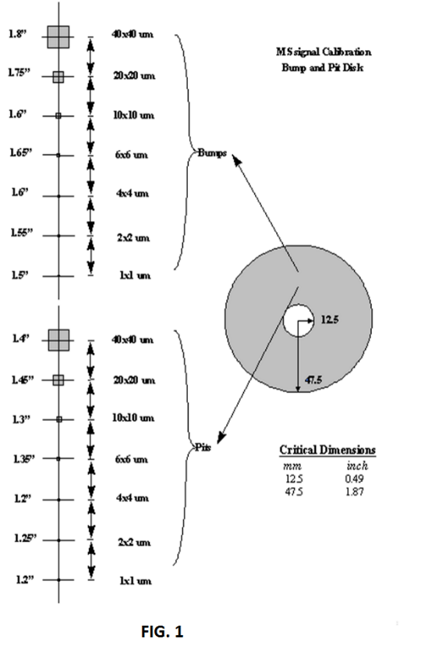
Figure 4 Design Specification Drawing [not to scale]. [25]
“To obtain accurate glide test results, many calibration methods and bump disks are designed.”(Zhong & Zheng, 2003)[26][31-37] Following fabrication, the disk was placed on the spindle of a Phase Metrics MG250 certifier and magnetically erased using a wide track MIG inductive head. The disk was then scanned using a 50% slider with a piezoelectric crystal mounted on the side of one of the sliders (i.e., a Piezo Glide or Glide head) and the disk was spinning at a constant linear velocity of 890 inches per second (ips) and was measured for mechanical force signal from the piezoelectric Glide head.(See Figures 9 and 10) [26] The MG250 Read channel was then used with a 50% Slider GMR head containing a magnetized MR element. The MR current was optimum at 16mA, and the linear velocity was maintained at 500 ips. Both the Glide head and the MR head were moved to the approximate location of the feature under analysis, and then stepped on a radius until a signal was detected on a Lecroy LC9370 1GHz BW Oscilloscope. The signal was then optimized for maximum signal level. The maximum signal was then recorded and characterized for signal amplitude and timing characteristics. The maximum signal measured was recorded and characterized for both [electro-]magnetic induction pulses and the gravitomagnetic induction pulse signal amplitudes and timing characteristics. The disk was then removed from the test spindle and each individual feature was characterized by utilizing a Park Scientific AFM for feature width along the direction of the circumference and the feature’s height or depth as reported in Table 1.
Force Calibration methodology
A magnetic force microscope (MFM) was utilized to quantify the peak value of magnetic force field strength as measured from a 10μm x 10μm square nano-pit.[25]
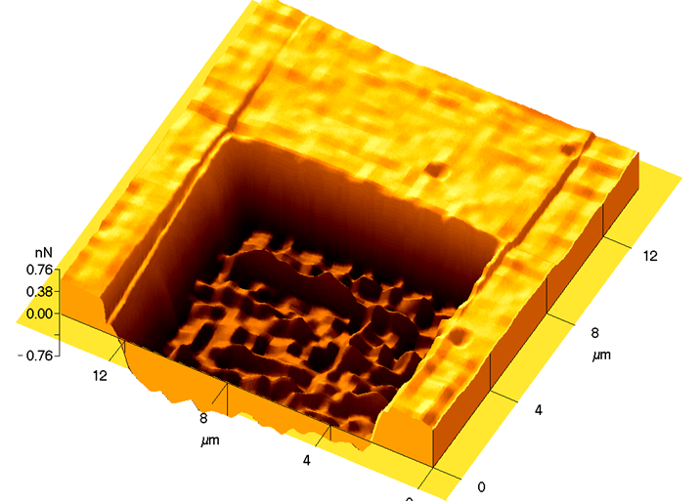
Figure 5 3-D cross section view of MFM image of 10μm x 10μm square nano-pit [25][37]
Figure 5 shows a magnetic force microscopy (MFM) provides a 3-D profile of the spatial variation of magnetic forces on a sample surface. For MFM, the AFM cantilever tip is coated with a ferromagnetic thin film. [25]
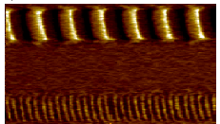
Figure 6 MFM micrograph of written track [bottom] with a servo track [top] [25]
The system operates in non-contact mode, detecting changes in the resonant frequency of the cantilever induced by the magnetic field’s dependence on tip-to-sample separation. Figure 6 shows the MFM can be used to image deliberately written domain structures [25] in magnetic materials.
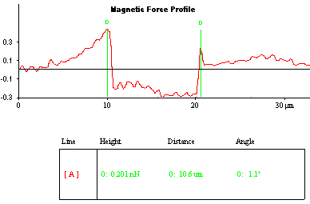
Figure 7 2-D MFM profile provides our calibration value of 0.3 nanonewtons = 0.3 Volts MR read signal [25]
Figure 7 shows the MFM data provides the 2-D cross section used for a control measurement using the ~200 nm deep ~10μm x 10μm nano-pit [25] in this experiment as shown. It shows that a 1 Volt read signal is equivalent to a 1 nanonewton gravitomagnetic force on the same nano pit as measured with an MFM.
Results
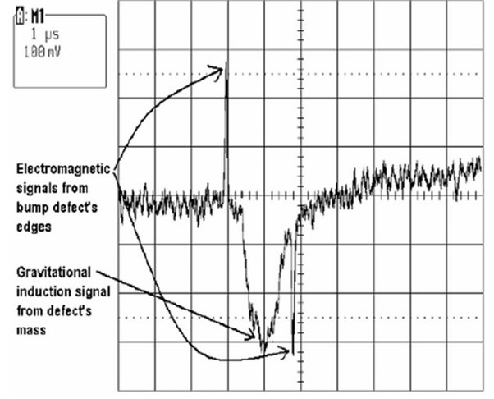
Figure 8 MR read signal from 10μm x 10μm square nano bump 52nm depth [25]
Examine the difference between gravito-magnetic induction and [electro-]magnetic induction. Figure 8 shows the GMR read head signal is observed from a 10μm x 10μm square bump of around 32 nanometers tall on a hard disk platen spinning at a constant linear velocity of 500 ips [12.7 meters per second]. [25] The disk is spinning counter-clockwise, so observe the first [electro]-magnetic induction signal on the left as the edge of the square nano-bump moves under GMR sensor. This upward magnetic induction is induced by the 90° change in the angle at the edge of bump at the speed of light. This is followed by the downward gravitomagnetic signal of a bump 1μSecond later traveling at the speed of gravity. Observe the downward polarity second [electro]magnetic induction signal on the right of the gravitomagnetic signal as the edge of the square nano-bump moves under GMR sensor 0.8μSecond later traveling at the speed of light. In this example observe the gravitational frame dragging is 1μSecond. Voltage is in millivolts (mV). The time difference between these two electromagnetic induction pulses is referred to as the MR modulation pulse delay in Table 1.
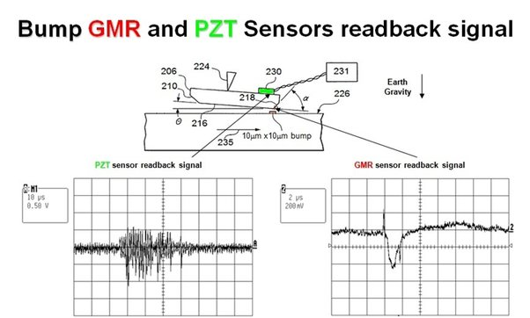
Figure 9 The presence of matter moving produces a pull force and negative polarity gravity.
Figure 9 shows the image of a cross sectional view of the GMR read head with a piezo-electric crystal mounted on the back side of the head slider. The GMR read head is sensitive to magnetic field changes while the piezo-electric crystal on the back of the slider is sensitive to physical motion of the head slider.[25] A 10μm x 10μm square bump of around 32 nanometer height measurement results are shown. On the left is the piezo-electric Glide Head signal an undamped physical pull against the head slider against the force of Earth Gravity is shown. On the right the GMR sensor shows a negative polarity gravitomagnetic signal. Therefore, this infers the presence of matter on the spinning disk produced a physical pull force and negative polarity gravitomagnetism. In this example observe the gravitational frame dragging is 1μSecond.
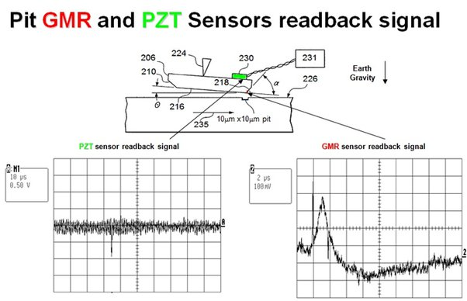
Figure 10 The absence of matter moving produces a push force and positive polarity gravity.
Figure 10 shows the image of a cross sectional view of the GMR read head with a piezo-electric crystal mounted on the back side of the head slider with a nano-pit on the surface of the disk. A 10μm x 10μm square pit of around 52 nanometer depth measurement results are shown. On the left is the piezo-electric Glide Head signal where is observed a short dampened physical push against the head slider against the force of Earth Gravity. On the right the GMR sensor shows a positive polarity gravitomagnetic signal. Therefore, this infers the absence of matter on the spinning disk produced a push force and positive polarity gravitomagnetism. In this example observe the gravitational frame dragging is 1μSecond. This also infers that there exist two different time frames: one for matter [or the lack there of], and another for electromagnetism [EM].
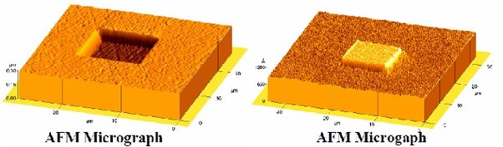
Figure 11 10μm x 10μm square pit and bump 3-D AFM micrographs.
Figure 11 shows a 3-D images (micrographs) of measurements taken from a Park Systems atomic force microscope (AFM) of the 10μm x 10μm square pit of around 52 nanometer depth and a 10μm x 10μm square bump of around 32 nanometer height associated is displayed.

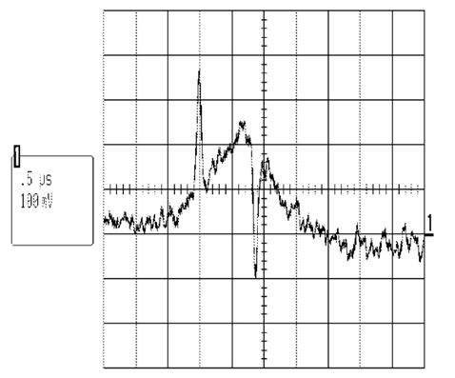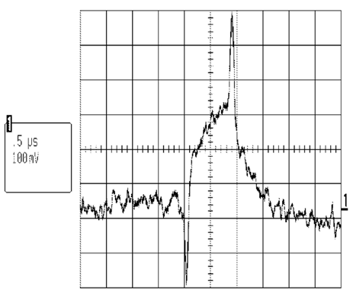
Figure 12a one erase polarity[25] Figure 12b the opposite erase polarity
Figures 12a and 12b [25] illustrate that magnetic induction is independent from the gravitational induction in the mass spin-valve device. To examine the dependence of the measured magnetic induction read back signals on DC erase polarity, the two wires connected to the write transducer were disconnected and re-attached to the head's paddle board for the opposite polarity to be applied to the write element during erasure. Figure. 12a illustrates the results at one erase polarity. Figure. 12b illustrates the results at the opposite erase polarity. The two magnetic inductions read back signals correspond to the switch in the magnetic field's direction produced by the edges of the falling and rising edges of the nano pit are induced magnetically by a micro-fabricated feature’s and is dependent on the polarity of DC erase on the magnetic media; but the gravitomagnetic induction signal (i.e., the gravitomagnetic force field's direction) is independent of the polarity of DC erase.
Table 1
In a metallic conductor, current is carried by the flow of electrons. In semiconductors, current is often characterized as being carried either by the flow of electrons or by the flow of positively charged “holes” in the electron structure of the material. It seems reasonable to infer there exists an equivalent quantum nature to gravity associated with the presence and absence of matter on the spinning disk to the quantum nature in electromagnetism in the semiconductor junction, or in a rectifier, as a type of electromagnetic spin valve device which is based on the spin of conduction energy band electrons in the semiconductor crystal. Holes is semiconductor terminology. In semiconductor physics we distinguish holes and electrons using Hall effect measurements. The term “holes” in the experiment refers to the absence of protons, i.e., nano-pit features on the surface of the spinning disk [the absence of mass] moving under the stationary sensors. Nano-bump features on the surface of the spinning disk [the presence of mass] moving under the stationary sensors would be protons [gravitational rectification] replace electrons [semiconductor rectification] therefore.
Figure 13 illustrates the gravitational induction equivalent of the semiconductor; as a gravitational rectifier in the mass spin valve device; whereby the downward gravitational induction force (N type donor gravitons) is produced by additional mass; equivalent to the electrons in the semiconductor rectifier; and the upward gravitational induction force (P type acceptor anti-gravitons) is produced by the absence of mass, equivalent to “holes” in the semiconductor rectifier. [25]
The relationship of mass to this extra dimension for gravity is described by the relationship (additional mass),
Bump Volume (μm³)=6(−Gf)²−7(−Gf)−0.4 (1)
Gf is the [−] attractive force of Gravity which is a parabolic force field which has two mathematically real factors. (See Figure 13) Assuming the Gravitational induction force (−Gf) is variable x and the volume of additional mass is y. Solving for y=0, by simplifying the equation by multiplying both sides with 5, gives two real factors x1 and x2: x1=1.221255, x2=−0.054589.
Repulsive [+] anti-gravity exists in hyperbolic force field with one real part and two imaginary factors relative to the MR sensor described by the relationship of missing mass,
Assuming the anti-gravitational induction force (Gf) is variable x,
Pit Volume (μm³)=−3000Gf³+1000Gf²−200Gf+8 (2)
and the volume of missing mass is y, then y=−3000x³+1000x²−200x+8=8(−375x³+125x²−25x +1) and (375x³+125x²−25x+1) the factors are two imaginary one real. Solving for y=0 gives: x1=0.0510251, x2=0.141154+0.179826*i, x3=0.141154−0.179826*i . [25]
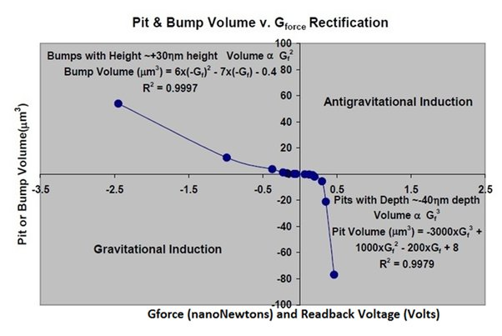
Figure 13 Gravitational junction : parabolic pull force of nano-gravity and hyperbolic push force of nano-antigravity [25]
Figure 13 shows by varying the area of the nano-pits and the nano-bumps on the surface of the spinning disk, the graph of the measured gravitational force is derived. A gravitational diode curve is observed for variable area pits and bumps. The P-type side of the gravitational diode is the acceptor side of the junction producing positive gravitational induction and a push force with a third order polynomial of a hyperbolic force like that of a balloon. The N-type side of the gravitational diode is the donor side of the junction producing negative gravitational induction and a pull force with a second order polynomial of a parabolic like that of normal gravity but magnified. [25]
To determine the calculated mass values shown in Table 1 and Table 2 take the nano-bump’s volume and multiply it by 19.3g/cm³, the density of Tungsten (W).
Table 2

Figure 14
Figure 14 shows a plot of the calculated gram mass derived using the variable area nano-bump’s volume [x-axis] versus the measured G-force magnification, (measured/expected) [y-axis]. (See Table 2 for values) The trendline shows the power relationship G_{Force} Magnification = 0.1034 x (calculated mass[grams])^{-0.364} using the values listed in Table 2 the power relationship equation is derived.
Error analysis

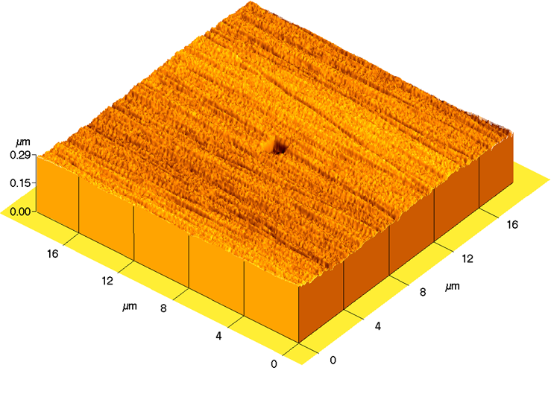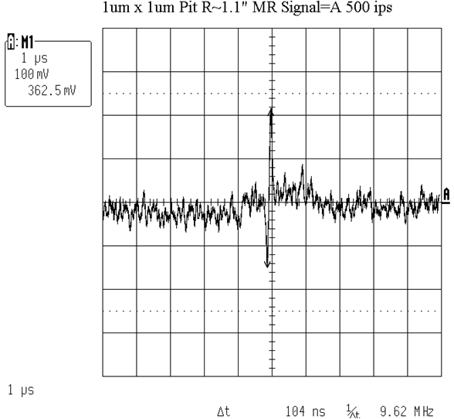
Figure 15a [37] Figure 15b
Figures 15a and 15b is the 3-D AFM micrograph and the MR readback signal for an approximately 1.3μm x 1.3μm x 47nm deep pit. [37]
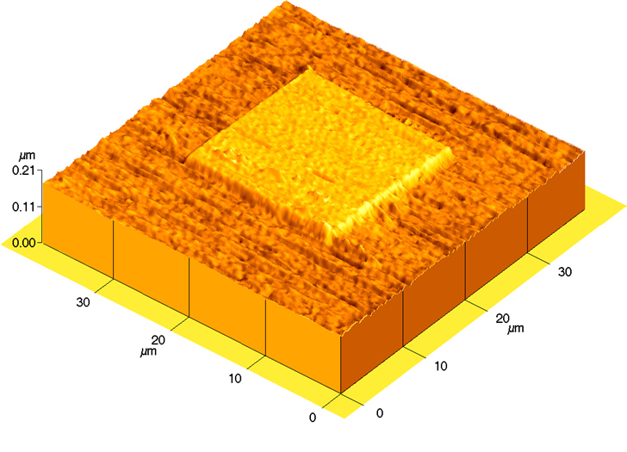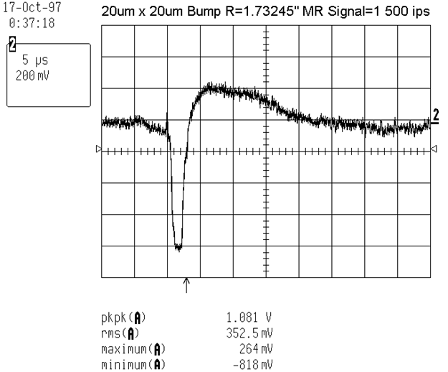
Figure 16a Figure 16b
Figures 16a and 16b is the 3-D AFM micrograph and the MR readback signal for an approximately 20μm x 20μm x 31nm tall bump. [37]
Please note Table 1 shows an AFM measurement of a 1.28μm x 1.28μm x 47nm deep pit shown in Figure 15a and that the missing volume is -0.077μm³. The measured push force was 0.055 nanonewton. Using Figures 16a and 16b for an example, the AFM measurement found that the nano-bumps dimensions where 20.2μm x 20.2μm x 31nm tall with a volume of 12.6μm³. The measurement showed a pull force of -0.805 nanonewtons force. Calculating the expected mass equals 12.6μm³ times 19.3g/cm³ gives a mass of 2.441x10⁻¹⁰ grams a factor of roughly one hundred thousand time less than the Planck mass, 2.177x10⁻⁵ grams. Table 1 and 2 shows the calculated value of the nano-gravity force is 2.441x10⁻¹⁰ grams times 0.009807 Newtons/gram gives an expected -2.394x10⁻³ nanonewtons gravity force. The measured force was -0.805 nanonewtons, 336.2 times stronger than the expected -2.394x10⁻³ nanonewtons.
The time difference between these two electromagnetic induction pulses is referred to as the MR modulation pulse delay in Table 1. Linear velocity is constant at 500 ips (12.7 m/s). Multiplying the MR modulation pulse delay times, the linear velocity obtains a measurement value for the circumferential width (μm) of the nano-feature under measurement. Using the nano-pit in Figure 15b gives a width of 1.3208μm. This compares favorably with the AFM measurement of the width as 1.28μm with a standard deviation between the AFM measurement and the MR modulation pulse width method of 0.0288μm. Using the nano-bump in Figure 16b gives a width of 20.3μm. This compares favorably with the AFM measurement of the width as 20.2μm with a standard deviation between the AFM measurement and the measured MR modulation pulse width method of 0.0707μm.
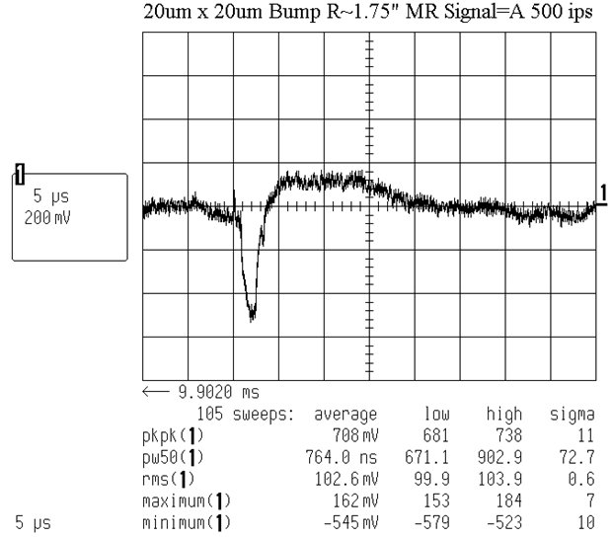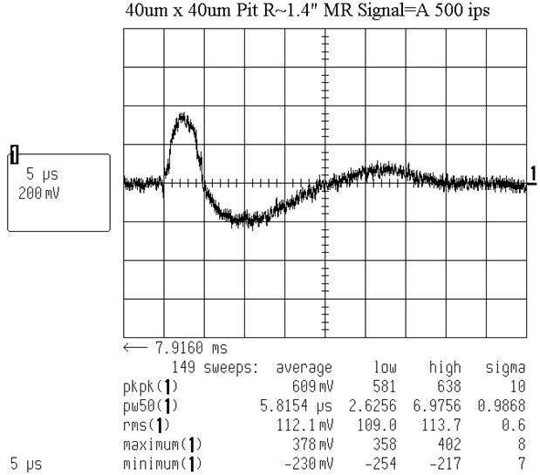
Figure 17a 20μmx20μm bump σ=10mV Figure 17b 40μmx40μm pit σ=8mV
The Lecroy oscilloscope data was collected over multiple sweeps of the nano-feature below the GMR sensor, sweeping typically 100 to 150 times as shown in Figures 17a and 17b.
Table 3
Figure 17a shows a 20μm x 20μm nano-bump had a minimum voltage σ of 10mVolts and Figure 17b shows a 40μm x 40μm nano-pit had a maximum voltage σ of 8mVolts. Table 3 shows the measurement standard deviation σ, of multiple voltage measurement sweeps, and also shows the measurement standard deviation σ between the MR modulation delay and AFM width.
Discussion
While electromagnetic effects like photons, magnetism, and electricity are properties of electromagnetism, gravitomagnetic effects are inertial or gravitational field effects that might be expected when there is relative motion between bodies. Some of these effects are currently included within standard "core" physics, some aren't. The name comes from an analogy with electromagnetism, where the motion of an "electric" charge produces "magnetic" side-effects. In gravitomagnetism, the "moving charge" is inertial-gravitational, and the "gravitomagnetic" effect can be considered as being due to a distortion of a body's surrounding inertial-gravitational field. These effects can be considered consequences of the finite speed of gravitational signals. If a body changes its location or velocity while its previous signals are in flight, the way that its signals are distributed through space should be affected. If we consider the inertia of a body to be partly or wholly determined by its interactions with its environment, then interfering with the way that it communicates with that environment might alter its apparent inertial properties.
Direct measurements of the gravitational force had been reported in 2021 utilizing as the gravitational source a spherical gold mass of radius r = 1.07 mm and mass m_{s} = 92.1mg. A similarly sized gold sphere acts as test mass with m_{t} = 90.7mg. “The idea is that a periodic modulation of the source mass position generates a time-dependent gravitational potential at the location of the test mass, whose acceleration is measured in a miniature torsion pendulum configuration.”(Westphal et al.,2021) [38]
[38]
Figure 18 Measured AC Force (fN) v. Center of Mass Distance (mm)
Figure 18 in the article reported approximately 20fN [20x10⁻¹⁵ newtons or 20 femtonewtons] of gravitational force at a 3mm center of mass distance and that the measured results “agree well with the expected force modulation due to Newtonian gravity.” The article also suggests “Casimir forces will become relevant at distances below 100 μm.” (Westphal et al.,2021) [38] At less than 100nm from the sensor used in the experiment this would suggest Casimir forces would apply here.
“The Casimir force is an effect of quantum vacuum field fluctuations”.(Reynaud & Lambrecht, 2017) [39] This would suggest the interplay of vacuum engineering and the experiment would be reasonable to infer.
The article Advanced space propulsion based on vacuum (spacetime metric) engineering (Puthoff, 2010) [40] (the “Puthoff model” herein) puts forward the hypothesis “The concept that empty space itself (the quantum vacuum, or spacetime metric) might be engineered proposes spacetime metrics engineering ‘the vacuum engineering concept was based on the recognition that the vacuum is characterized by parameters and structure that leave no doubt that it constitutes an energetic and structured medium in its own right. Foremost among these are that (1) within the context of quantum theory the vacuum is the seat of energetic particle and field fluctuations, and (2) within the context of general relativity the vacuum is the seat of a spacetime structure (metric) that encodes the distribution of matter and energy.’ ”
Table 1 in the article shows Metric Effects on Physical Processes in an Altered Spacetime as Interpreted by a Remote (Unaltered Spacetime) Observer. Table 4 herein is an excerpted version that adds a separate attribute variable for spacetime itself for the author’s purposes.
Metric Effects on Physical Processes in an Altered Spacetime as Interpreted by a Remote (Unaltered Spacetime) Observer.
Variable Typical Stellar Mass Spacetime-Engineered Metric
Time Interval
processes (e.g., clocks) run slower run faster
Frequency red shift toward blueshift toward
lower frequencies higher frequencies
Energy energy states lowered energy states raised
Spatial measure objects (e.g., rulers) shrink objects (e.g., rulers) expand
Velocity of light effective v_{L} < c effective v_{L} > c
Mass m effective mass increases effective mass decreases
Gravitational “force” “gravitational” “antigravitational”
[40]
Spacetime* denser expanded
*Added by author.
Table 4 [40]
“From the perspective of a photon, there is no such thing as time. It's emitted, and might exist for hundreds of trillions of years, but for the photon, there's zero time elapsed between when it's emitted and when it's absorbed again. It doesn't experience distance either” (Cain, 2014). [41]
Assuming the concept of wave particle duality of the photon applies to gravitation, there exists three forms of wave particles, massive time dependent gravitons [aka dark matter], massless time dependent anti-gravitons [aka dark energy], and massless time independent photons. The geometry of matter, or lack thereof, causes a measurable force field to be produced. Both forms of gravitation experience the same amount of frame dragging as described in Einstein's General Relativity theory, 1μSecond. [See Figures 9 and 10.] The hypothesis here is gravitational spacetime is produced by proton states of matter and electromagnetism spacetime (EM or light) is produced by electron states of matter. Quantum mechanics (QM) is built on EM spacetime. Special Relativity is built on EM space time while General Relativity is built on gravitational spacetime. The manifold of events in spacetime is a "substance" which exists independently of the matter within it. [42] While the speed of light is constant, that's not true for gravitation. Gravitation can be slower in speed and faster, too. [See Figures 24 and 23.]
That "electromagnetism is in spacetime A," let's call that spacetime "EM spacetime", and this is what Einstein's "Zur Elektrodynamik bewegter Korper" (Einstein,1905) [43] ("On the Electrodynamics of Moving Bodies") described, which reconciles Maxwell's equations for electricity and magnetism with the laws of mechanics, by introducing major changes to mechanics close to the speed of light. This later became known as Einstein's special theory of relativity (SR) (Einstein & Grossman, 1913)(Einstein, 1916).[44][45] That "gravitation is in spacetime B," let's call that spacetime "G spacetime" and this is what Einstein's General Relativity (GR) describes. According to general relativity, (Hilbert, 1924)[46] the observed gravitational attraction between masses results from the "warping of space and time by those masses".
The Puthoff model of the GR spacetime metric appears to be applicable to the nano-scale experiment utilizing pits and bumps fabricated on the surface of the hard disk platen to create regions of expanded and denser spacetime at the μm scale of the nano-features utilized in the experiment.
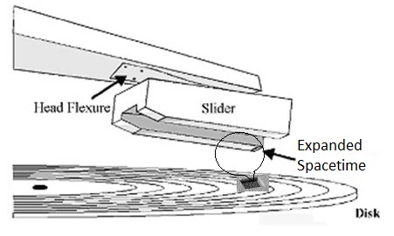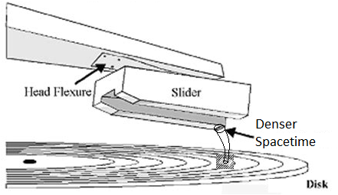
Figure 19a nano-pit produces expanded spacetime Figure 19b nano-bump produces denser spacetime.
The nano-pit creates a region of effective mass decrease, on the spinning disk in the form of a nano-pit, inducing a region of expanded spacetime, as shown in Figure 19a. The Puthoff model predicts an antigravity force is associated with this region of expanded spacetime which was confirmed in the experiment. (See Figure 10.) The nano-bump creates a region of effective mass increase, on the spinning disk in the form of a nano-bump, inducing a region of denser spacetime, as shown in Figure 19b. The model predicts a gravity force is associated with this region of denser spacetime which was confirmed in the experiment. (See Figure 9.)
To travel in time is to travel in space. This has been described as “offset spatial divergence." The manifold of events in spacetime involves movement through space back to where an object was during the target time, or forward to where it will be, the superposition of the past and future [virtual worldlines] in the [real worldline] of the here and now. The earth [real worldline] rotates around the sun, which rotates around the galaxy, which moves in a galactic cluster through the universe. Everything is moving with respect to everything else in a manifold of events in spacetime, all which is interconnected at the quantum level in spacetime.
The Puthoff model predicts clocks run faster in expanded spacetime and slower in denser spacetime. Let's assume that the speed of light is our fixed time reference with gravitational interaction time being our variable. The magnetic induction pulse on the left is time τ=0.
With expanded spacetime time shrinks, length dilates, so an anti-gravity pre-signal would be expected.
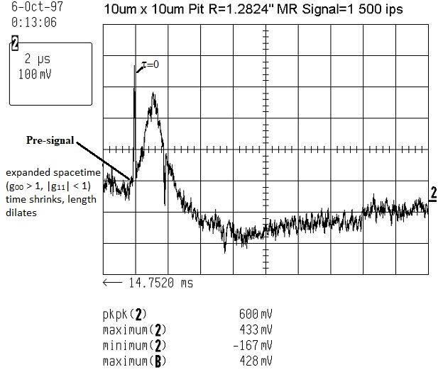
Figure 20
A pre-signal is observed from the MR readback signal produced by 10μm x 10μm nano-pit as shown in Figure 20. To a non-expanded spacetime observer, objects moving in expanded spacetime appear to exceed the speed of light. Likewise with denser spacetime time dilates, length shrinks, so a post-signal would be expected.
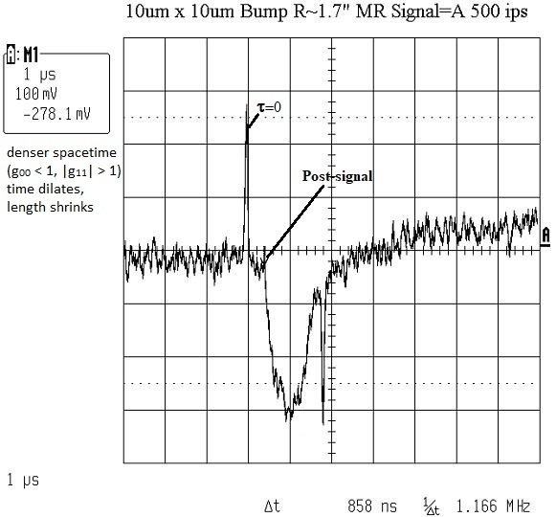
Figure 21
A post-signal is observed from the MR readback signal produced by 10μm x 10μm nano-bump, as shown in Figure 21. Figures 20 and 21 show examples of the phenomenon of offset spatial divergence.
Conclusions
There exists two strong extra dimensions for gravitation below 100nm interaction distance where the force of gravity is multiplied. [Figure 14] The presence of matter moving, e.g., nano-bumps induced a gravity pull force measurable with a GMR sensor and piezoelectric force sensor. [Figure 9] The absence of matter moving, e.g., nano-pits induced an anti-gravity push force measurable with a GMR sensor and piezoelectric force sensor. [Figure 10] The [presence of matter moving] gravity and [absence of matter moving] anti-gravity dimensions exist in the same time frame. Therefore, there exist two different time frames: one for matter [or the lack there of], and another for electromagnetism [EM]. Gravitation can be slower than the speed of light and faster, too. [See Figures 21 and 20.] The Puthoff model of the GR spacetime metric appears to be applicable to the nano-scale experiment utilizing nano-pits and nano-bumps fabricated on the surface of the hard disk platen to create regions of expanded and denser spacetime at the cubic μm scale of the nano-features utilized in the experiment.

References
[1] Arkani–Hamed, N., Dimopoulos, S., & Dvali, G. (1998). The hierarchy problem and new dimensions at a millimeter. Physics Letters B, 429(3-4), 263-272.
[2] Antoniadis, I., Arkani-Hamed, N., Dimopoulos, S., & Dvali, G. (1998). New dimensions at a millimeter to a Fermi and superstrings at a TeV. Physics Letters B, 436(3-4), 257-263.
[3] Long, J. C., Chan, H. W., & Price, J. C. (1999). Experimental status of gravitational-strength forces in the sub-centimeter regime. Nuclear Physics B, 539(1-2), 23-34.
[4] Krause, D. E., & Fischbach, E. (2001). Searching for extra dimensions and new string-inspired forces in the Casimir regime. In Gyros, Clocks, Interferometers...: Testing Relativistic Gravity in Space (pp. 292-309). Berlin, Heidelberg: Springer Berlin Heidelberg.
[5] Fischbach, E., Krause, D. E., Mostepanenko, V. M., & Novello, M. (2001). New constraints on ultrashort-ranged Yukawa interactions from atomic force microscopy. Physical Review D, 64(7), 075010.
[6] Adelberger, E. G., & EÖT-WASH GROUP. (2002). Sub-millimeter tests of the gravitational inverse square law. In CPT and Lorentz Symmetry (pp. 9-15).
[7] Rizzo, T. G. (1999). More and more indirect signals for extra dimensions at more and more colliders. Physical Review D, 59(11), 115010.
[8] Hewett, J. L. (1999). Indirect collider signals for extra dimensions. Physical Review Letters, 82(24), 4765.
[9] Abbott, B., Abolins, M., Abramov, V., Acharya, B. S., Adams, D. L., Adams, M., ... & Hahn, K. S. (2001). Search for large extra dimensions in dielectron and diphoton production. Physical review letters, 86(7), 1156.
[10] Abreu, P., Adam, W., Adye, T., Adzic, P., Albrecht, Z., Alderweireld, T., ... & Gamba, D. (2000). Measurement and interpretation of fermion-pair production at LEP energies of 183 and 189 GeV. Physics Letters B, 485(1-3), 45-61.
[11] Abdallah, J., Abreu, P., Adam, W., Adzic, P., Albrecht, T., Alemany-Fernandez, R., ... & Kerzel, U. (2009). Search for one large extra dimension with the DELPHI detector at LEP. The European Physical Journal C, 60, 17-23.
[12] Cullen, S., & Perelstein, M. (1999). SN 1987A constraints on large compact dimensions. Physical Review Letters, 83(2), 268.
[13] Barger, V., Han, T., Kao, C., & Zhang, R. J. (1999). Astrophysical constraints on large extra dimensions. Physics Letters B, 461(1-2), 34-42.
[14] Hanhart, C., Phillips, D. R., Reddy, S., & Savage, M. J. (2001). Extra dimensions, SN1987a, and nucleon–nucleon scattering data. Nuclear Physics B, 595(1-2), 335-359.
[15] Hannestad, S., & Raffelt, G. G. (2001). New supernova limit on large extra dimensions: Bounds on Kaluza-Klein graviton production. Physical Review Letters, 87(5), 051301.
[16] Hannestad, S., & Raffelt, G. G. (2003). Supernova and neutron-star limits on large extra dimensions reexamined. Physical Review D, 67(12), 125008.
[17] Hall, L. J., & Smith, D. (1999). Cosmological constraints on theories with large extra dimensions. Physical Review D, 60(8), 085008.
[18] Hannestad, S. (2001). Strong constraint on large extra dimensions from cosmology. Physical Review D, 64(2), 023515.
[19] Fairbairn, M. (2001). Cosmological constraints on large extra dimensions. Physics Letters B, 508(3-4), 335-339.
[20] P. A. Zyla et al.(2020) (Particle Data Group), PTEP 2020, 083C01 (2020).
[21] Forero, D. V., Giunti, C., Ternes, C. A., & Tyagi, O. (2022). Large extra dimensions and neutrino experiments. Physical Review D, 106(3), 035027.
[22] Boyd, M.E., (2016). Device and method to produce gravitomagnetic induction, mass spin-valve or gravitational rectifier. U.S. Patent 9,318,031.
[23] Computer Hard Drive, Image, Website- Encyclopædia Britannica, Publisher-Encyclopædia Britannica. (Accessed May 14, 2023) Url: https://www.britannica.com/technology/hard-disk/images-videos#/media/1/1521171/68191
[24] Hard Disk Drives, Image, Website- Department of Mechanical Science and Engineering MicroTriboDynamicsLaboratory [MTDL], Publisher- University of Illinois at Urbana-Champaign(Accessed May 14, 2023). Url:https://microtribodynamics.tamu.edu/tribology_intro/examples/hdd_files/image005.gif
[25] Boyd, M.E., (2022). Device and method to generate and apply gravito-magnetic energy. U.S. Patent 11,496,033.
[26] Zhong, Z. W., & Zheng, Z. (2003). Head–disk interfacial behavior in glide tests for manufacturing hard disks. Materials and Manufacturing Processes, 18(1), 123-134.
[27] Grochowski, E., & Goglia, P. (2016). Magnetic hard disk drive today’s technical status and future. In the Storage Networking Industry Association (SNIA) Data Storage (DSC) Conference Santa Clara CA- Ed Grochowski. SNIAVideo. https://youtu.be/0UpdIxkDBqc?t=536
[28] Hsia Y.-T., (2006). The ever shrinking hard disk drive and its components: What are the challenges?, in Int. Symp. Micro-Nanobdechatronics and Human Science, pp. 1-2.
[29] Tang Y., Hong S.-Y., N., Kim Y., and Che X., (2007). Overview of fly height control applications in perpendicular magnetic recording, IEEE Trans Magn., vol. 43, no. 2, pp. 709-714.
[30] Sakhalkar S. , Cheng Q., Ghafari A., and Bogy D., “Investigation of heat transfer across a nanoscale air gap between a flying head and a rotating disk,” J. Appl. Phys. 128, 084301. https://doi.org/10.1063/5.0012516
[31] Baumgart, P.M.; Flechsig, K.A.; Lee, M.F.; Leung, W.P.; Nayak, U.V.; Nguyen, T.A.; O’Sullivan, T.C.; Tam, A.C. (1997). Calibration Disk with Disk Bumps for Calibrating PZT Sliders. US Patent No. 5,689,057.
[32] Suzuki, S.; Shiraki, D.M.; Patel, J.P.; Frusescu, D.; Treves, D.; Hua, T.H. (2000). Calibration Disk Having Discrete Bands of Calibration Bumps. US Patent No. 6,164,118.
[33] Ayabe, S.(1997). Disk Used for Calibrating Floating Height of Protrusion Detection Head, Method of Calibrating Floating Height of Protrusion Detection Head Using the Disk and Glide Tester Using the Method. US Patent No. 5,675,462.
[34] Marchon, B.J.; Kuo, D.S.-M.; Yao, W.H.; Ku, C.-P. (2000). Method and Apparatus for Calibrating a Glide Head and Detection System for a Magnetic Disk Drive. US Patent No. 6,142,006.
[35] R. Sundaram, Y. Wei, R. C. Ku, and D. Kuo, (1999). Study of head/disc interface dynamics using a thermal asperity sensor,”. IEEE Trans. Magn., pt.1, vol. 35, pp. 2481–2483.
[36] Nayak, U. V., Lee, C. K., O'Sullivan, T. C., Hernandez-Fernandez, J., & Gonzalez, D. (2003). An overview of glide testing. IEEE transactions on magnetics, 39(2), 729-734.
[37] Boyd M. & Xiaopeng X. (1999). MR glide inspection for hard disk defect detection, in Proc. SPIE-Int. Soc. Opt. Eng., vol. 3619, pp.53–64.
[38] Westphal, T., Hepach, H., Pfaff, J., & Aspelmeyer, M. (2021). Measurement of gravitational coupling between millimetre-sized masses. Nature, 591(7849), 225-228.
[39] Reynaud, S., & Lambrecht, A. (2017). Casimir forces and vacuum energy. Quantum Optics and Nanophotonics, 101, 407.
[41] Puthoff, H. E. (2010). Advanced space propulsion based on vacuum (spacetime metric) engineering," Jour. Brit. Interplanetary Soc. 63 (3), 82-89.
[42] Cain, F. (2014). Does light experience time?. Physics Org. (Accessed June 21, 2023).
[43] Boyd, M. E. (2013). Theoretical Implications of Nano-Scale Quantum Gravito-Magnetism on the Nature of our Steady State Universe. Editor-Chefe, 101.
[44] Einstein, A. (1905). Zur Elektrodynamik bewegter Korper. Annalen der Physik 17: 891-921.
[45] Einstein, A.; Grossmann, M. (1913). Entwurf einer verallgemeinerten Relativitatstheorie und einer Theorie der Gravitation. Zeitschrift fur Mathematik und Physik 62: 225-261.
[46] Einstein, A. (1916). Die Grundlage der allgemeinen Relativitatstheorie. Annalen der Physik, 49.
[47] Hilbert, D. (1924) Die Grundlagen der Physik. Mathematische Annalen, 92.

