Progress Report on 4D Visualization of Battlefield Environment
January 1st 2001 through December 31st 2001

Abstract

The goal of the visualization MURI project is to develop methodologies, and the tools required for the design and analysis of mobile, and stationary augmented reality systems. Our goal is to devise and implement fast, robust, automatic, and accurate techniques for extraction and modeling of time varying 3D data with compact representation for efficient rendering of virtual environments. To this end, we have developed experimental apparatus to gather 3D close range data from facades of buildings on the street level, and developed post-processing algorithms to generate accurate, coherent models on a short time scale. In addition to ground based 3D data, we have gathered 3D airborne Lidar data in cooperation with commercial entities in order to construct 3D aerial models, to be merged with 3D ground based data. The merged model is then texture mapped using aerial photographs and ground based intensity images obtained via video cameras. To achieve the above, we have developed hybrid tracking technologies based on sensor fusion, and 6 DOF auto calibration algorithms in order to refine models to create common visualizations. In addition, to creating models, we are now in the process of developing (a) multi-resolution techniques for interactive visualization of high detail urban scenes, and (b) novel interfaces with multimodal interaction for multiple environments; in the general area of uncertainty visualization, we have developed techniques for computation and visualization of uncertainty for (a) terrain while preserving point and line features of terrain, and (b) mobile GPS-tracked targets embedded within a GIS environment;

1. Modeling Urban Environments
As part of the 4D Battlefield Visualization MURI, the U.C. Berkeley Video and Image Processing Lab continued developing algorithms for automated generation of large-scale, photo realistic 3D models representing the city environment. This model is the base for visualizing any 4D component, such as cars, tanks, soldiers, and hostile activity, since typically these changes over time are small compared to the entire model. Current achievements include the development of a fast data acquisition system as well as fast, automated methods to generate photo realistic façade models without any manual intervention. Eventually we aim to be able to generate a large-scale, highly detailed city model of a 2x2 square miles, in less than a day. To our knowledge, there exists no other city data set similar to the one we acquired in terms of level of detail and size.

1.1 Model generation from airborne laser scans
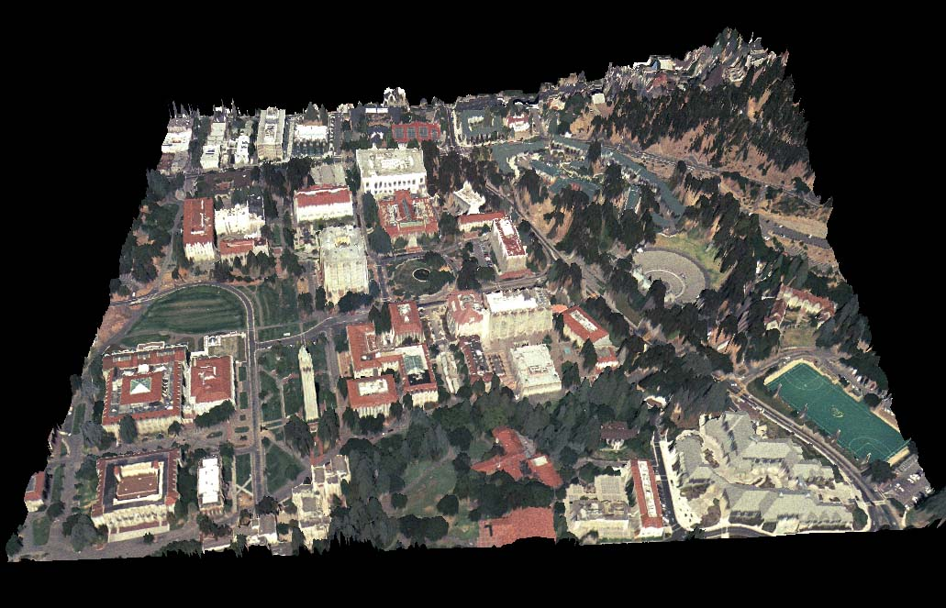
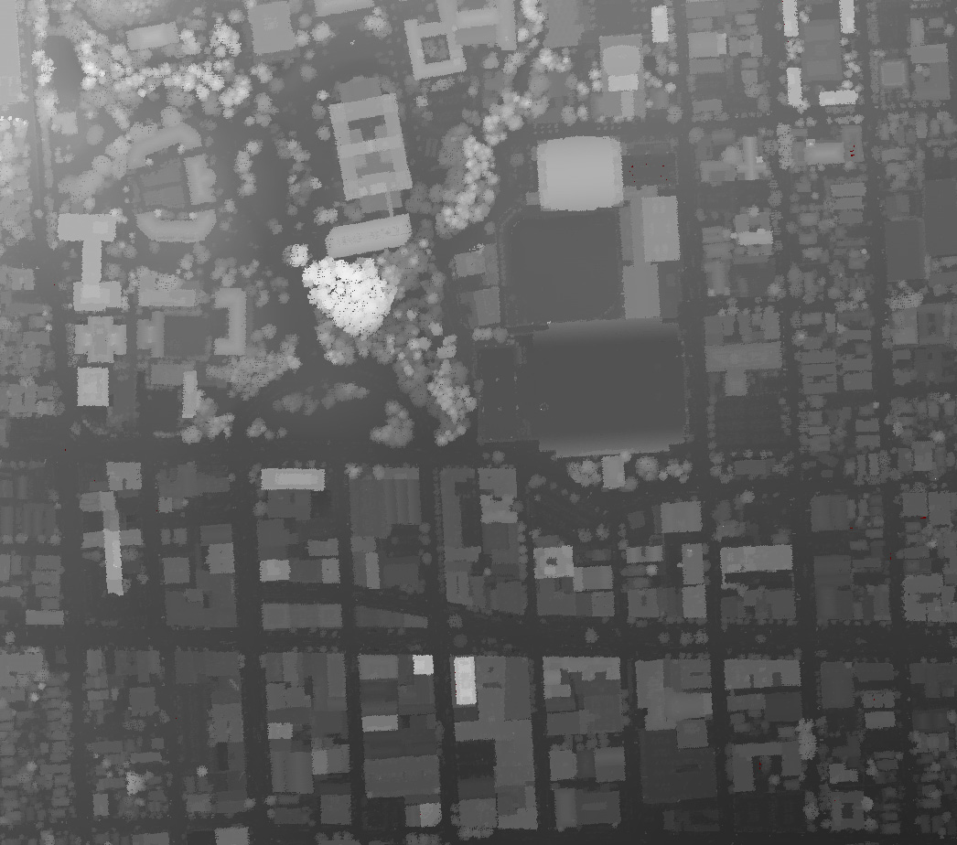
Our mobile data acquisition vehicle, which was described in details in the last progress report, can only capture facades visible from the street level, but not geometry behind the facades and the building roofs. In order to obtain a complete 3D city model for both walk and fly-thrus, it is necessary to capture this hidden geometry from airborne views. In cooperation with Airborne 1 in Los Angeles, we have acquired airborne laser scans of Berkeley. Since this data is not in a regular row-column-fashion, we have developed algorithms for resampling the data by sorting all 3D scan points into a rectangular grid. We fill grid cells without a scan point with the height value of their closest neighbors, and assign grid cells with multiple scan points the highest value. The result is a dense height field similar to a map, as shown in Figure 1, with a resolution higher than one meter. The brightness of each pixel is proportional to its height above sea level. This height map can be used for global position correction of the vehicle, using the Monte-Carlo-Localization described later. Moreover, since the topology between neighboring grid cells is regular, it can directly be transferred into a 3D surface mesh by connecting adjacent grid cells. As many neighboring scan points are coplanar, the resulting mesh is oversampled and contains significantly more triangles than actually necessary to recover the geometry. In order to remove this redundant information, the surface mesh is simplified using the Qslim mesh simplification tool. The resulting mesh is texture mapped with an aerial image taken from the same area. Therefore, in a matter of few minutes for the entire downtown Berkeley, about 20 to 30 correspondence points are manually selected, and the camera pose from which the image was taken is automatically computed. Then, the texture coordinates for all mesh triangles are automatically calculated and finally the textured mesh can be exported in any desired 3D representation, e.g. a VRML model. Figure 2 shows a portion of the resulting 3D model. Visible is the east side of the Berkeley campus with the Campanile and Cory Hall.
Figure 1: Map-like depth image of downtown Berkeley
Figure 2: Airborne 3D model of east Berkeley campus

1.2 Full global 3D pose estimation
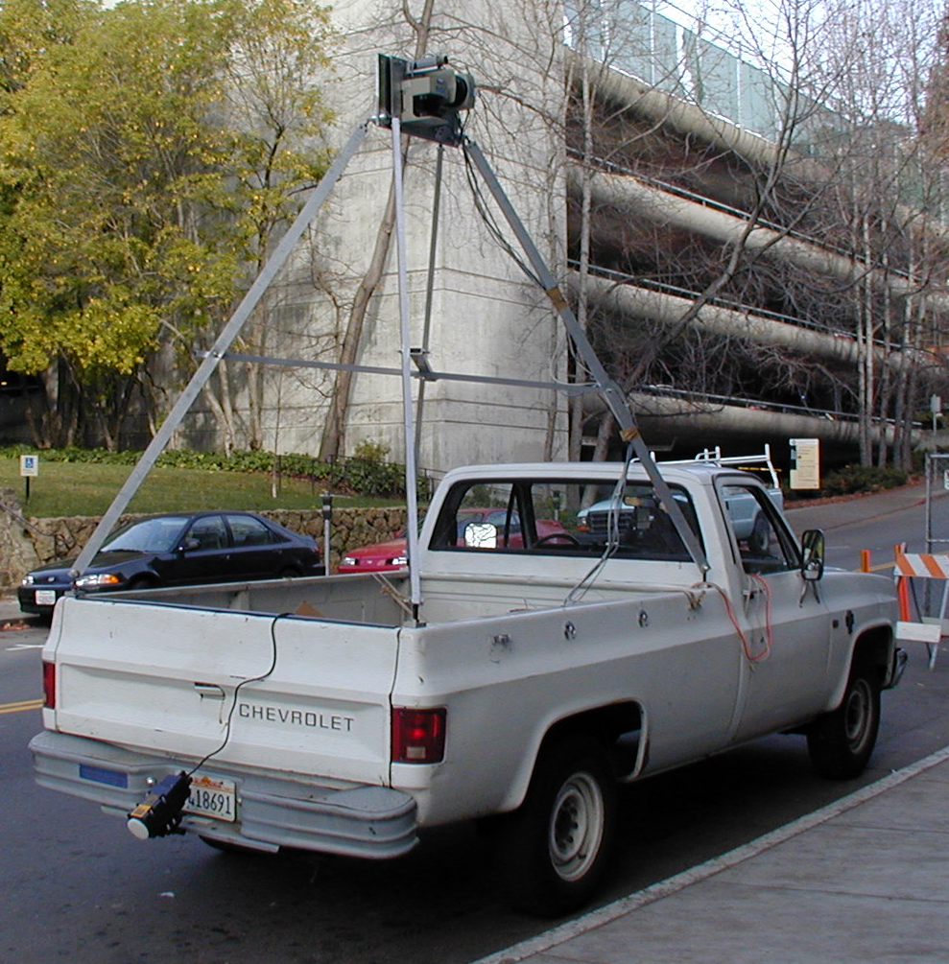
As described in the previous report, we have developed (a) data acquisition vehicle, shown in Figure 3, which is capable of capturing 3D geometry and texture from ground level, and (b) algorithms to estimate relative 2D position changes and global position corrections. We continued this work by creating an image based enhancement of our scan-to-scan matching algorithm. The original algorithm only computes a 2D pose estimate, i.e. 3 degree-of-freedom, since it assumes all motion is in a ground plane, and neglects vertical motion and rotation. This can cause problems when texture mapping the models, as can be seen in Figure 4 below. We have developed a method of estimating the missing 3 components of the vehicle motion using images, so that we obtain a full 3D motion estimate (6 degree-of-freedom) of the truck at all times. Our pose estimation algorithm exploits the fact that the scan points for a particular scan are visible in many images. For every image that is captured using our system, there is an associated horizontal and vertical laser scan recorded at exactly the same time as the image. There is a fixed transformation between the laser scanners and the camera. Thus, the 3D coordinates of the points from the laser scanners are known with respect to the coordinate system of the camera. The projections of these points can be identified in nearby views using image correlation and the relative rotation and translation between the nearby views can be estimated using a pose estimation algorithm that we have developed. Our algorithm is a generalization of Lowe’s algorithm that allows us to estimates the pose of many images simultaneously, minimizing the error the re-projection error across all images. We use RANSAC to ensure robustness.
Figure 3: Data acquisition vehicle

To demonstrate the effect of improved pose on the model quality, we created one model using only the original 2D pose and a second model using the full 3D pose. Seams can occur when the texture-mapping switches between consecutive images, if the transformation between consecutive images is not known accurately. When there is any vertical motion the scan matching algorithm cannot estimate, then the images do not match at the join. As shown in Figure 4(a) and (c), rolling motion of the vehicle causes clearly visible seams in the textured model, even though the computed 3 degrees-of-freedom are correct. In contrast, as shown in Figure 4(b) and (d), there are no seams with the enhanced full 6 degrees-of-freedom pose. The difference is particularly remarkable in hillside areas with numerous changes in slope.
(a)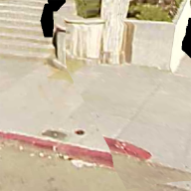 (b)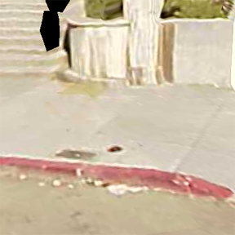 (c)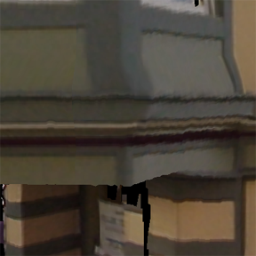 (d)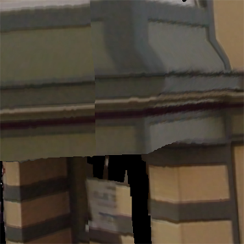
Figure 4: Effect of enhanced pose estimation on model quality; (a) and (c) using 2D pose; (b) and (d) using full 3D pose

While the above 3D pose estimation algorithm works well locally, slight inaccuracies in the relative 3D position estimates accumulate after long driving periods to result in significantly erroneous global pose estimates; these errors can propagate directly into the 3D model, if no global correction is applied. As described in the previous progress report, we have developed techniques to correct 2D global position errors of the data acquisition vehicle using aerial images. Among the developed techniques, Monte-Carlo-Localization (MCL), which represents vehicle position by a probability function, has been found to be robust even in the presence of perspective shifts; we have modified this technique for use in conjunction with the airborne height field described earlier. The airborne height field is not only more accurate than an aerial photo, since there is no perspective shift, but also provides 3D feature location rather than 2D as is the case in aerial images. We extract edges as height discontinuities, and use the derived edge map as the global map input for the MCL correction. Furthermore, we extend MCL to the third dimension, z, and compute an estimate of the ground level at the vehicle location by determining the nearby vertices with the lowest altitude and smoothing. Since our vehicle can only drive on the ground, its z coordinate is always identical to the ground level. We use this absolute position information to adjust the initial path estimate to the global reference by distributing corrections among the relative motion estimates. As a result, we obtain a path that not only has a full 3D position estimate, but also is automatically registered with the airborne height field. Since the airborne 3D model is derived from this height field, both 3D models are registered with respect to each other.
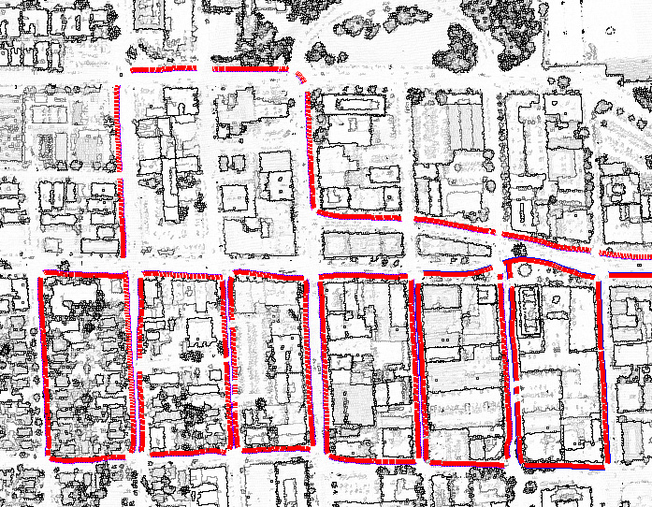
The amount of both, 3D geometry and texture, for the entire path is extraordinarily high: about 15 million scan points, 10 GB of texture data, for a 24-minute drive. Therefore, it is necessary to split the path into easy-to-handle segments and to process these segments individually. In order to segment the data into single city block sides, we detect curves and empty areas in the vertical scans and divide the path at these locations. As a result, we obtain multiple quasi-linear path segments registered with the airborne height field, as shown in Figure 5. These segments are individually processed using a set of post processing algorithms described in the next section.
Figure 5: Aerial edges overlaid with segmented path

  - Ground based model processing
We continued our work on ground based model generation by developing a framework to process the captured raw data in order to obtain visually appealing 3D façade models. Typical outdoor scenes are characterized by their complexity, and numerous foreground objects occlude building facades, and hence cause holes in the reconstructed model. We have developed algorithms that are able to reconstruct building facades accurately even in the presence of occlusions and invalid scan points, caused by multi-path reflections on glass surfaces. We first find dominant vertical building structures by histogram analysis over the scan points, as shown in Figure 6. Then we separate scan points into a foreground and a background layer, with the former containing objects such as cars, trees, pedestrians, street signs etc., and the latter containing the building facades we wish to reconstruct; we apply segmentation to the foreground objects and identify the corresponding holes in the background layer. With RANSAC algorithms, we detect whether vertices surrounding the holes are on planes and depending on this, we use different interpolation algorithms to fill the hole, i.e. planar interpolation for planar holes and horizontal/vertical interpolation if non-planar features extend over the holes. Next, we perform a vertex validation algorithm based on segmentation and the described histogram analysis algorithm to identify and remove invalid scan vertices due to reflecting glass surfaces, which are common in city environments. Finally, the entire mesh is cleaned up by filling small remaining holes and removing isolated regions not connected to building structures, and as a result we obtain a visually pleasing façade mesh, as shown in the bottom of Figure 7.
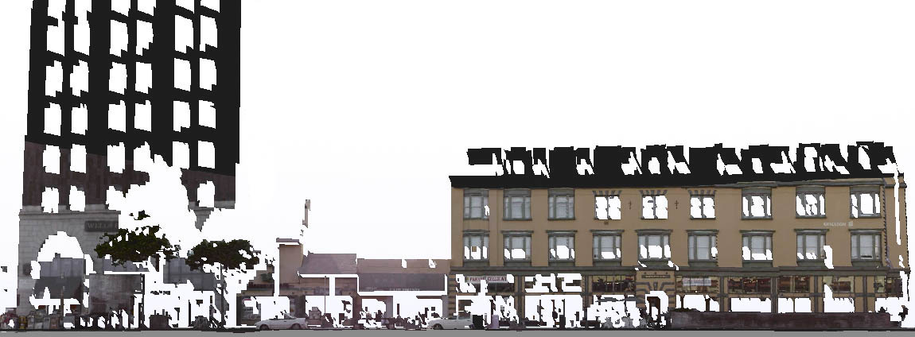

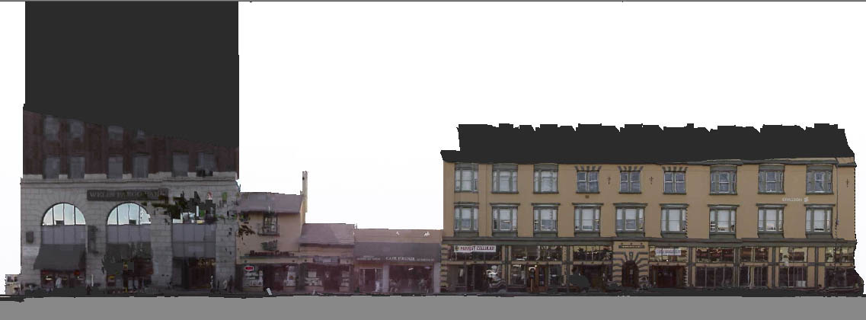
Figure 7: Facade mesh before and after processing

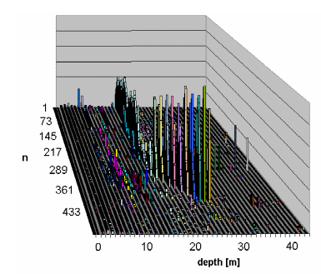
Figure 6: Histogram analysis of depth values
We have applied our façade mesh processing algorithms to a large set of data, i.e., 73 path segments, each with approximately the same size as the one shown in Figure 7, and have evaluated the results. Since the described algorithms require the presence of building structures, they cannot be applied to residential areas entirely consisting of trees, and hence we have developed a classification algorithm, which correctly identifies 10 of these segments as not-to-process. For the remaining 63 data segments, visual inspection has revealed 87% of the segments looked significantly better or better after applying our algorithms, whereas only 17% remained about the same quality and none of them appeared worse.
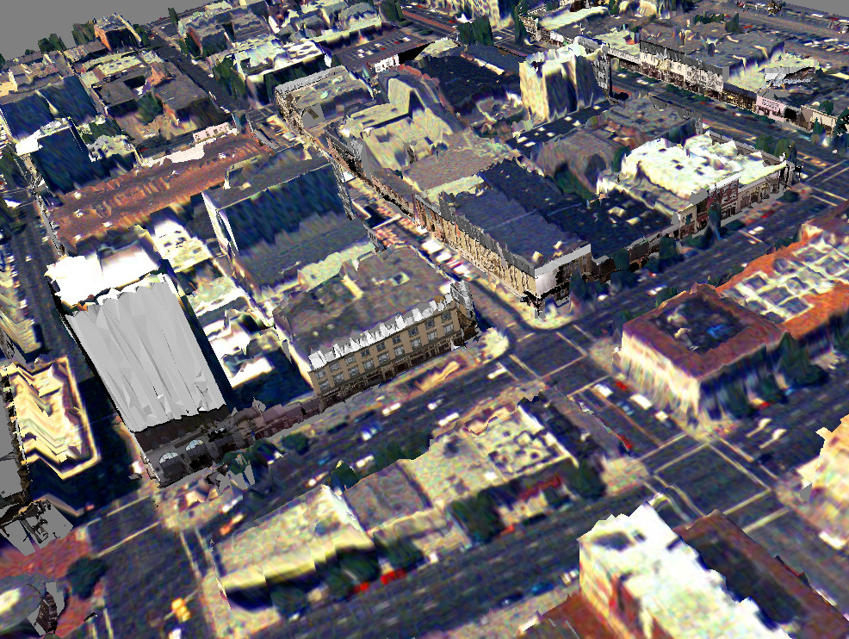
We have extended our initial texture mapping algorithm, which is based on projecting camera images on the corresponding 3D triangles, to correctly handle occlusion. After processing the geometry, we mark the objects identified as foreground in the camera images, and can hence detect whether a particular triangle is occluded in a particular camera image. For each triangle, we determine all camera images containing the triangle in its field of view, and exclude those images from texture mapping, where either the corresponding location is marked as occluded by foreground, or the brightness of the image suggests the camera has been in saturation because of blinding sunlight. From the remaining list of images, which can potentially all be used for texturing the triangle, we select the image with the largest pixel area. Finally, we compute a texture atlas, which is a compact representation of the multiple camera images used to texture map the model. For this compact, mosaic-like representation, we copy only those parts from each camera image into the atlas, which are actually used for texture mapping, and warp these parts to fit into the regular grid structure defined by the scanning process. Figure 8 shows an example of some of the original images and the resulting texture atlas. In this example, originally 61 pictures are combined to form one single atlas with a size similar to about 5 of the original images.
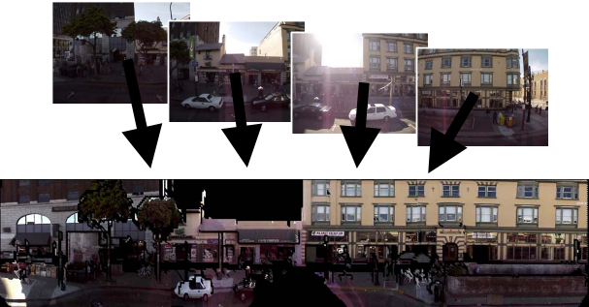
Figure 8: Texture Atlas
Figure 9: Facade meshes overlaid with airborne model of downtown Berkeley
In order to represent our façade models with as few triangles as possible, we apply Qslim simplification to compute multiple levels of details for the geometry. This, in conjunction with the efficient texture representation, reduces the size of our models drastically and allows us to render our models with off-the-shelf standard engines such as web-based VRML players. Since the MCL registers the facade models with respect to the airborne laser scans, both models fit together and can be overlaid as shown in Figure 9.

  - LiDAR data tessellation and model reconstruction
The group at USC also acquired, in cooperation with Airbornal Inc, the LDAR model of the entire USC campus and surrounding Coliseum Park. This 3D model data that has accuracy to sub-meter in ground position and cm in height is served as the base model on which we paint images and videos acquired from our roving tracked camera platform. Since the LiDAR data came in unorganized 3D point cloud that was defined in sensors or world coordinate system (ATM - Airborne Topographics Mapper), we processed the raw data for grid re-sampling, hole filling and geometry registration, to reconstruct a continuous 3D surface model. In our work, we adopted the triangle meshes as the 3D geometric representation. We feel confident that we can many benefits from this representation. First, triangle meshes can easily be converted to many other geometric representations, whereas the reverse is not always true. Second, many level-of-detail techniques operate on triangle meshes. Third, photometric information can be easily added to the data in the form of texture projections, and finally, most graphics hardware directly supports fast image creation from triangle meshes.
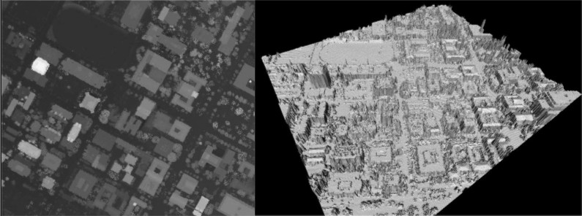
We have implemented above strategies as a preprocessing module in our visualization testbed. With the raw point cloud as input, the system automatically performs all the necessary processes and outputs the reconstructed 3D model in VRML format. Figure 10 shows a snapshot of the applying the system to process our USC campus LiDAR dataset. The left image is the reconstructed range image from the unorganized 3D point cloud, and the right one shows the reconstructed 3D model.
Figure 10 - LIDAR data acquired for USC campus: (left) reconstructed range image, and (right) reconstructed 3D model.

1.5 Real time video texture projection
We developed the approach for real-time video texture projection. Given the calibrated camera parameters, we can dynamic “paint” the acquired video/images onto the geometric model in real-time. In the normal texture mapping, the textures for each polygon are described by a fixed corresponding polygon in an image. Since the corresponding relationships between models and texture are pre-computed and stay fixed, in this case, it is impossible to update new texture image without preprocessing. In contrast, the texture projection technology mimics the dynamic projection process of the real imaging sensor to generate the projected image in the same way as the photo reprinting. In this case, the corresponding transformations between models and texture are computed and updated dynamic based on the relationships of projective projection. Texture images are generated by a virtual projector with known imaging parameters. Moving the model or sensor will change the mapping function and image for a polygon, and also change the visibility and occlusion relationships that make the technology well suited for dynamic visualization and comprehension of data from multiple sensors.
We have implemented a rendering testbed based on the projection approach and hardware acceleration engine of GPU graphics card with supports fast image creation from pixel shaders. We can project real-time video or imagery files onto 3D geometric models and produce visualizations from arbitrary viewpoints. The system allows users to dynamic control during visualization session, such as viewpoint, image inclusion, blending, and projection parameters. Figure 11 illustrates two snapshots of our experimental results. The left image shows the aerial view of a texture image is projected on a 3D LiDAR model (campus of Purdue University, for which we have the aerial texture image coming with the LiDAR dataset), and the right one shows façade view of the video texture is projected on the USC LiDAR building model. For this building model, we manually segmented one target building from our LiDAR dataset and reconstructed its 3D geometric model. We captured the video and tracking data with our portable data acquisition system around the target building, and then fed the model, video sequence and tracked pose information to the rendering system to generate the visualizations from arbitrary viewpoints.
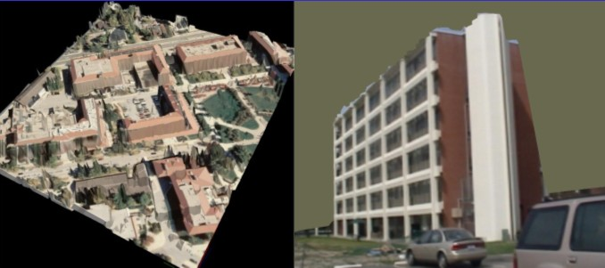
Figure 11 – Image/video textures are projected onto 3D LiDAR models: (left) aerial view of projected image texture (campus of Purdue University), and (right) façade view of the video texture is projected on the USC LiDAR building

Our rendering system also supports multi-texture projectors that simultaneously visualize many images projected on the same model. This feature enables the comprehension of data from multiple sensors. For example, image data (of multiple modalities) are potentially available from any and all different kind platforms and sensors (mounted and dismounted personnel, unmanned vehicles, aerial assets, and databases). As these arrive to a command center, painting them all on a base or reference model makes them immediately comprehendible. Figure 14 illustrates the results of two sensors are projecting onto one model. The first projector (sensor-1) view provides useful “footprint” information about global and building placements, while the second sensor (sensor-2) view potentially provides details of interested building.

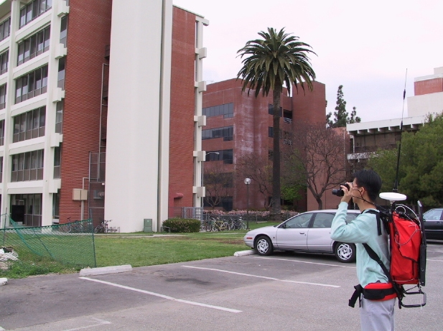
- Tracking and Calibration
Figure 12 – System was used for data acquisition around USC campus
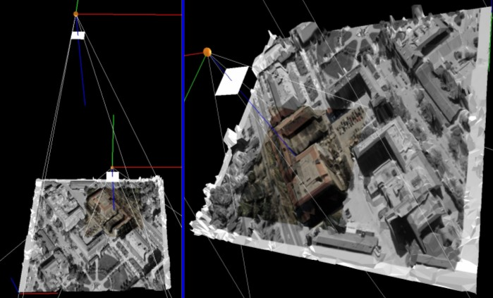
Figure 14 – Two images from different sensors are projected onto a model that makes the visualization more comprehendible
Sensor-2
Sensor-2
Sensor-1
2.1 Sensor fusion for outdoor tracking
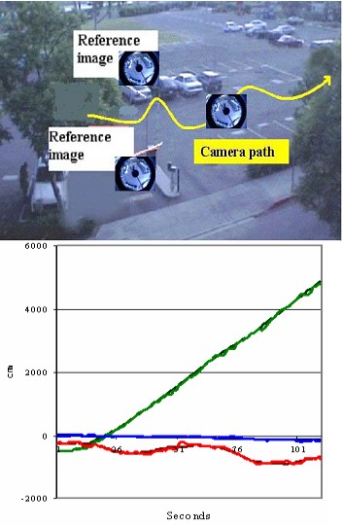
Tracking is a critical component in the process of data acquisition and dynamic visualization. Since we consider the case where images/video/data from different sensor platforms (still, moving, aerial), A tracking device attached to the sensors allows the sensors to be moved around the scene for data fusion and projection. Tracking is also necessary for data registration and assembly during the model reconstruction phase. Two systems have been developed for outdoor and indoor experiments with the complete systems for both data (image/video) acquisition and display (as augmented reality overlays). The first system is complete self-contained portable tracking package consisting of a high resolution stereo camera head, differential GPS receiver, 3DOF gyro sensor, and a laptop computer.
The stereo head equipping two high resolution digital cameras using Firewire (IEEE 1394) interface to the laptop computer. The dual cameras configuration has multi-purposes, e.g. one channel (left) of the acquired video streams will be used for video texture projection and vision tracking processing, while the both stereo streams are used to feed in a real-time stereo reconstruction package for detailed façade reconstruction. The integrated GPS and gyro sensors are used for tracking 6DOF (degree-of-freedom) pose. We developed data fusion approach to fuse and synchronize those different timing data streams. Our approach is to compensate for the shortcomings of each sensing technology by using multiple measurements to create continuous and reliable tracking data.
The whole system is complete self-contained including all the sensor modules, a laptop computer and two batteries packaged into a backbag weighted ~15LB allows us to move freely (relatively) around gathering image, video, and data (Figure 12). The system runs in real-time (all the data streams are synchronized to 30Hz video rate) including display and capturing data to the hard-disk. The system also includes a media rendering software allows user to playback and verify the captured data streams. We have conduced outdoor experiments with the system for both data acquisition and display (as augmented reality overlays) on the LiDAR base model we have.
Figure 13 – Tracking with panoramic camera: working space of the outdoor experiment conducted at USC campus (top), and the estimated positions compared with GPS (bottom). The Green, red and blue color indicate x, y, z values. Darker and lighter colors describe GPS measures and estimates respectively.
The second tracking system we developed is based a novel panoramic (omni-directional) imaging system. Currently, most vision based pose tracking methods require a priori knowledge about the environment. Calibration of environment is often relied on several pre-calibrated landmarks put in the work space to collect the 3D structure of environment. Attempting to, however, actively control and modify an outdoor environment in this way is unrealistic, which makes those methods impractical for outdoor applications. We emphasized this problem by using a new omni-directional imaging system (which can provide a full 360-degree horizontal viewing) and a RRF (Recursive Rotation Factorization) based motion estimate method we developed. We have tested our system on both indoor and outdoor environment with wide tracking range. Figure 13 illustrates the outdoor experiment with actual workspace and results. Compared with GPS measures, the estimated position accuracy is about thirty-centimeter with tracking range up to 60 meters.

2.2 6DOF Auto-calibration technology
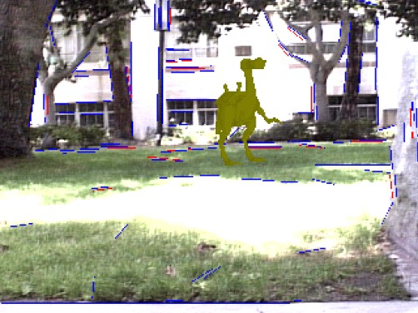
We extended our point based auto-calibration technology to line feature. The new algorithm can automatically estimate 3D information of line structures and camera pose simultaneously. Since the lines or edges are dominant features of man-made strictures, we should make full use of them for tracking and modeling. We will used both those features for computing/refining camera pose and refining structure based on auto-calibration of line/edge features. First, auto-calibration of the tracked features (points and lines) provides the necessary scale factor data to create the 6th DOF that is lacking from vision. It also provides absolute pose data for stabilizing the multi-sensors data fusion. Since all the vision-tracked features have variable certainty in terms of their 2D and 3D (auto-calibrated) positions, adaptive calibration and threshold methods are needed to maintain robust tracking over longer periods. Second, the auto-calibration of structure features (point, line and edge) can provide continually estimates of 3D position coordinates for feature structures. The tracked feature positions are iteratively refined till the residual error reach minimum. Combining the auto-calibration and image analysis technologies, we intend to be able to refine the dominant features of model acquired from LiDAR or other sensors. Figure 15 illustrates a result of applying the line auto-calibration algorithm to an outdoor scene. The camera pose and 3D structure of tracked line features (marked as Blue line) are estimated simultaneously. Based on the estimated pose, a 3D graphics dinosaur model is inserted into the real scene.
Figure 15 – auto-calibration of line feature: the camera pose and 3D structure of tracked line features (marked as Blue line) are estimated simultaneously. Based on the estimated pose, a 3D graphics dinosaur model is inserted into the real scene

3.Visualization and User Interface

3.1 Situational Visualization

We introduced a new style of visualization called “situational visualization”, in which the user of a robust, mobile networked visualization system uses mobile computing resources to enhance the experience, understanding, and awareness of the surrounding world. In addition the situational visualization system allows the user to the visualization, its database, and any underlying simulation by inputting the user’s observations of the phenomena of interest, thus improving the quality of the experience for the user and for any other users that may be connected through the same database. Situational visualization is structured to allow many users to collaborate on a common set of data with real-time acquisition and insertion of data.

An attribute of situational visualization is that data can be received all the time, either in discrete or streaming form. The method’s interactivity requirement means that these data must be readily available when received. To meet these needs, we have built an appropriately tailored universal hierarchy. For geospatial data this leads to a global forest of quadtrees, which we have shown can handle a wide variety of data including terrain, phototextures and maps, GIS information, 3D urban data, and time-dependent volume data (e.g., weather). For collaborative situational visualization, this structure must be distributed and synchronized since any user may be collecting and putting data into her own database, which must then be synchronized with databases of her peers. The synchronization mechanism is illustrated in Figure 16. Three types of peers are defined, each with different attributes: neighbors, servers, and collaborators. Neighbors are the set of all peers who may communicate; servers are neighbors with large repositories of data at defined locations; and collaborators are neighbors who are in active communication. This structure and the applications described briefly below are discussed more fully in the Situational Visualization paper listed in Item 1 above.
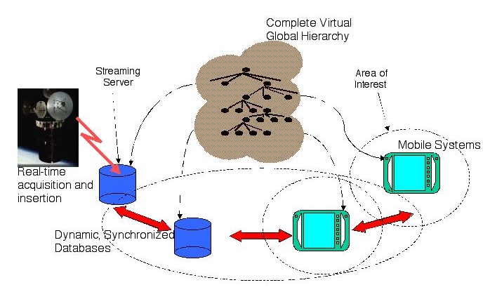
Fig. 16. Distributed databases for collaboration. The two mobile systems on the right have overlapping areas of interest.
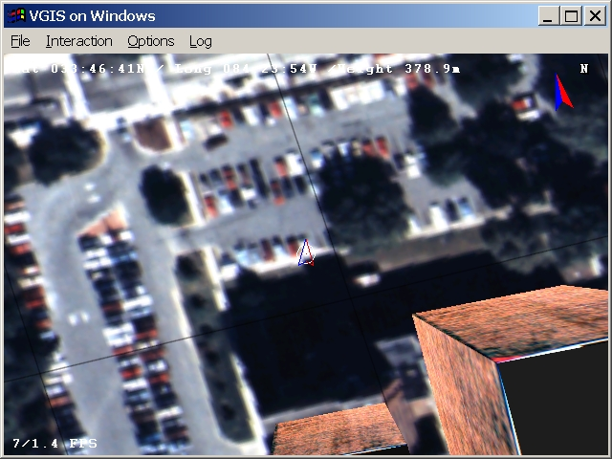
Fig. 17. Screenshot of situational visualization application with GPS-tracked user. Arrow indicates position of user.
Our prototype situational visualization system consists of a set of central computers and a mobile system. All systems are connected by an 802.11b WaveLan wireless network. To reach mobile users, WaveLan antennas have been mounted on the exteriors of buildings. A nominal 11 Mb Ethernet runs on the wireless network. The mobile user carries a GPS, which sends position updates to the system, and will ultimately also carry an orientation tracker. Our initial location finding and awareness application simply locates the user’s position and direction of movement in the database and displays this information on an overhead view with continuous updates (Figure 17). This application works well for a user walking around a campus area. Another application provides awareness of atmospheric conditions. We have used this in an emergency response exercise for a terrorist attack involving release of a toxic gas into the atmosphere. The initial exercise involved visualization of static images of the spreading gas cloud sent from a central computer to the mobile system. A future version of this application will provide the user with full interactivity including updates of the spreading gas cloud and of positions of other emergency responders from his own position. A generalization of this application will provide pinpointed weather forecasts to mobile users based on their current positions or where they are going.

3.2 User Studies of Multimodal Interface
Situational visualization and other mobile or pervasive visualization applications provide interaction challenges. Users may be standing, moving, encumbered, or away from desktop surfaces. In any of these cases, traditional mouse and keyboard interfaces may be unavailable or unusable. Furthermore the user may be attending to other tasks, spreading her cognitive resources thinly. Yet the mobile or pervasive system will be an ever-richer source of information and decision-support tools. To meet these challenges we have developed a speech and gesture multimodal interface as an alternative to the traditional mouse and keyboard interface. We have recently evaluated this interface for a navigation task using our VGIS global visualization system. This is the sort of task that users will often undertake, where they fly from some high level overview to a detailed ground-level view to find, identify, and observe an item of interest.

The multimodal system we have developed includes a gesture pendant camera worn on the chest by the user, which communicates with our mobile laptop visualization system. The gesture pendant is surrounded by an array of infrared lights and contains a camera with an infrared filter (Figure 18). Human skin, whatever the color, clearly reflects infrared light, and the system can be used even in ambient visible light. The user interacts through a collection of finger input gestures as shown in Fig. 4. A set of image processing and recognition software on a Linux machine does the recognition. Concurrently speech recognition software (Microsoft Speech API) running on a PC collects voice commands. By restricting the vocabulary, the speech software can be used without training; the gesture commands require a small amount of training.
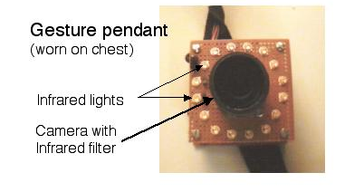
Fig. 18. Gesture pendant.
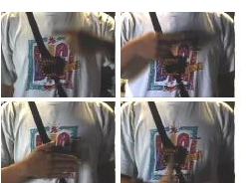
Fig. 19 Hand gestures involving a moving finger in different orientations or an open hand.
The experiment compared the effect of a single variable (interface type: mouse, multimodal, speech only, or gesture only) on a variety of objective (e.g., task completion time and object recall) and subjective tests (e.g., ease of use, overall effective interface). Users were required to navigate to 4 different targets. Each target was associated with a unique symbol. The time needed to reach each target was recorded, and participants were given a memory test to determine remembrance of symbols they saw, the order in which they were seen, and where they were located. Each participant began in a stationary position about 12,000 KM above North America and navigated to a white cube placed above a particular area (e.g., Lake Okeechobee in Florida). As the participant got closer, the cube changed to reveal the symbol. Several panning and zooming interactions were typically needed for each navigation. The user study involved 24 students from an undergraduate computer games design course. The participants were male and most had experience with 3D graphics in gaming. Some had used speech recognition, but none had used a multimodal interface.

The general results were as follows:
- Mouse interface has best performance, then speech alone, multimodal, and gesture alone.
- When mouse is not available or easy to use, a speech interface is a good alternative for navigation tasks.
- Better, faster recognition of gestures could significantly improve performance of the multimodal interface.
Although the mouse interface was the winner in this evaluation, the speech interface would be a good alternative, for the type of task tested, when the a mouse is not available. However, a multimodal interface, which performed about as well in several measures though not in overall user preference, might be superior for more complicated tasks. The experiment showed clearly where improvements could be made in the gesture interface. These had to do with better recognition of the gestures (fewer errors), faster response, and a better choice of gestures for interaction. With these improvements the results of the user study could be significantly different. We plan some follow-on studies to test this hypothesis.
- Uncertainty Visualization

As we move into a high performance time-critical distributed computing and data analysis environment, the issue of credibility of the models, the simulations, the visualizations, the data sources, time-dependence of information, and the hidden assumptions behind decision-making processes for the end-users become paramount. This proposal seeks to address the issue of credibility in visualizations and decision-making processes emerging from a mobile augmented battlespace visualization system.

Our vision is that all information and decisions should include a measure of confidence. This measure of confidence, or uncertainty, may be encoded directly with the visualization, or it may be provided to the user in another form.

This part of the project focuses on creating a common uncertainty paradigm for computing and visualizing distributed data from various sources in a mobile battlespace system. These uncertainty mappings will also be tested through user evaluation.

4. 1 Computation and Visualization of Uncertainty for Terrains

Here we include a brief summary of our efforts on computing and visualizing uncertainty related to compressed terrains. In this example, we study the uncertainty arising due to compression of large terrain data sets. We present an algorithm for compressing terrain data that preserves topology. We use a decimation algorithm that simplifies the given data set using hierarchical clustering. Topology constraints along with local error metrics are used to ensure topology preserving compression and compute precise error bounds in the compressed data. Earth's mover distance is used as a global metric to compute the degradation in topology as the compression proceeds. Experiments with both analytic and real terrain data
are presented. Results indicate that one can obtain significant compression with low uncertainty without losing topology information. During the first year of effort, we focused on preserving point features such as high points, low points, or transition points. During the second year of effort, we have extended the results to line features such as isocontours or polyline data that may be relevant in a battlespace scenario. Since global uncertainty computation for preserving line features is very expensive, we have designed an approximate local computation algorithm that works well in practice.

4.2 Multimodal means to convey uncertainty using sound

Here we include a summary of results of user testing for conveying uncertainty of multidimensional fuzzy data using vision and sound. We have created a multimodal data exploration tool that allows for the visualization and sonification (non-speech sound) of multidimensional uncertain fuzzy data in an interactive environment. Multidimensional fuzzy data typically result from (a) measuring qualities or features of real world objects or (b) the output of multivariate statistical analysis. The uncertain fuzzy data set was visualized with a series of 1D scatter-plots that differed in color for each category. Sonification was performed by mapping three qualities of the data (within-category variability, between category variability, and category identity) to three sound parameters (noise amplitude, duration, and pitch). An experiment was conducted to assess the utility of multimodal information compared to visual information alone for exploring this multidimensional data set. Tasks involved answering a series of questions to determine how well each feature or a set of features discriminate among categories, which categories are discriminated and how many. Performance was assessed by measuring accuracy and reaction time to 36 questions varying in scale of understanding and level of dimension integrality. Scale varied at three levels (ratio, ordinal, and nominal) and integrality also varied at three levels (1, 2 , and 3 dimensions). A between-subjects design was used by assigning subjects to either the multimodal group or visual only group. Results showed that accuracy was better for the multimodal group as the number of dimensions required to answer a question (integrality) increased. Also, accuracy was 10% better for the multimodal group for ordinal questions. Based on this experiment alone, it seems that sonification provides useful information in addition to that given by visualization, particularly for representing more than two dimensions simultaneously.

4.3. Uncertainty-Driven Target Tracking

We have created visualization of uncertain information associated with target tracking in collaboration with Syracuse University. As a first step, we have modeled the uncertainty associated with the location and velocity of targets as probability distributions. We have visualized the uncertain location of the target as a blob, which can be tracked over time. We discuss the algorithmic complexity of the algorithm for uncertainty computation, and ways to improve its performance. Three visualization techniques (galaxy, transparency, and pseudo-color) are developed to represent the resulting probability distribution associated with the particle at a later time. An appropriate time-dependent sampling approach is adopted to make the visualizations more comprehensible to the human viewer. Experiments with different distributions indicate that the resulting visualizations often take the form of recognizable real-world shapes, assisting the user inunderstanding the nature of a particle's movement.

4.4 Spatio-Temporal GPS Uncertainty within a GIS Environment

Importance of accurate registration of GPS (Global Positioning System) tracked objects embedded within a GIS (Geographic Information Systems) context has emerged as a critical need in several land, marine, and air navigational systems both for civilian and defense applications. is to measure, model and geo-spatially register the positional accuracy of objects carrying GPS receivers against a GIS background. Although positional accuracy is affected by a number of factors, in this work we have focused on GPS modes (standalone or differential), type of environment (urban or foliage), and type of expected movement of objects. The Ashtech Z-12 sensor is used to collect the data. Linear models are used to estimate the errorsassociated with the horizontal position information. This error is then visualized upon a 1/2 foot resolution aerial imagery of the UCSC (University of California, Santa Cruz) campus. Estimates of speed and direction errors are used to create visualizations of spatio-temporal uncertainty associated with an object walking through the campus.

4.5 Embedding Uncertainty within VGIS

This effort required collection, rectification, and registration of various GIS data sets related to Santa Cruz region. We now have many different types of GIS data sets including ½ foot resolution imagery data, elevation data, detailed AUTOCAD drawings, street maps, and LIDAR data for parts of this region. We have also successfully inserted the imagery and elevation data within the VGIS (Virtual Geographic Information System) developed at the Georgia Institute of Technology. We are currently engaged in embedding the visualization of mobile targets within the VGIs system.

5. Information Fusion and Target Uncertainty Visualization

Modern command and control systems are supported by high performance time-critical distributed computing and data analysis environments consisting of fixed as well as mobile nodes. It is imperative that most accurate information along with associated uncertainties be provided to analysts for improved situation awareness. Issues of target detection, target tracking, decision-making, and time-dependence of information are of paramount importance. This task of the MURI project addresses the issue of information fusion and decision-making processes for a mobile augmented battlespace visualization system.

Our vision is that all information and decisions provided to an analyst should include a measure of confidence. This measure of confidence, or uncertainty, may be encoded directly with the visualization, or it may be provided to the user in another form. Uncertainty representation and computation for information processing systems along with visualization of uncertainty can be viewed as illustrated below.

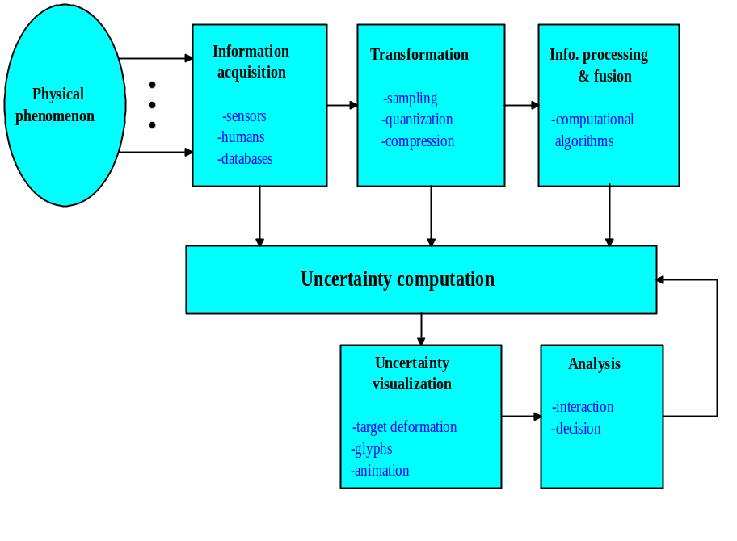Figure 20: Information Pipeline for Uncertainty Computation and Visualization

The target uncertainty can be in any form of the following: probability of miss detections, probability of false alarms, the estimation errors of the target location, velocity, distortion and error incurred by quantization and compression, etc. A system usually consists of multiple nodes or sensors. The information gathered by different nodes should be processed and finally fused in either distributed manner or centralized manner to reduce the uncertainty about the target(s).

Research is being carried out along several directions, especially on temporal aspects of information fusion. Progress on each of these thrusts is briefly discussed below.

1. The sequential detection problem is investigated in a distributed sensor network under bandwidth constraints. Assignment of incremental bandwidth to more informative sensors is found to result in better performance in terms of average sample number (ASN). With more bandwidth available, the performance in terms of ASN can be improved by better allocation of bandwidth among sensors. If both bandwidth and decision latency costs are considered, there exists an optimum tradeoff point between them to minimize the generalized cost. A system optimization algorithm is developed, including both the optimal fusion center design and optimal local quantizer design.

2. For a multi-sensor tracking system, the effects of temporally staggered sensors are investigated and compared with synchronous sensors. To make fair comparisons, a new metric, the average estimation error variance, is defined.

Many analytical results are derived for sensors with equal measurement noise variance. Temporally staggered sensors always result in a smaller average error variance than synchronous sensors, especially when target is highly maneuvering (with high maneuvering index). The higher the target-maneuvering index is, the more we can benefit by using temporally staggered sensors. The corresponding optimal staggering pattern is such that the sensors are uniformly distributed over time.

For sensors with different measurement noise variances, the optimal staggering patterns have been found numerically. Intuitive guidelines on selecting optimal staggering pattern have been presented for different target tracking scenarios.

In addition, we have studied the realistic scenarios where false alarms and missed detections exist. Again, the simulation results are in favor of the system with temporally staggered sensors in terms of both average in-track time and average estimation variance.

3. A new temporal update mechanism for decision making with aging observations is developed based on the evidence propagation rule in Bayesian network. The time delay effect can be modeled by introducing an additional node between target and evidence nodes. The decay coefficient is linear when time delay is within certain time interval, and exponential after that.

This mechanism is implemented by using Matlab. The program has a friendly graphic user interface which will lead user finish the required input, and then will identify the structure of the network (and simplify it if necessary), perform the belief updating calculation and display the result graphically. The program is flexible: it allows user to specify all the factors in the beginning or change it later. It can also simulate the temporal effect as the function of time. The results from the Matlab program are reasonable and consistent. From this implementation we can draw the conclusion that the temporal update mechanism we proposed is reasonable.

6. Technology Transfer, Transitions and Interactions

1. Interactions with AFRL Information Directorate, Raytheon, Lockheed-Martin, Sensis Corp., and Andro Computing Solutions took place.

2. Presentation of mobile emergency response application to President Bush and Governor Ridge
Presentation of situational visualization and mobile battlefield applications to Paul Dumanoir and Pamela Woodard, program directors at STRICOM in Orlando.

3. Marine exercise—have done some work in developing full 3D model, trees, etc. Displayed results on laptop with GIS positioning. Started working on mesoscale weather simulation (MM5). Eventually will be steered based on current weather conditions. Planning for a new exercise and preparation for a new funded phase.
4. Rhythm & Hues Studio (Los Angeles CA) software evaluation - using tracking methods and software for commercial applications.
5. Olympus America (New York) software evaluation - using tracking methods and software for commercial applications.
6. Boeing (Long Beach CA) for training - using tracking methods and software for DOD and commercial applications.
7. Briefings and demonstrations to industry are part of IMSC partnership program at USC. Over calendar year 2001, 2002, IMSC hosted over 470 visitors from companies and government agencies.
Dr. Jong Weon Lee (PhD, 2002) was hired at the IMSC, University of Southern California.
7. Briefings and demonstrations to Bosch, Palo Alto, CA, on mobile visualization of city models for car navigations;
8. Briefings and demonstrations to Sick, Inc, Bloomington, MN; received laser scanners for 3D modeling activities;
9. Collaborated with HJW, Oakland, CA to receive high resolution, color aerial photos of Berkeley for 3D modeling activities;

- Personnel

William Ribarsky, Principal Research Scientist
Nickolas Faust, Principal Research Scientist
Weidong Shi, Graduate Student Researcher
Olugbenga Omoteso, Graduate Student Researcher
Guoquan (Richard) Zhou, Graduate Student Researcher
Jaeil Choi, Graduate Student Researcher
Prof. Pramod K. Varshney,
Prof. Kishan G. Mehrotra,
Prof. C.K. Mohan,
Dr. Ruixin Niu,
Qi Cheng, Graduate Student Researcher
Zhengli Huang, Graduate Student Researcher
Jie Yang, Graduate Student Researcher
Prof. Ulrich Neumann
Dr. Suya You, Postdoctoral Researcher
Jinhui Hu , Graduate Student Researcher
Prof. Suresh Lodha
Amin P. Charaniya, Graduate Student Researcher
Nikolai M. Faaland, Undergraduate Student
Srikumar Ramalingam, Graduate Student Researcher
Prof. Avideh Zakhor
Chris Frueh, Graduate Student Researcher
John Flynn, Graduate Student Researcher
Ali Lakhia, Graduate Student Researcher
Siddarth Jain, Graduate Student Researcher
Lu Yi, Undergraduate Student

- Publications

C. Früh and A. Zakhor, "3D model generation for cities using aerial photographs and ground level laser scans", Computer Vision and Pattern Recognition, Hawaii, USA, 2001, p. II-31-8, vol.2.

H. Foroosh, “ A closed-form solution for optical flow by imposing temporal constraints”, Proceedings 2001 International Conference on Image Processing, vol.3, pp .656-9.

C. Früh and A. Zakhor, "Data processing algorithms for generating textured 3D building façade meshes from laser scans and camera images”, accepted to 3D Data Processing, Visualization and Transmission, Padua, Italy, 2002

John Flynn, “Motion from Structure: Robust Multi-Image, Multi-Object Pose Estimation”, Master’s thesis, Spring 2002, U.C. Berkeley

S. You, and U. Neumann. “Fusion of Vision and Gyro Tracking for Robust Augmented Reality Registration,” IEEE VR2001, pp.71-78, March 2001
B. Jiang, U. Neumann, “Extendible Tracking by Line Auto-Calibration,” submitted to ISAR 2001
J. W. Lee. “Large Motion Estimation for Omnidirectional Vision,” PhD thesis, University of Southern California, 2002
J. W. Lee, B. Jiang, S. You, and U. Neumann. “Tracking with Vision for Outdoor Augmented Reality Systems,” submitted to IEEE Journal of Computer Graphics and Applications, special edition on tracking technologies, 2002

William Ribarsky, “Towards the Visual Earth,” Workshop on Intersection of Geospatial and Information
Technology, National Research Council (October, 2001).

William Ribarsky, Christopher Shaw, Zachary Wartell, and Nickolas Faust, “Building the Visual Earth,” to
be published, SPIE 16th International Conference on Aerospace/Defense Sensing, Simulation, and Controls
(2002).

David Krum, William Ribarsky, Chris Shaw, Larry Hodges, and Nickolas Faust “Situational
Visualization,” pp. 143-150, ACM VRST 2001 (2001).

David Krum, Olugbenga Omoteso, William Ribarsky, Thad Starner, and Larry Hodges “Speech and
Gesture Multimodal Control of a Whole Earth 3D Virtual Environment,” to be published, Eurographics-
IEEE Visualization Symposium 2002. Winner of SAIC Best Student Paper award.

William Ribarsky, Tony Wasilewski, and Nickolas Faust, “From Urban Terrain Models to Visible Cities,”
to be published, IEEE CG&A.

David Krum, Olugbenga Omoteso, William Ribarsky, Thad Starner, and Larry Hodges “Evaluation of a
Multimodal Interface for 3D Terrain Visualization,”submitted to IEEE Visualization 2002.

C. K. Mohan, K. G. Mehrotra, and P. K. Varshney, ``Temporal Update Mechanisms for Decision Making with Aging Observations in Probabilistic Networks’’, Proc. AAAI Fall Symposium, Cape Cod, MA, Nov. 2001.

R. Niu, P. K. Varshney, K. G. Mehrotra and C. K. Mohan, `` Temporal Fusion in Multi-Sensor Target Tracking Systems’’, to appear in Proceedings of the Fifth International Conference on Information Fusion, July 2002, Annapolis, Maryland.

Q. Cheng, P. K. Varshney, K. G. Mehrotra and C. K. Mohan, ``Optimal Bandwidth Assignment for Distributed Sequential Detection’’, to appear in Proceedings of the Fifth International Conference on Information Fusion, July 2002, Annapolis, Maryland.

Suresh Lodha, Amin P. Charaniya, Nikolai M. Faaland, and Srikumar Ramalingam, "Visualization of Spatio-Temporal GPS Uncertainty within a GIS Environment" to appear in the Proceedings of SPIE Conference on Aerospace/Defense Sensing, Simulation, and Controls, April 2002.

Suresh K. Lodha, Nikolai M. Faaland, Amin P. Charaniya, Pramod Varshney, Kishan Mehrotra, and Chilukuri Mohan, "Uncertainty Visualization of Probabilistic Particle Movement", To appear in the Proceedings of The IASTED Conference on Computer Graphics and Imaging", August 2002.

Suresh K. Lodha, Amin P. Charaniya, and Nikolai M.Faaland, "Visualization of GPS Uncertainty in a GIS
Environment", Technical Report UCSC-CRP-02-22, University of California, Santa Cruz, April 2002, pages 1-100.

Suresh K. Lodha, Nikolai M. Faaland, Grant Wong, Amin Charaniya, Srikumar Ramalingam, and Arthur Keller, "Consistent Visualization and Querying of Geospatial Databases by a Location-Aware Mobile Agent", In Preparation, to be submitted to ACM GIS Conference, November 2002.

Suresh K. Lodha, Nikolai M. Faaland, and Jose Renteria, ``Hierarchical Topology Preserving Simplification of Vector Fields using Bintrees and Triangular Quadtrees'', Submitted for publication to IEEE Transactions on Visualization and Computer Graphics.

Lilly Spirkovska and Suresh K. Lodha, ``AWE: Aviation Weather Data Visualization Environment'', Computers and Graphics, Volume 26, No.~1, February 2002, pp.~169--191.

Suresh K. Lodha, Krishna M. Roskin, and Jose Renteria, ``Hierarchical Topology Preserving Compression of 2D Terrains'', Submitted for publication to Computer Graphics Forum.

Suresh K. Lodha and Arvind Verma, ``Spatio-Temporal Visualization of Urban Crimes on a GIS Grid'',
Proceedings of the ACM GIS Conference, November 2000, ACM Press, pages 174--179.

Christopher Campbell, Michael Shafae, Suresh K. Lodha and D. Massaro, ``Multimodal Representations for the Exploration of Multidimensional Fuzzy Data", Submitted for publication to Behavior Research,
Instruments, and Computers.

Suresh K. Lodha, Jose Renteria and Krishna M. Roskin, ``Topology Preserving Compression of 2D Vector Fields'', Proceedings of IEEE Visualization '2000, October 2000, pp. 343--350.

